## ****Project Name****

**Azure Enterprise Landing Zone – Secure, Scalable & Automated Cloud Foundation**

## ****Documentation Overview****

This project demonstrates the design and implementation of an enterprise-ready Azure Landing Zone using best practices from Microsoft’s Cloud Adoption Framework. It covers identity, governance, networking, compute, security, monitoring, backup, and automation. The goal is to create a secure, scalable, and cost-optimized Azure environment suitable for real-world enterprise workloads.

## ****Objectives****

The primary objective of this project is to build a standardized Azure foundation that enforces security, governance, and operational efficiency from day one. The project focuses on implementing Zero Trust principles, infrastructure automation, high availability, disaster recovery, and cost optimization using native Azure services.

## ****Scope****

This project includes planning, architecture design, and implementation of core Azure platform services across multiple phases. It covers identity and access management, governance with Azure Policy, hub-spoke networking, compute workloads, application hosting, data storage, security services, monitoring, backup, disaster recovery, and automation. Application code development and third-party integrations are out of scope.

## ****Architecture Summary****

The solution uses a hub-and-spoke network topology with centralized governance and security. Azure Entra ID manages identity and access. Compute workloads are deployed using Infrastructure as Code with Bicep. High availability is achieved through Load Balancers and VM Scale Sets. Monitoring, backup, and disaster recovery ensure operational resilience, while automation reduces manual effort and costs.

**Tasks Performed by Phase**

**Phase 0 – Planning & Architecture**

* Defined business requirements and user count.
* Designed management group hierarchy.
* Planned subscription layout.
* Designed hub-spoke network model.
* Defined naming conventions and tagging standards.
* Defined environments (Prod / Non-Prod).
* Created high-level architecture documentation.

**Phase 1 – Identity & Access (Entra ID)**

* Created users and department security groups.
* Created admin and break-glass accounts.
* Configured MFA and Conditional Access policies.
* Implemented Administrative Units.
* Assigned Entra ID roles.
* Verified sign-in and audit logs.

**Phase 2 – Management Groups & Subscriptions**

* Created root and child management groups.
* Assigned RBAC at management group level.
* Moved subscriptions into appropriate groups.
* Validated permission inheritance.
* Isolated non-production workloads in Sandbox.

**Phase 3 – Governance & Azure Policy**

* Enforced naming conventions.
* Required mandatory resource tagging.
* Restricted allowed regions and VM SKUs.
* Enforced encryption standards.
* Assigned Azure Security Benchmark and CIS initiatives.
* Validated compliance using policy dashboard.

**Phase 4 – Core Networking**

* Created hub VNet and four spoke VNets.
* Created application and VM subnets.
* Applied subnet-level NSGs.
* Configured user-defined routes.
* Peered VNets using private connectivity.
* Designed for Zero Trust and controlled traffic flow.

**Phase 5 – Compute (VMs & VMSS)**

* Deployed department VMs using **Bicep templates and JSON parameters**.
* Configured VM auto-shutdown to reduce costs.
* Implemented Azure Load Balancer.
* Created VM Scale Sets for automatic scaling.
* Configured scaling rules.
* Validated high availability and traffic distribution.

**Phase 6 – App Services**

* Created App Service Plan.
* Deployed Web Apps.
* Enabled Managed Identity.
* Configured Application Insights.
* Created deployment slots.
* Secured application access.

**Phase 7 – Storage & Data**

* Created storage accounts per department.
* Enabled Geo-Redundant Storage (GRS).
* Enabled soft delete and versioning.
* Reviewed backup capabilities.
* Secured access using Azure controls.

**Phase 8 – Key Vault & Secrets**

* Deployed Azure Key Vault using Bicep.
* Enabled RBAC authorization model.
* Enabled soft delete and purge protection.
* Stored application secrets securely.
* Integrated applications using managed identities.

**Phase 9 – Security & Zero Trust**

* Implemented advanced Conditional Access policies.
* Enabled Microsoft Defender for Cloud.
* Reviewed Secure Score recommendations.
* Configured Identity Protection policies.
* Strengthened Zero Trust posture.

**Phase 10 – Monitoring & Logging**

* Created Log Analytics Workspace.
* Enabled diagnostic settings.
* Centralized logs across resources.
* Configured service health alerts.

**Phase 11 – Backup & Disaster Recovery**

* Created Recovery Services Vault.
* Configured VM backups.
* Defined backup schedules and retention policies.
* Enabled Azure Site Recovery for replication.
* Ensured business continuity readiness.

**Phase 12 – Automation & Optimization**

* Wrote PowerShell automation scripts.
* Modularized infrastructure using Bicep modules.
* Parameterized deployments using JSON files.
* Automated VM auto-shutdown.
* Created cleanup scripts for unused resources.
* Optimized costs and operational efficiency.

**Key Outcomes**

* Secure, compliant, and scalable Azure Landing Zone.
* Fully automated infrastructure using **Bicep + JSON**.
* High availability and disaster recovery enabled.
* Strong governance and Zero Trust security enforced.
* Cost-optimized and operationally efficient cloud environment

**PHASE 0 — Planning & Architecture (NO DEPLOYMENT)**

**Tasks**

1. Define business requirements (40 users, 4 departments, 45 total users)
2. Decide admin roles & least privilege model
3. Design management group hierarchy
4. Decide subscription layout
5. Design hub-spoke network
6. Define naming convention
7. Define tagging standard
8. Define environments (Prod / Non-Prod)
9. Create high-level architecture diagram
10. Write Phase-0 documentation

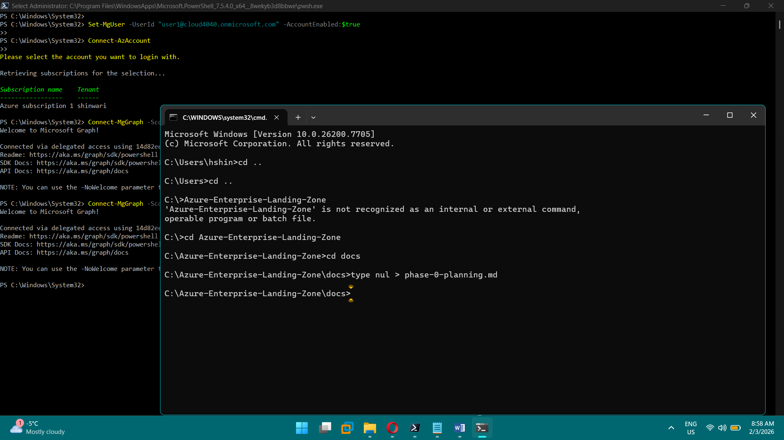

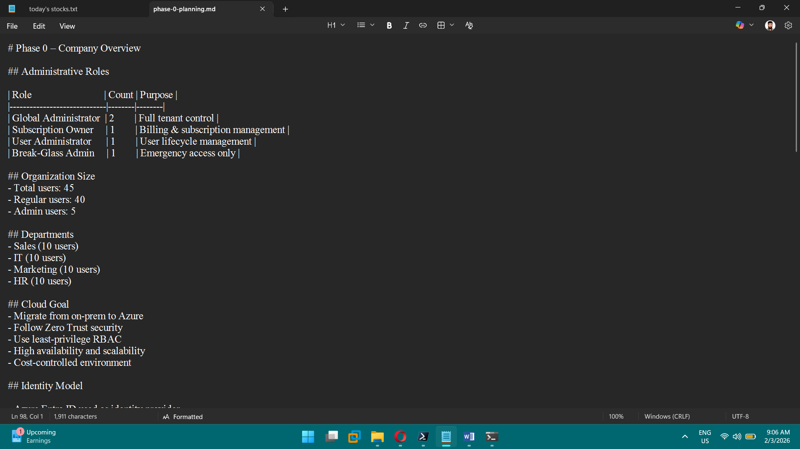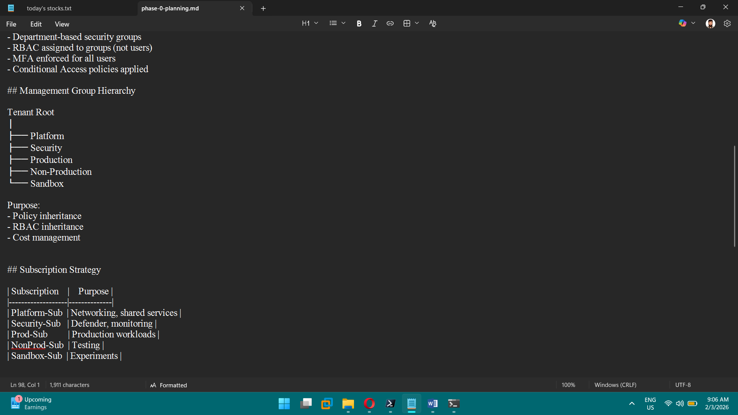

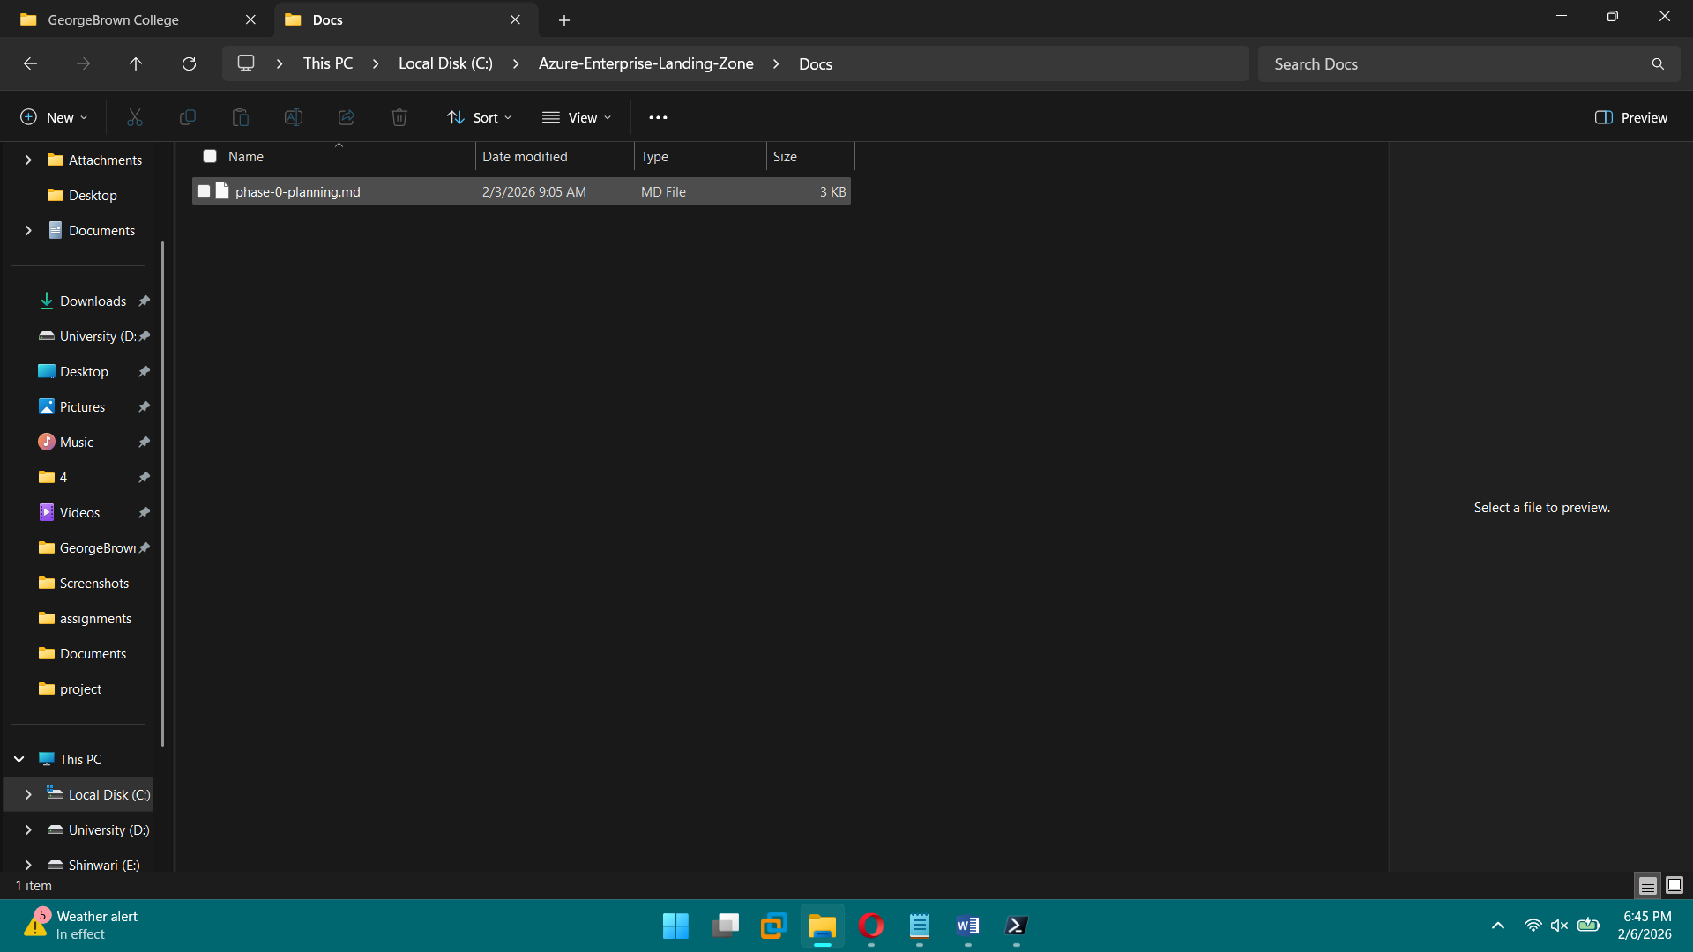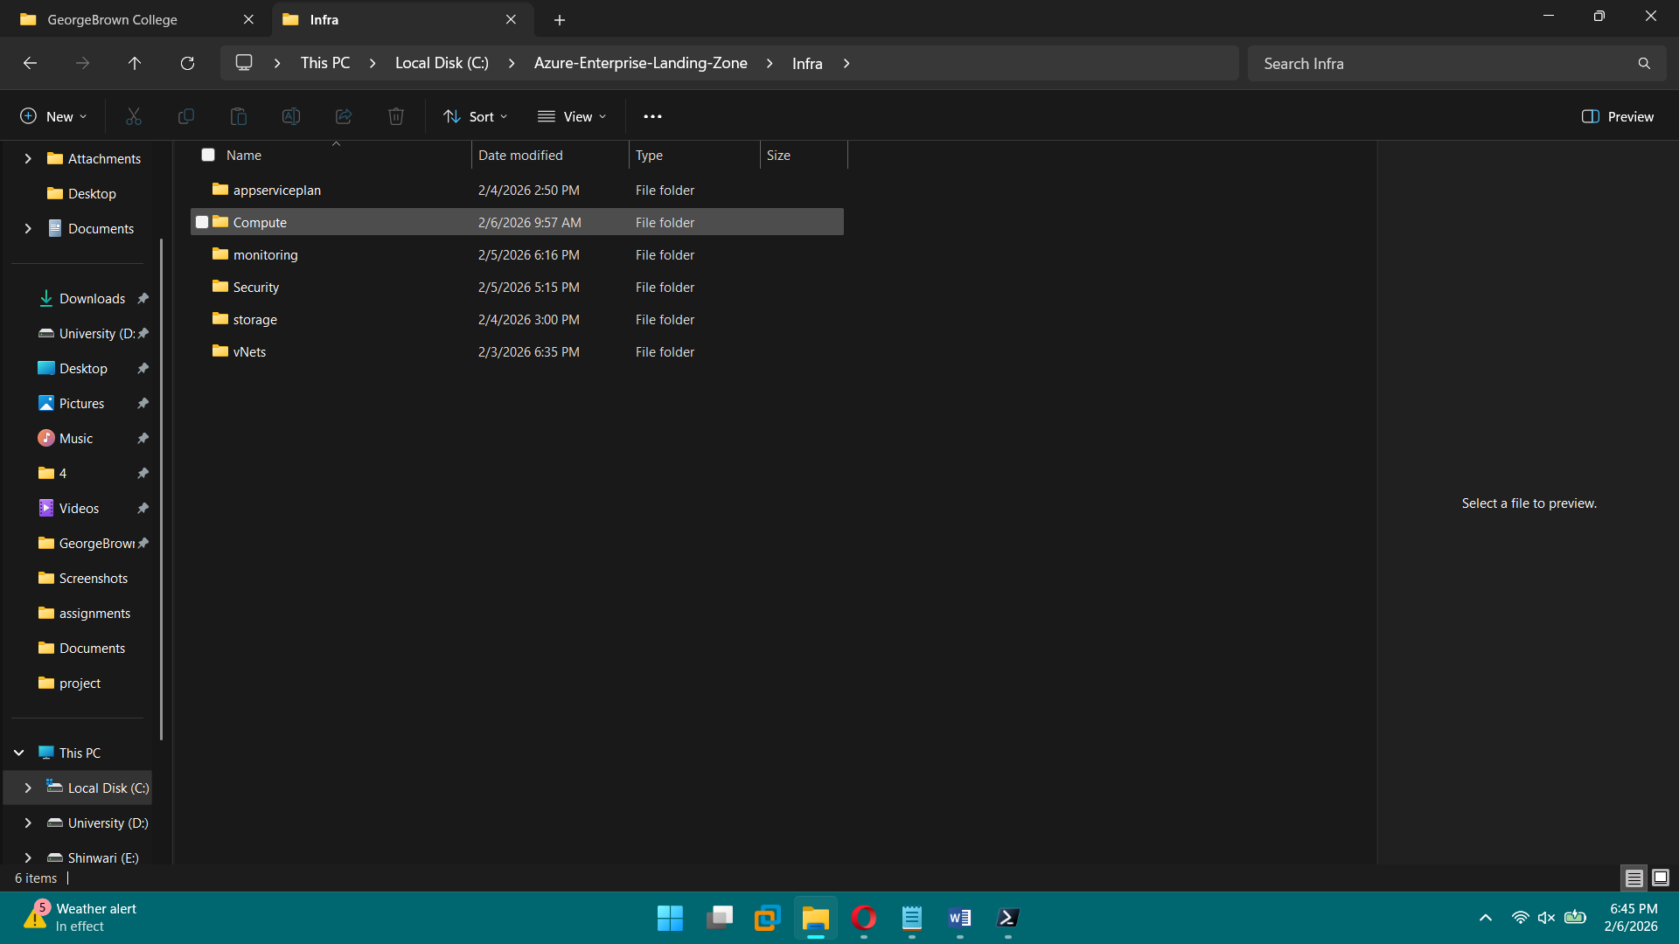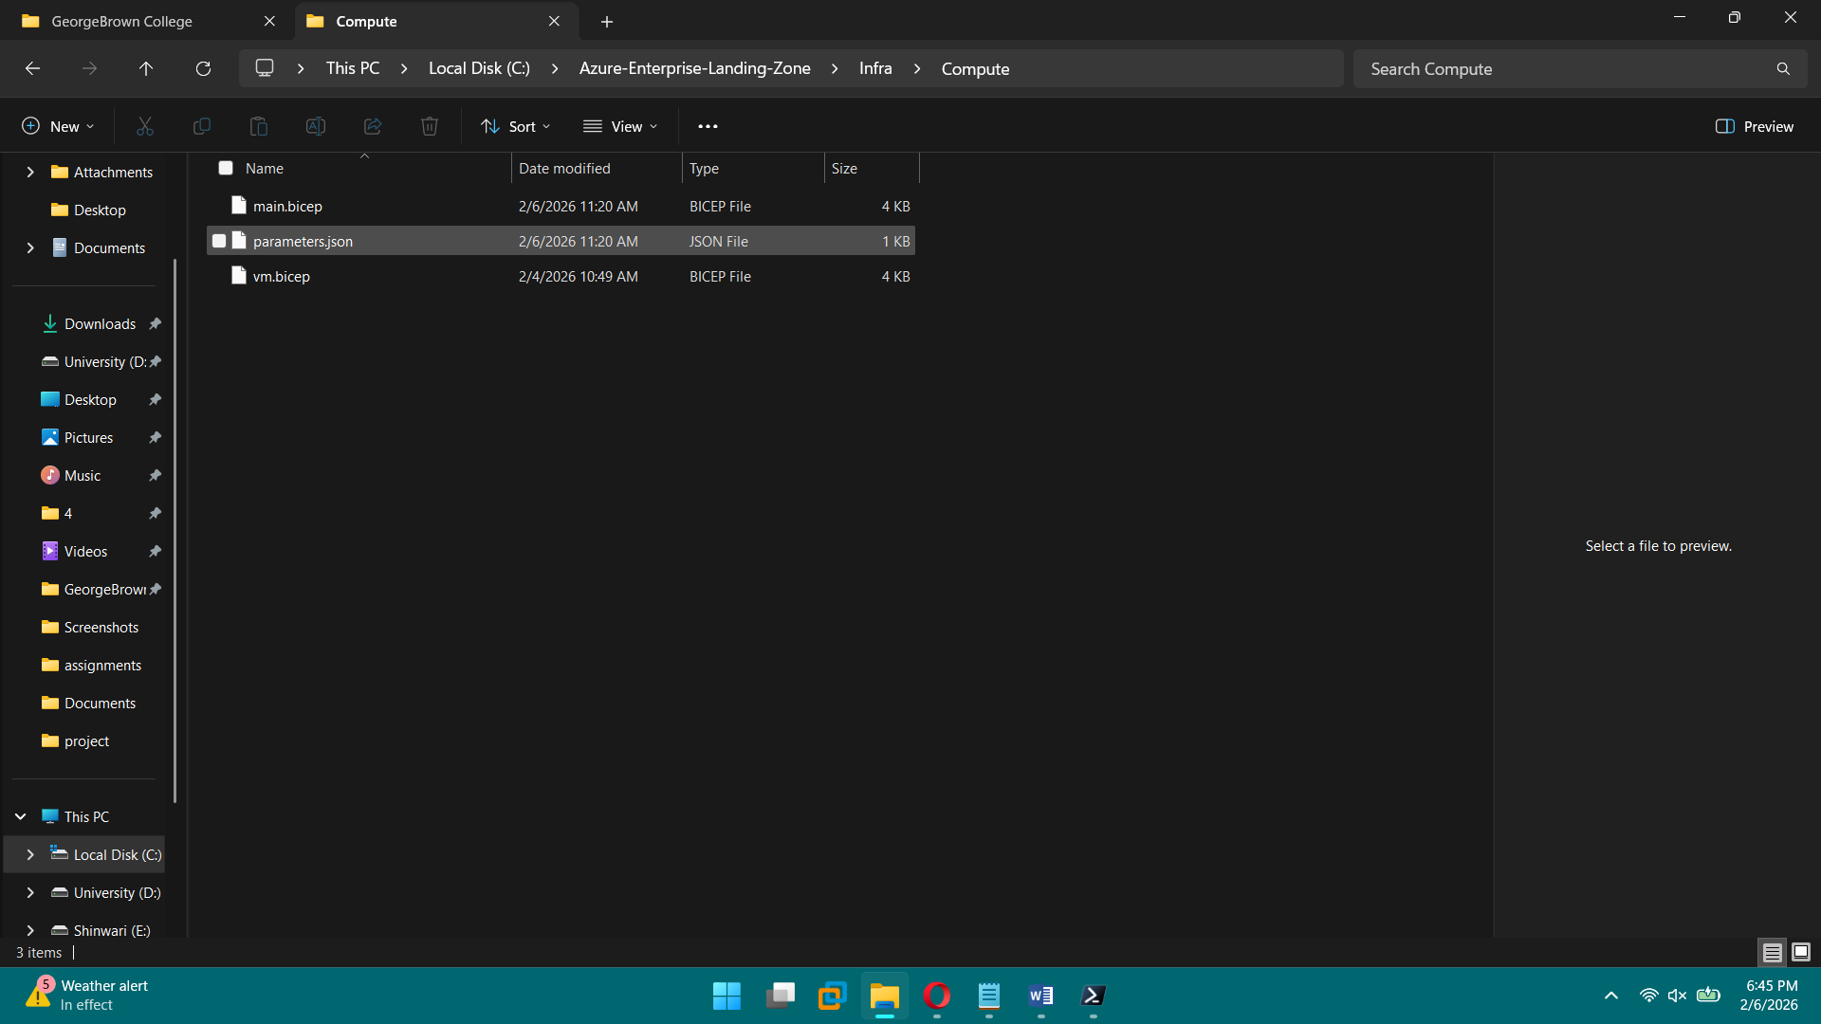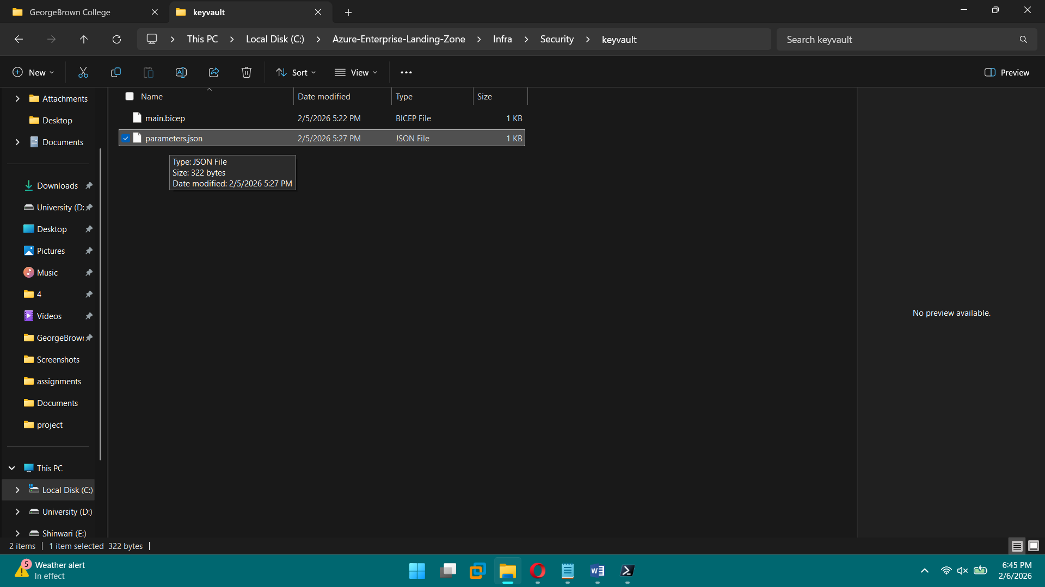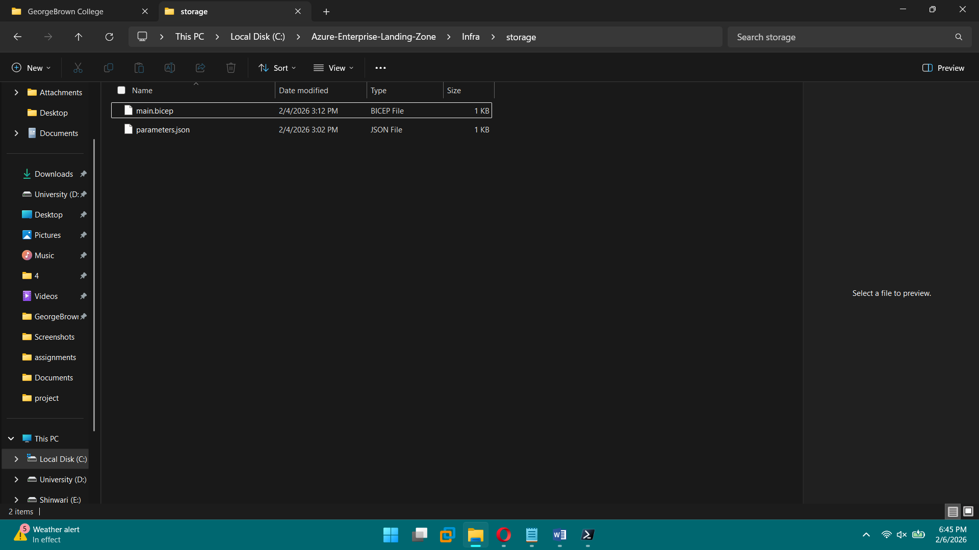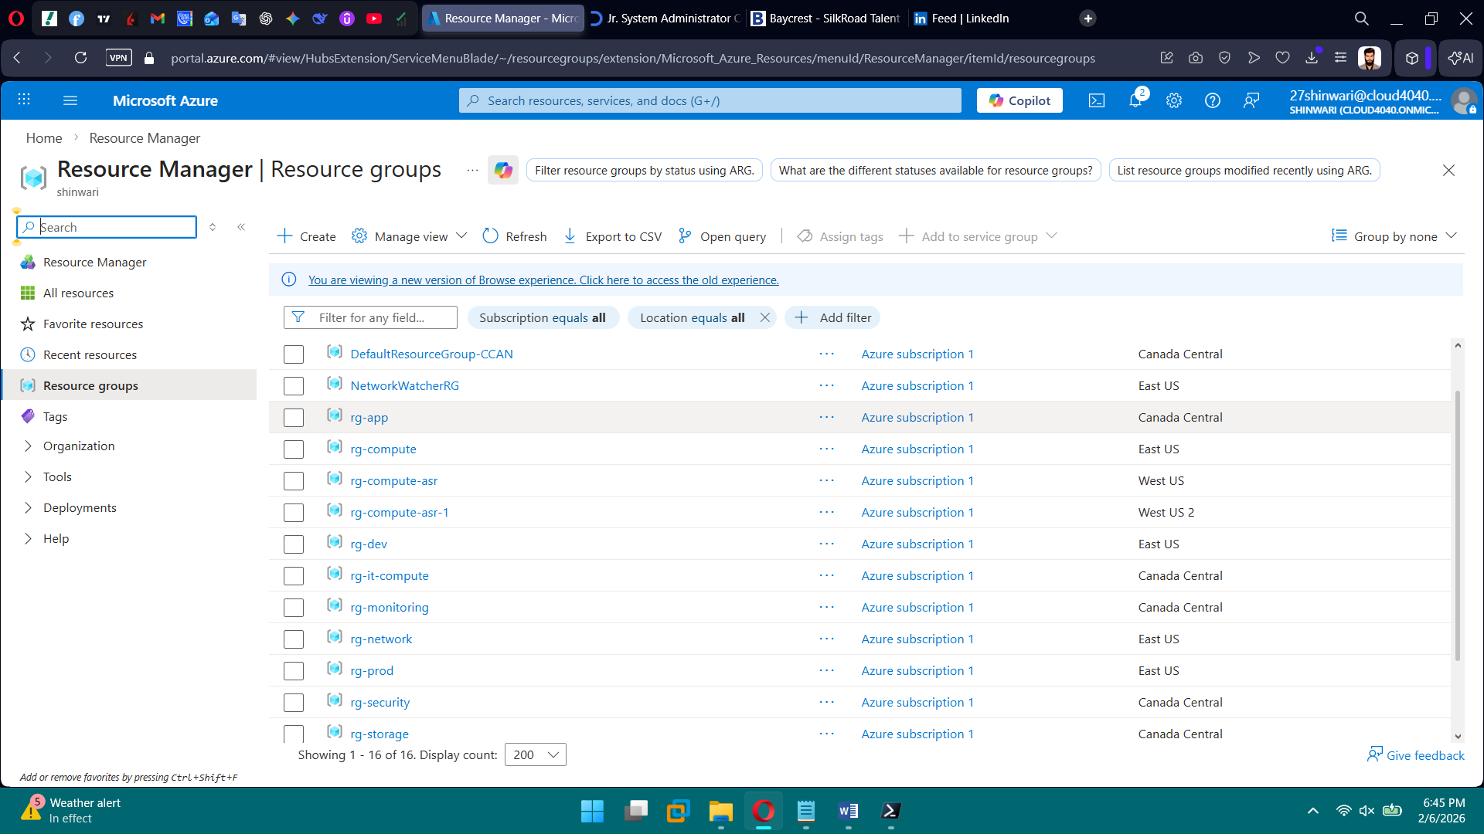

**PHASE 1 — Identity & Access (Entra ID)**

**Tasks**

1. Create 45 users
2. Create department security groups
3. Create admin accounts
4. Configure MFA
5. Create Conditional Access policies
6. Create break-glass account
7. Exclude break-glass from CA
8. Create Administrative Units
9. Assign Entra ID roles
10. Verify sign-in logs

**Brief Explanation of All Steps:**

* We built a secure Microsoft Entra ID foundation by creating users in bulk and defining clear administrative roles.
* We set up break-glass accounts and enforced MFA for all users using Conditional Access, while excluding emergency accounts.
* We created baseline Conditional Access policies to require MFA, block legacy authentication, and document device compliance.
* We organized users by department using Administrative Units (Sales, IT, Marketing, HR) for delegated management.
* We created a Helpdesk Administrator account to handle user support tasks without Global Admin privileges.
* We attempted PowerShell automation, but due to Graph module conflicts, we completed Administrative Units and role scoping via GUI.
* Overall, this design follows least privilege, Zero Trust, and enterprise-ready identity governance principles.

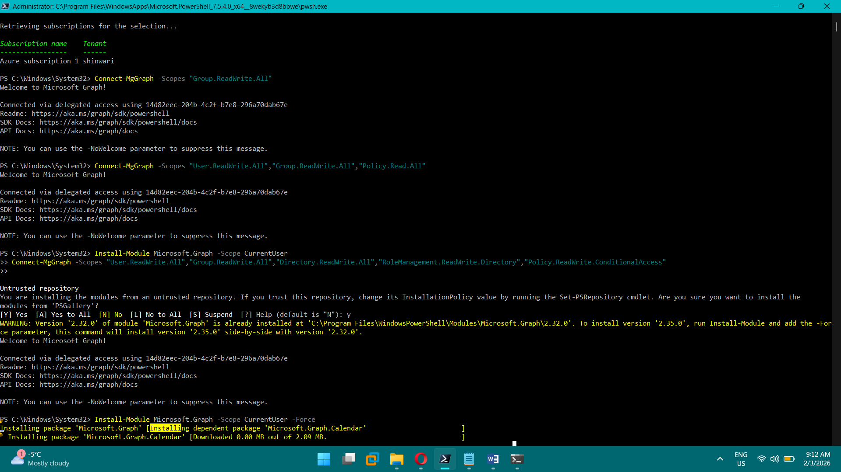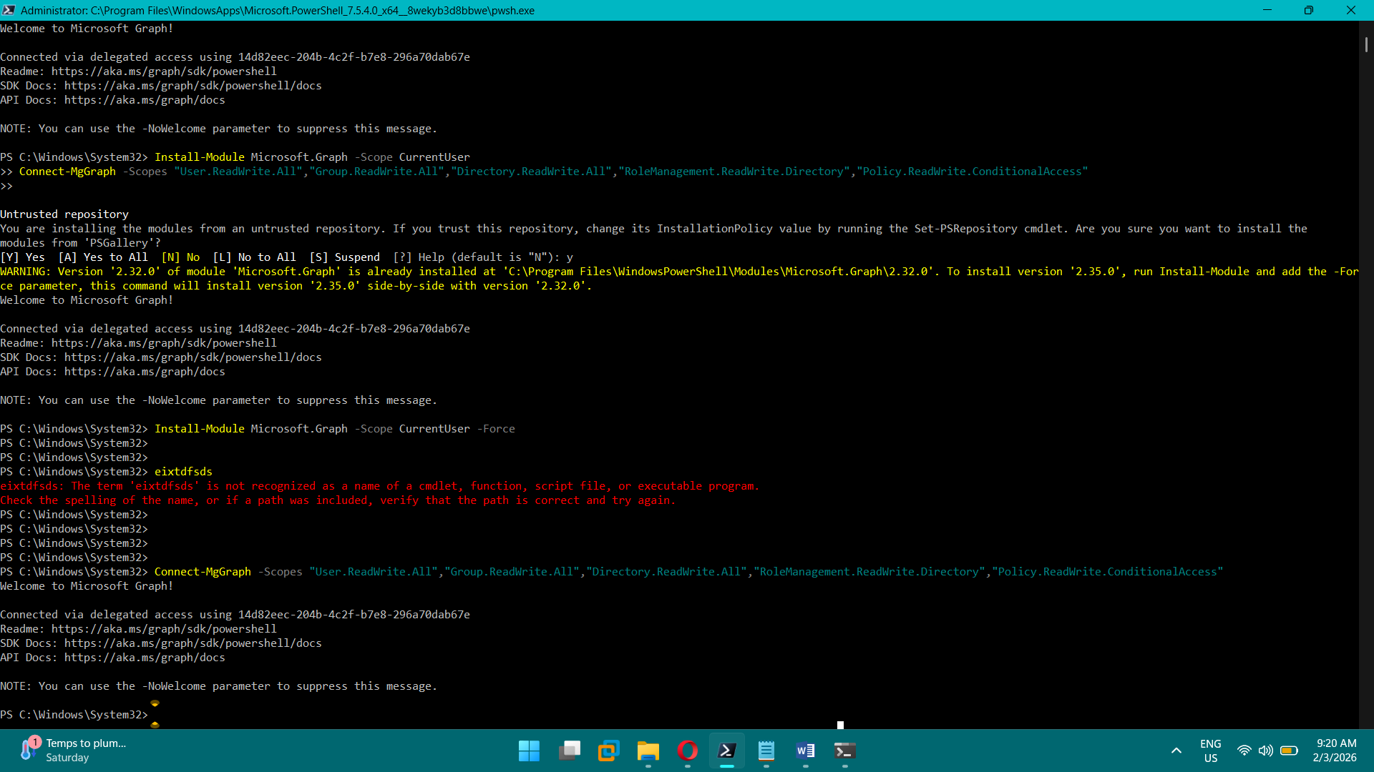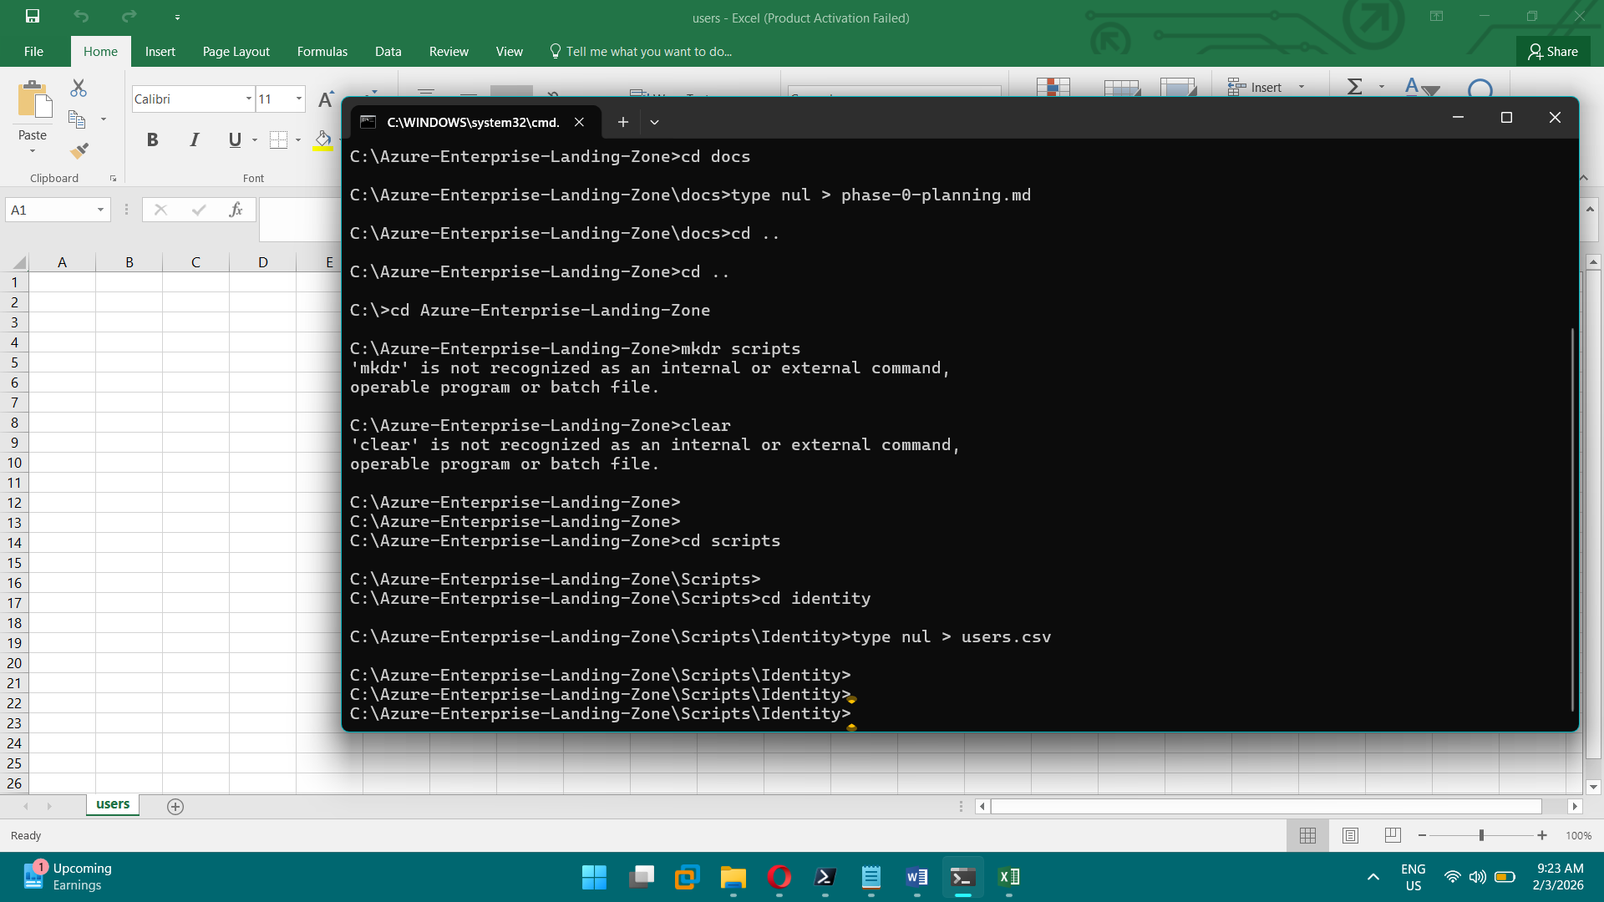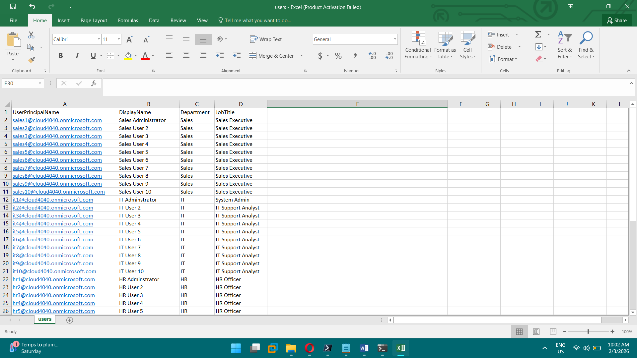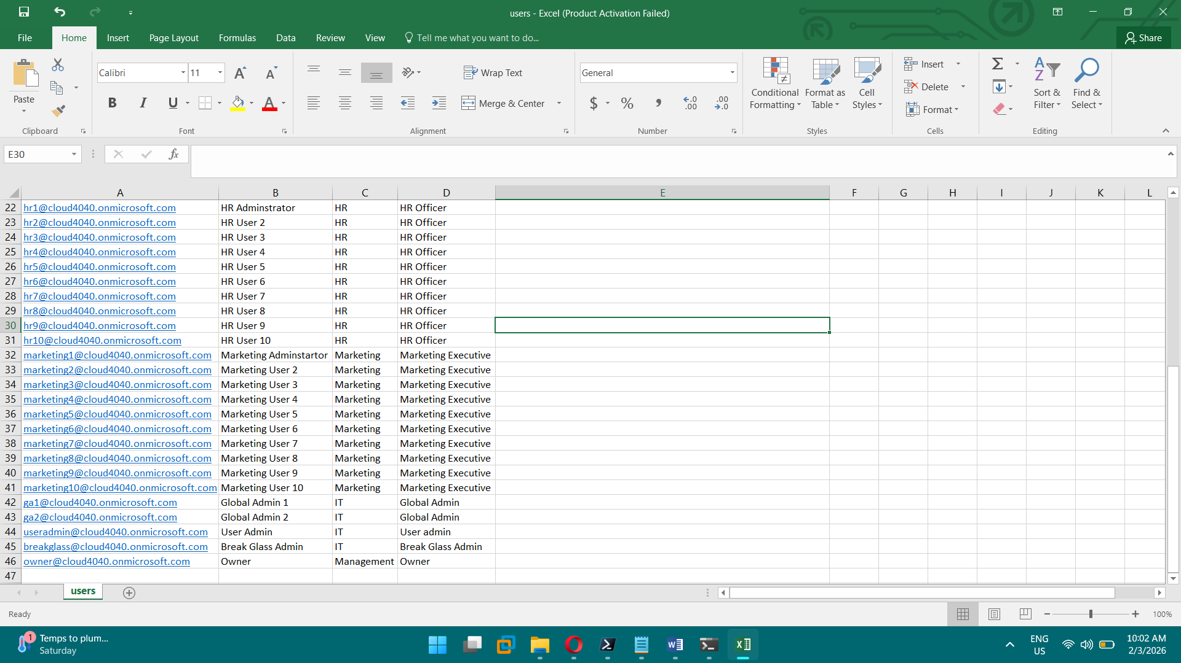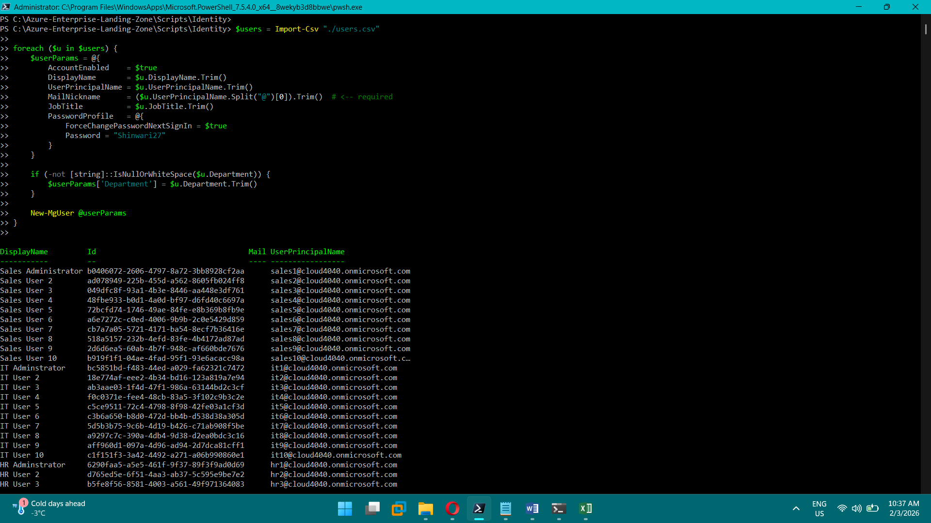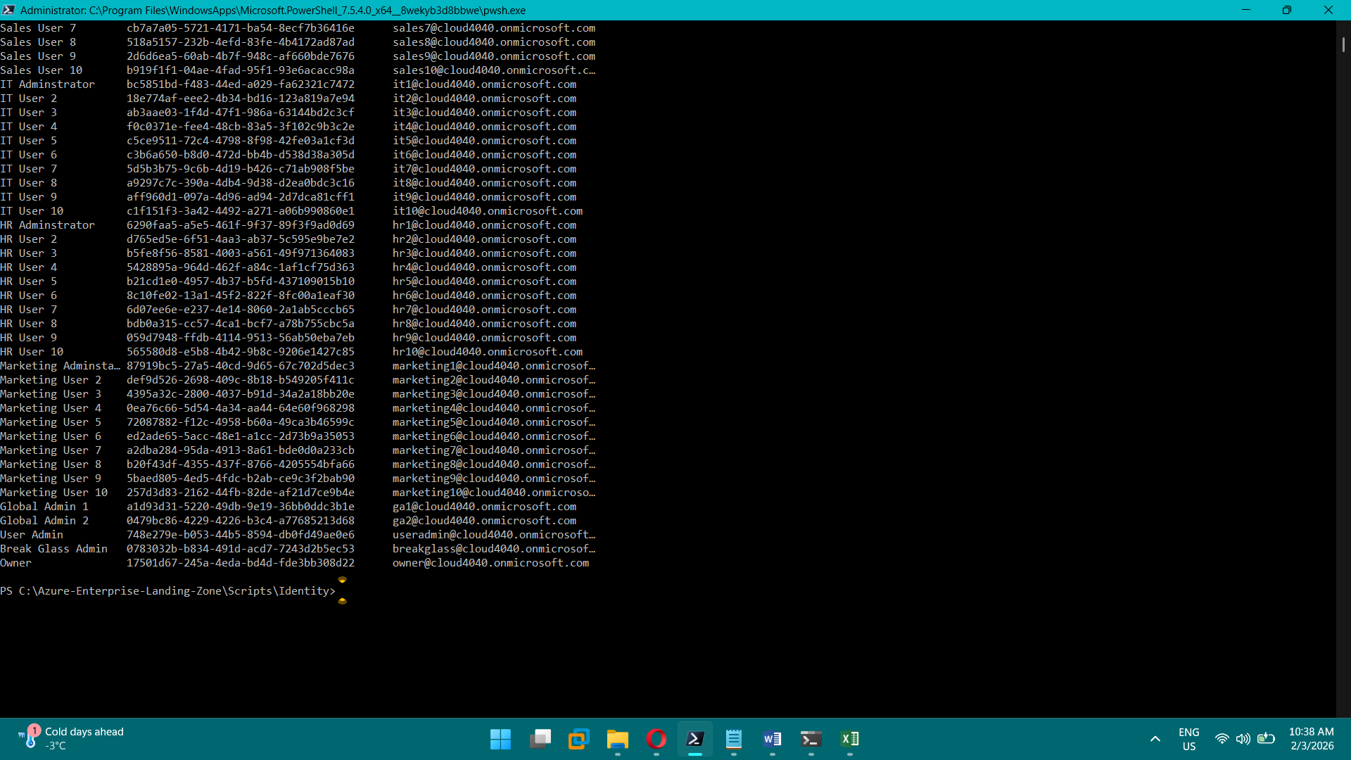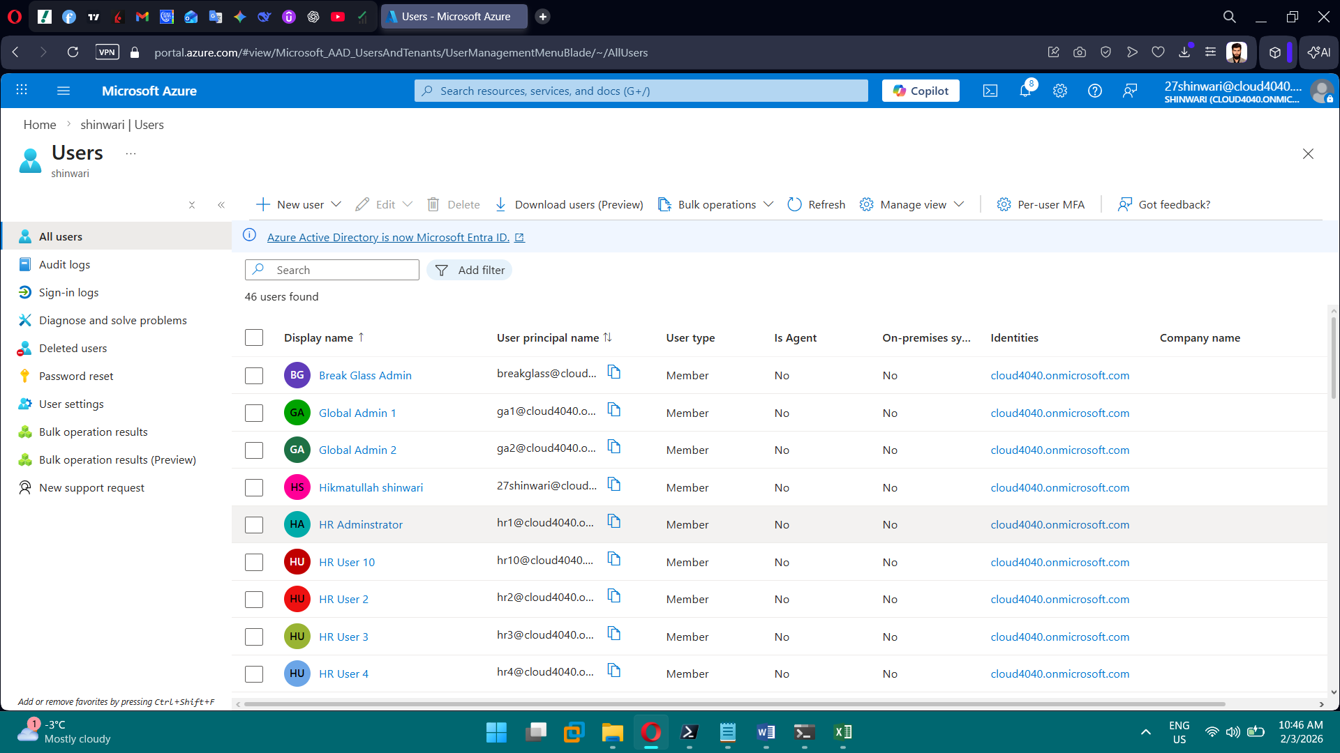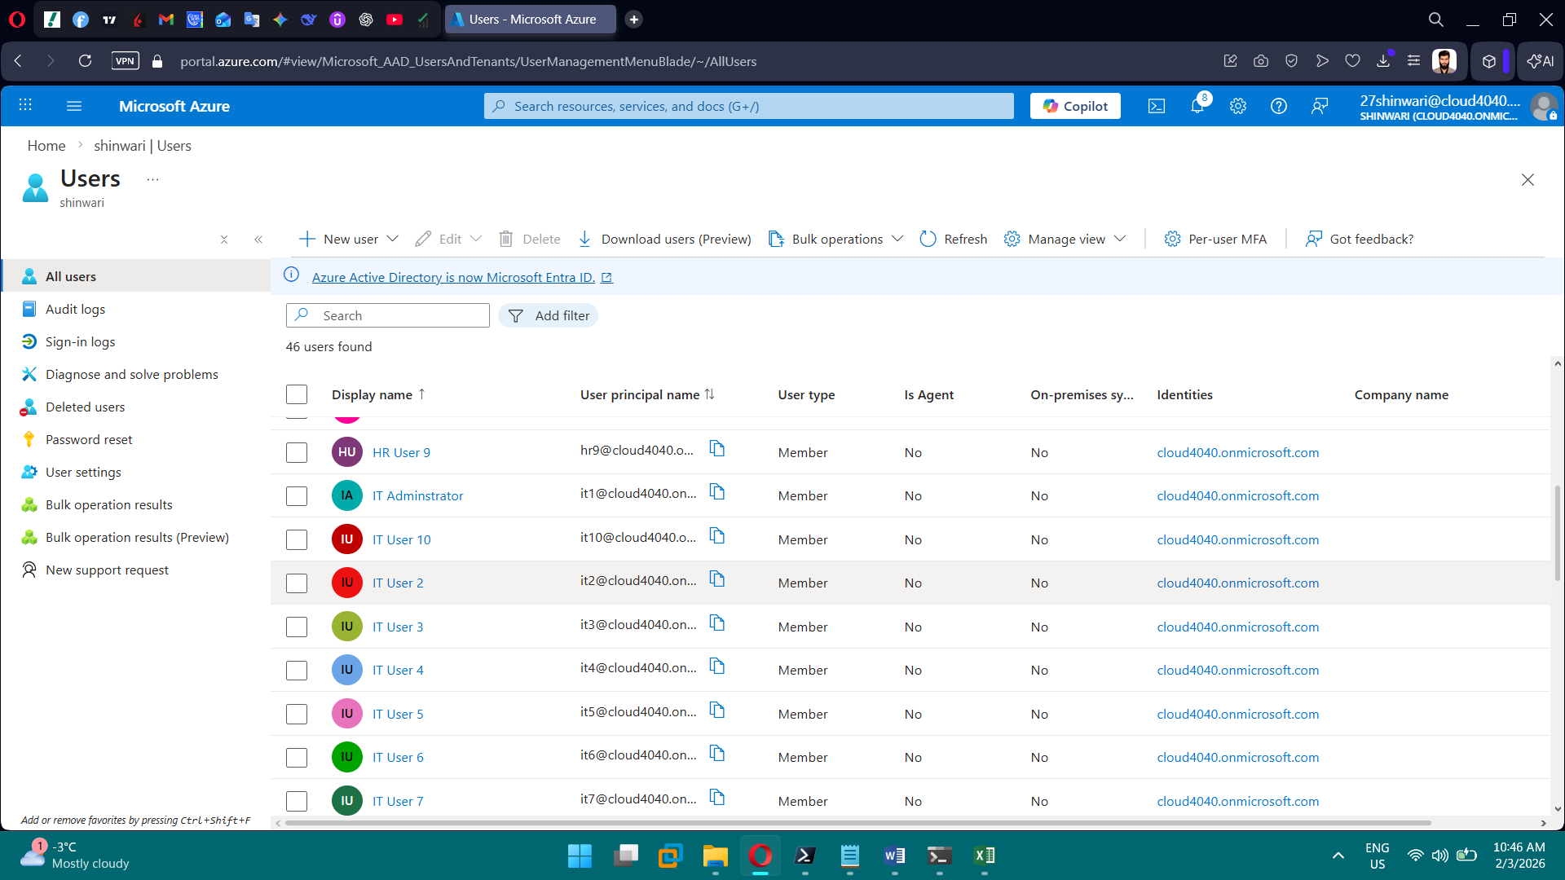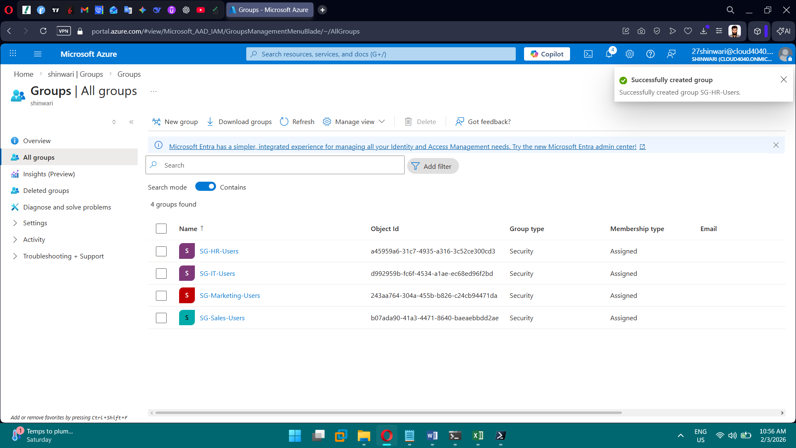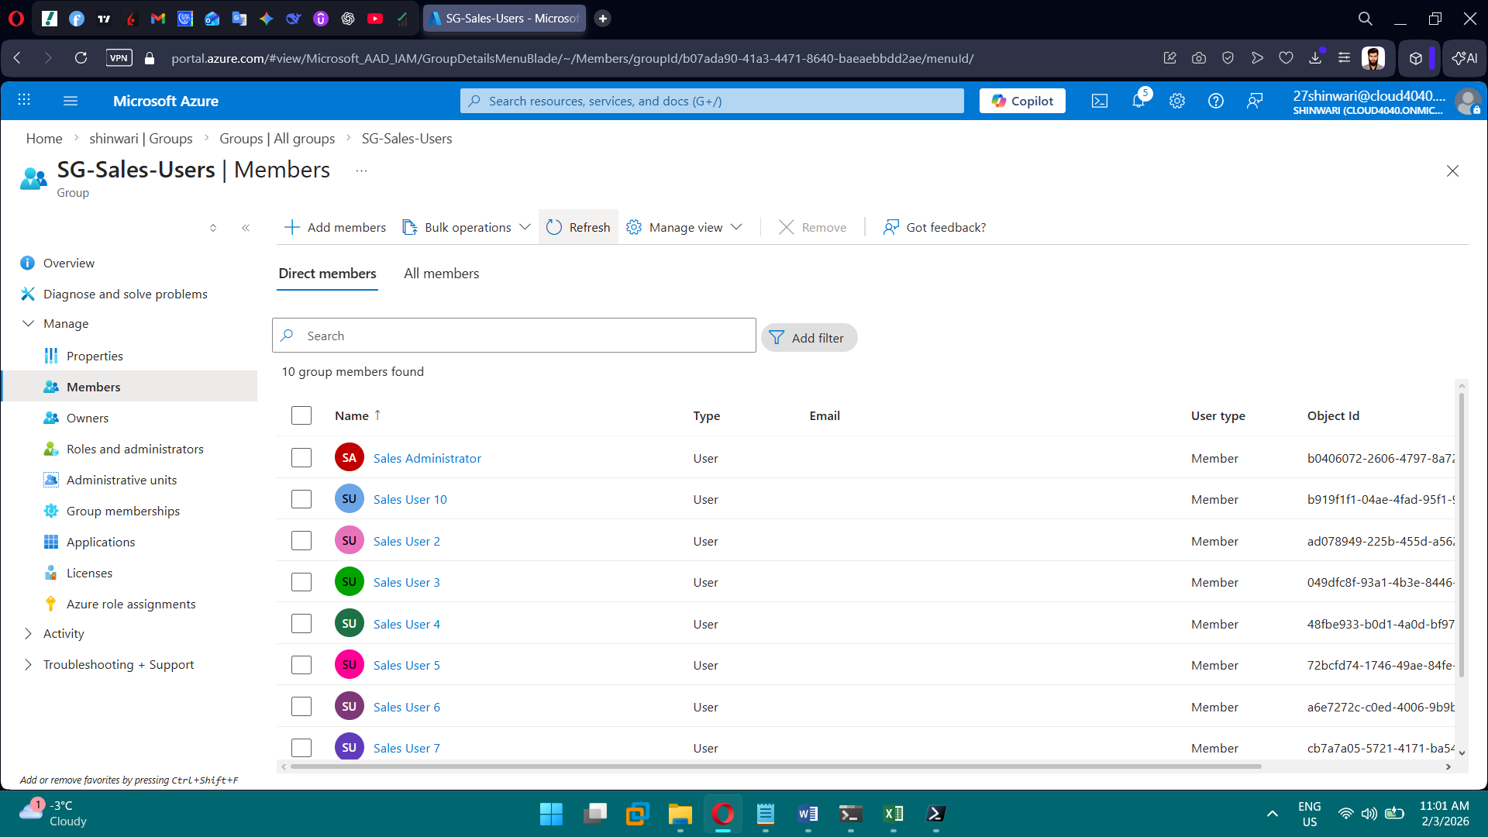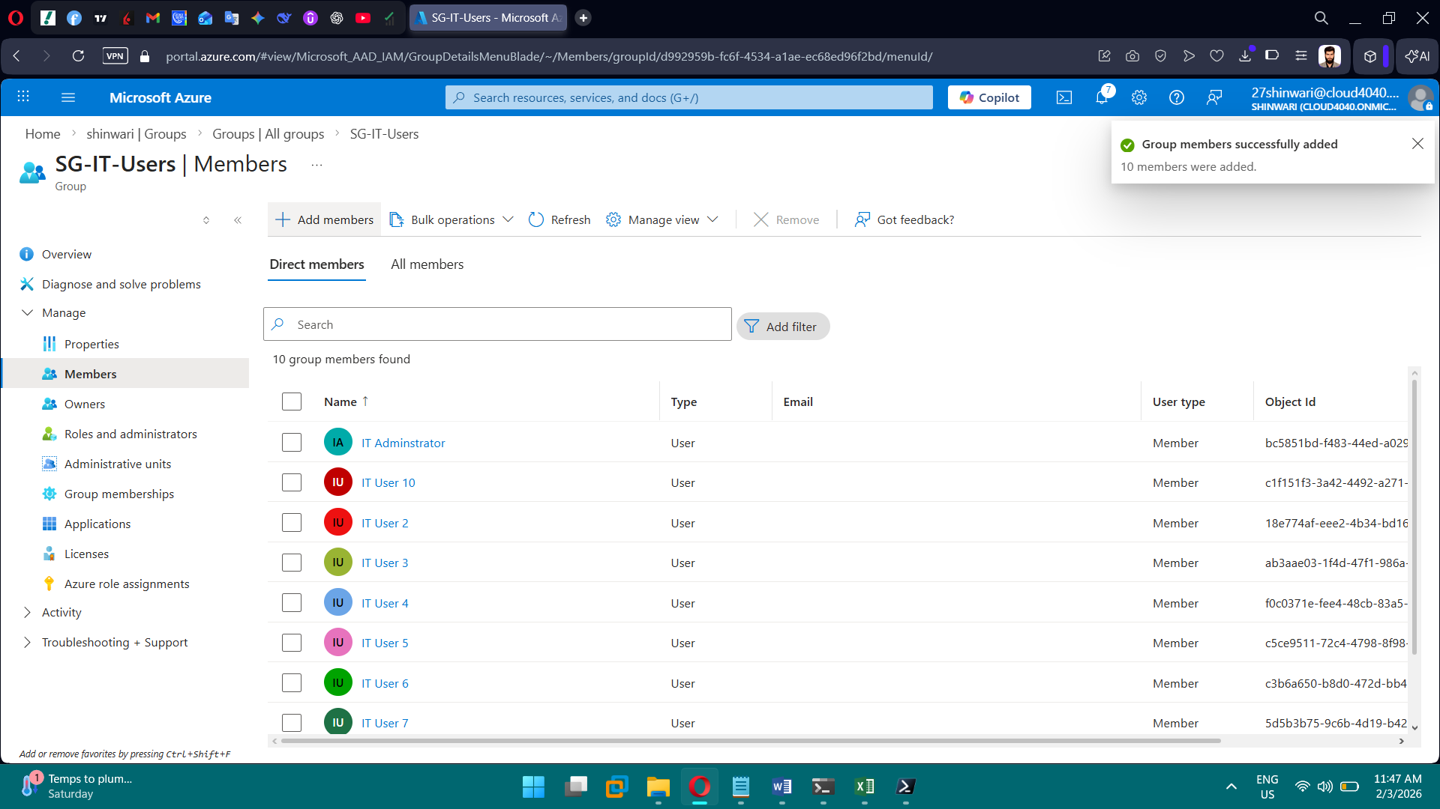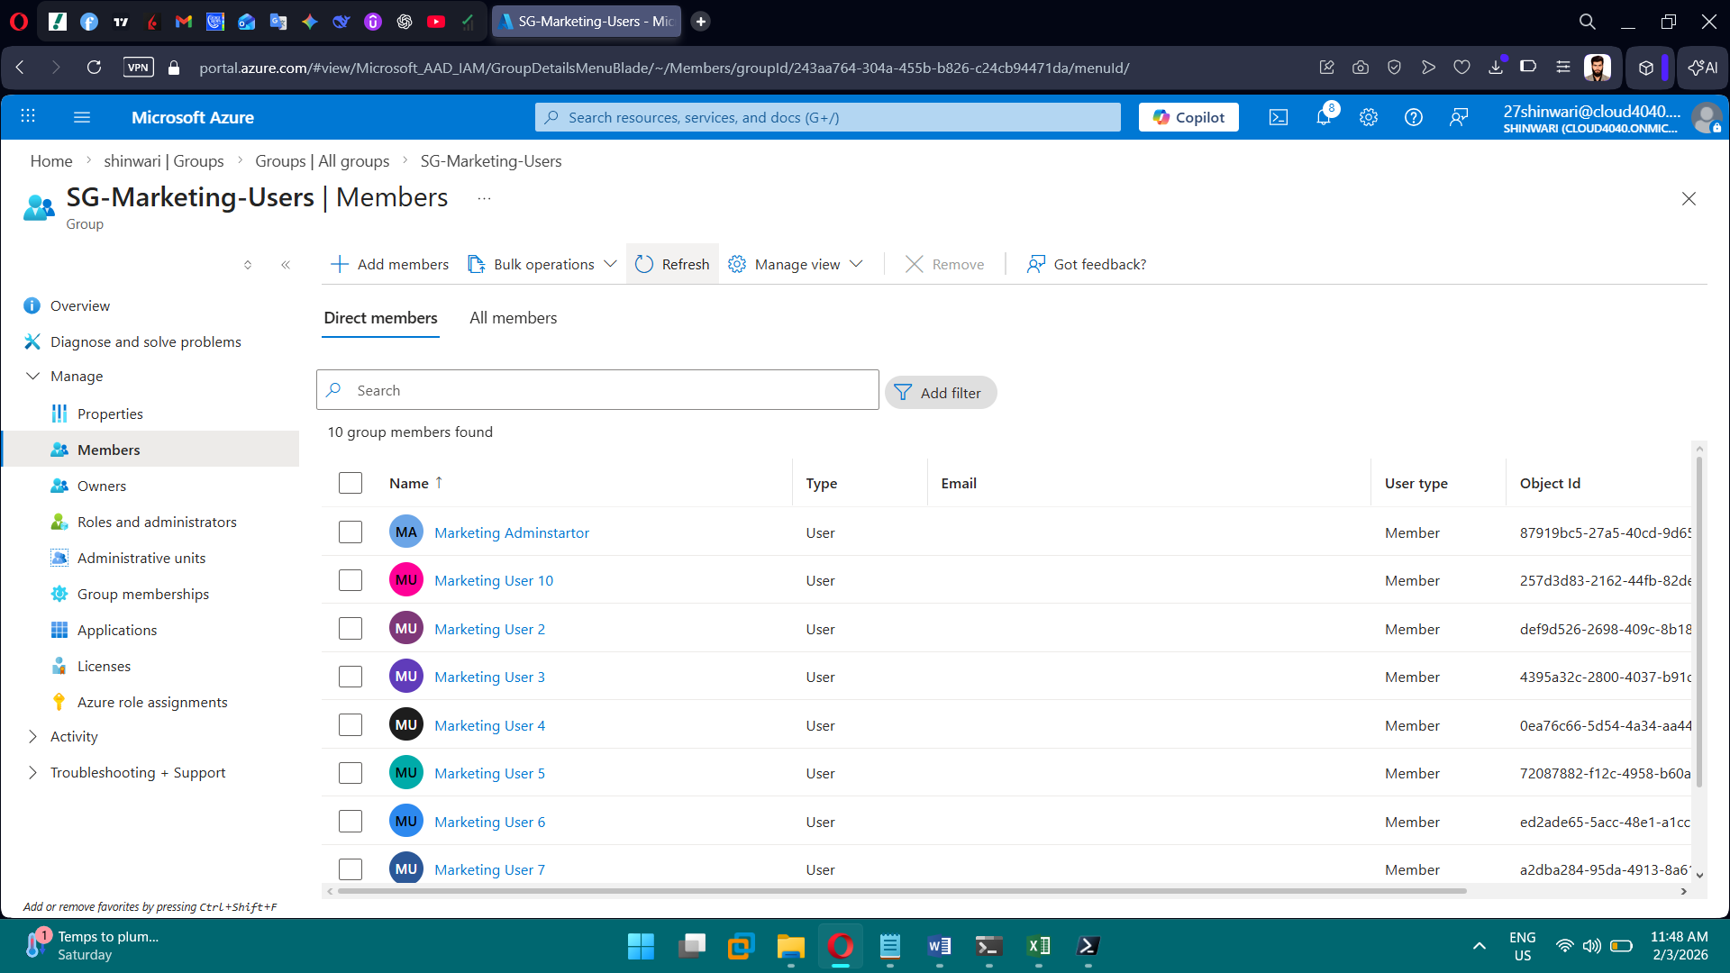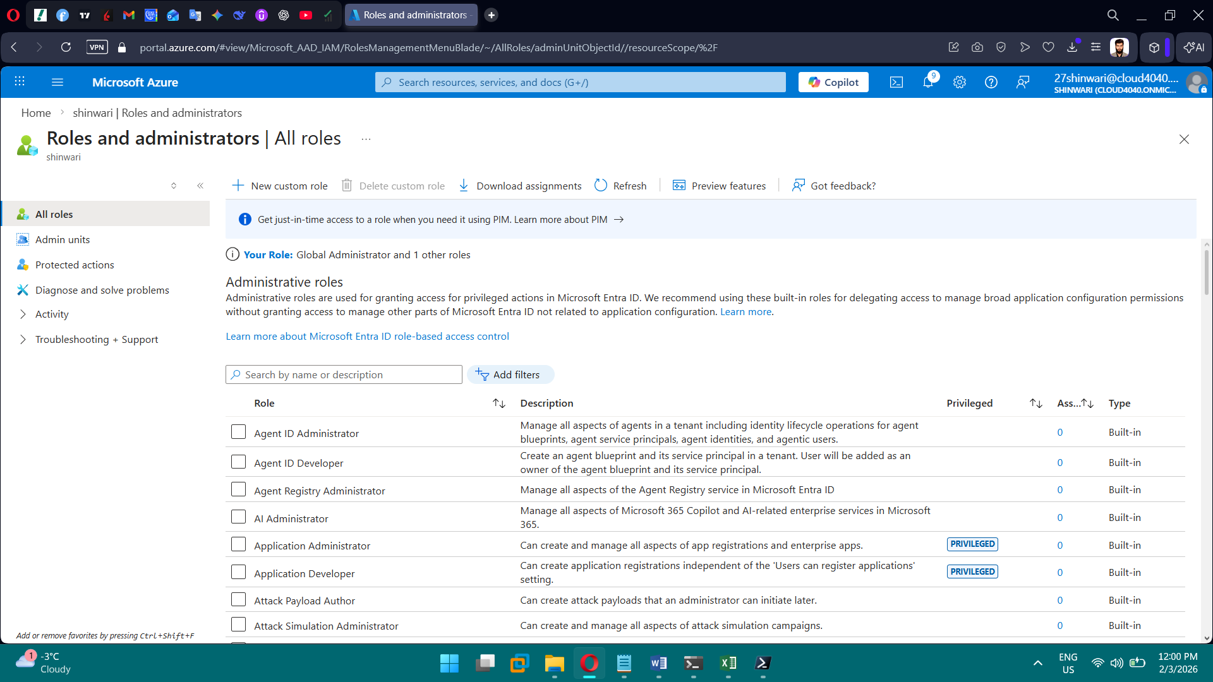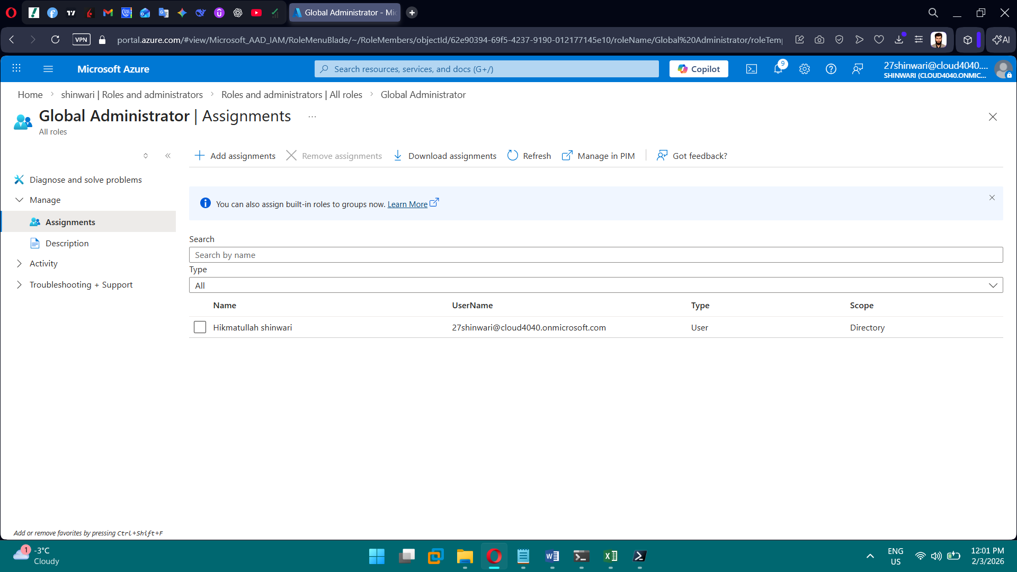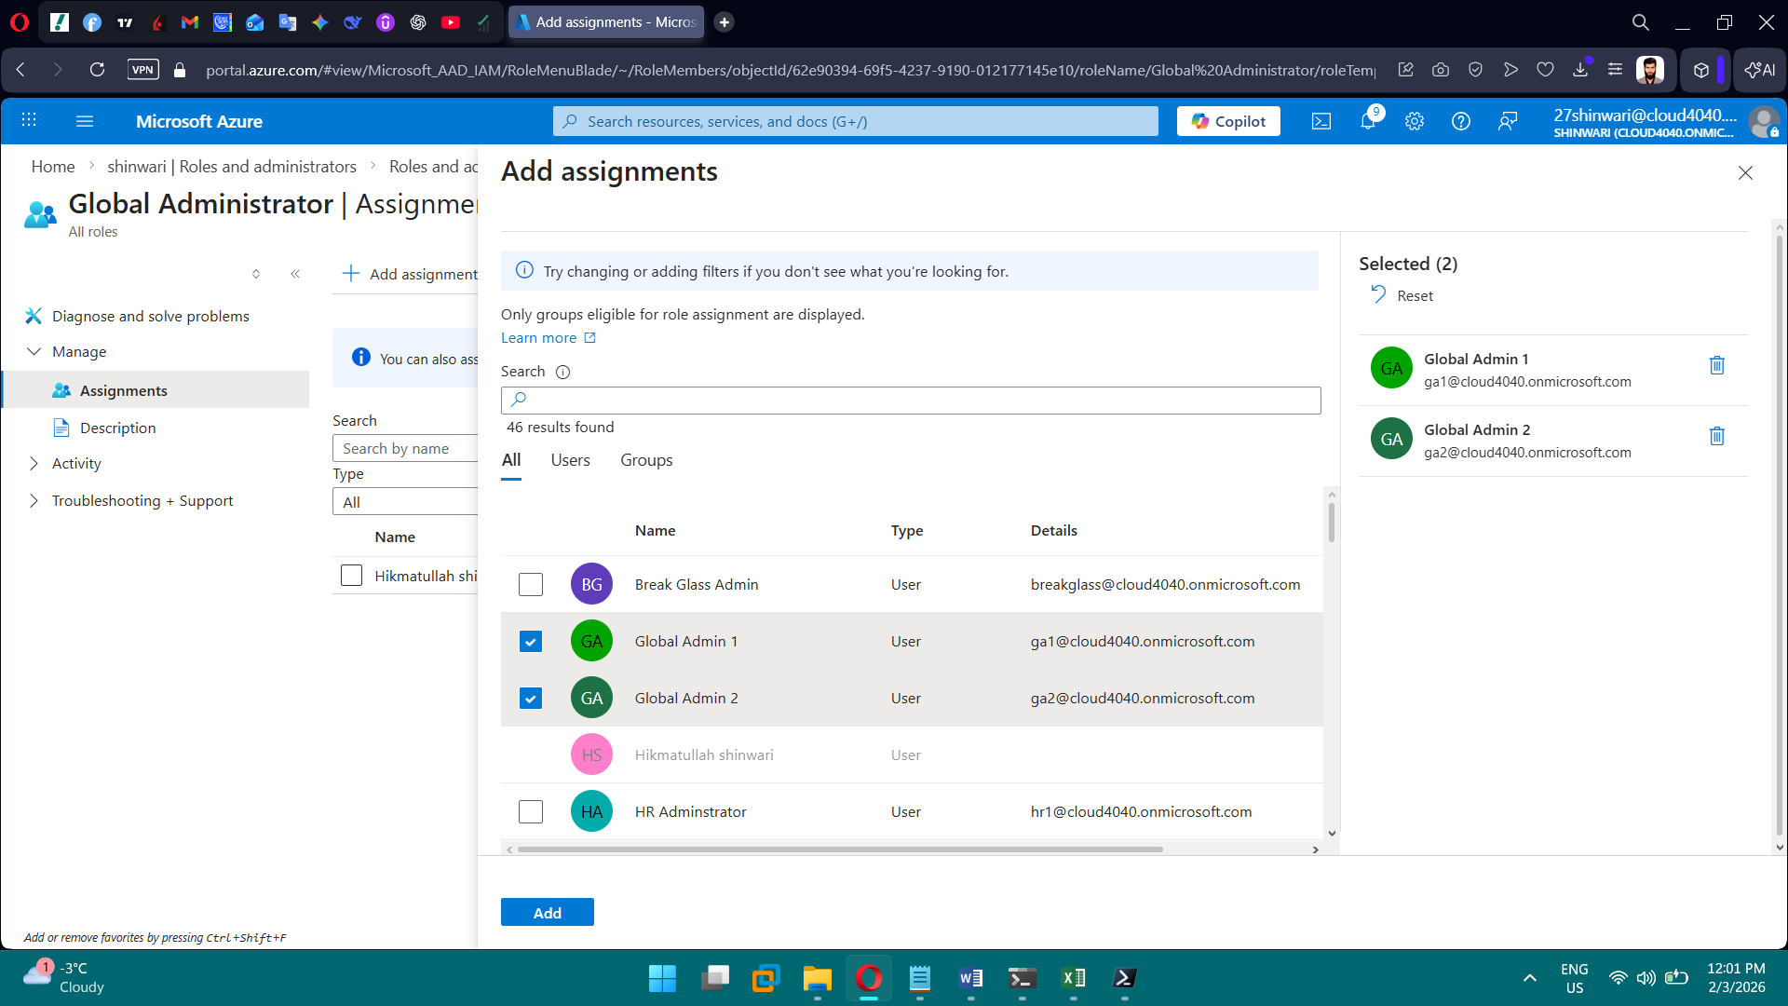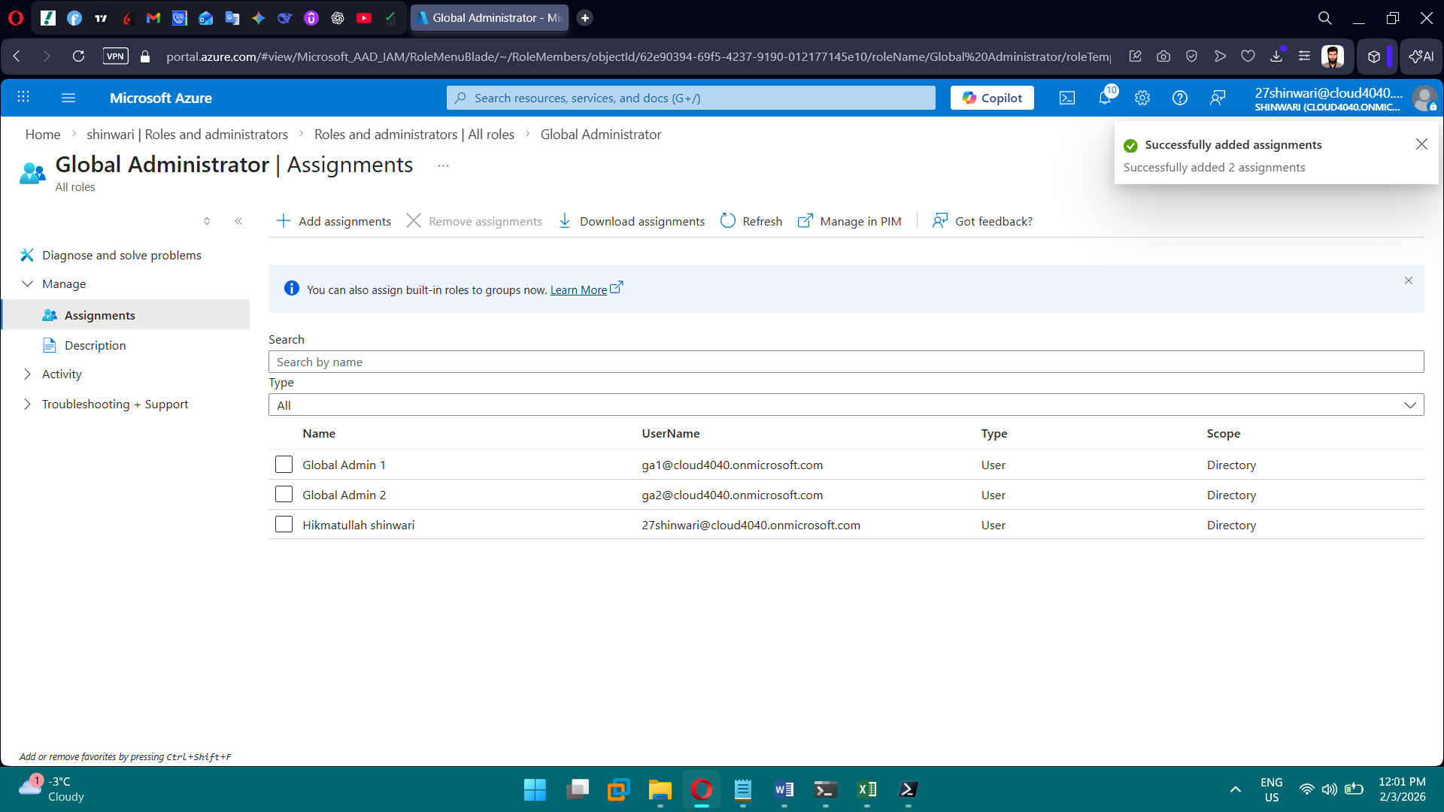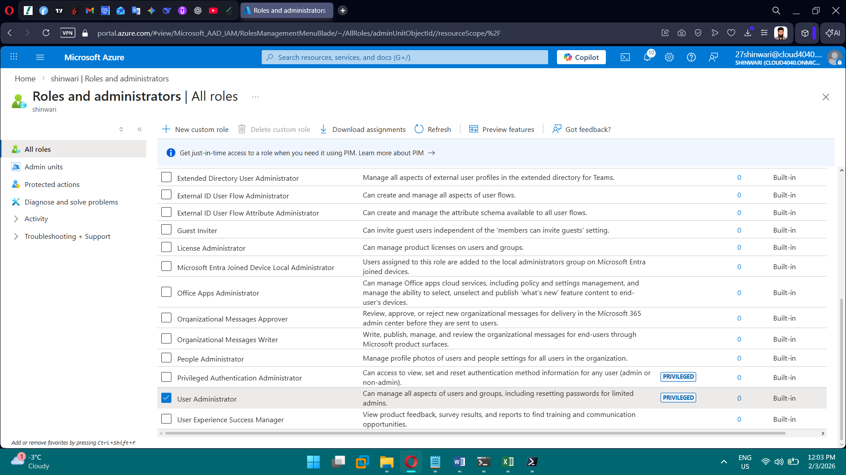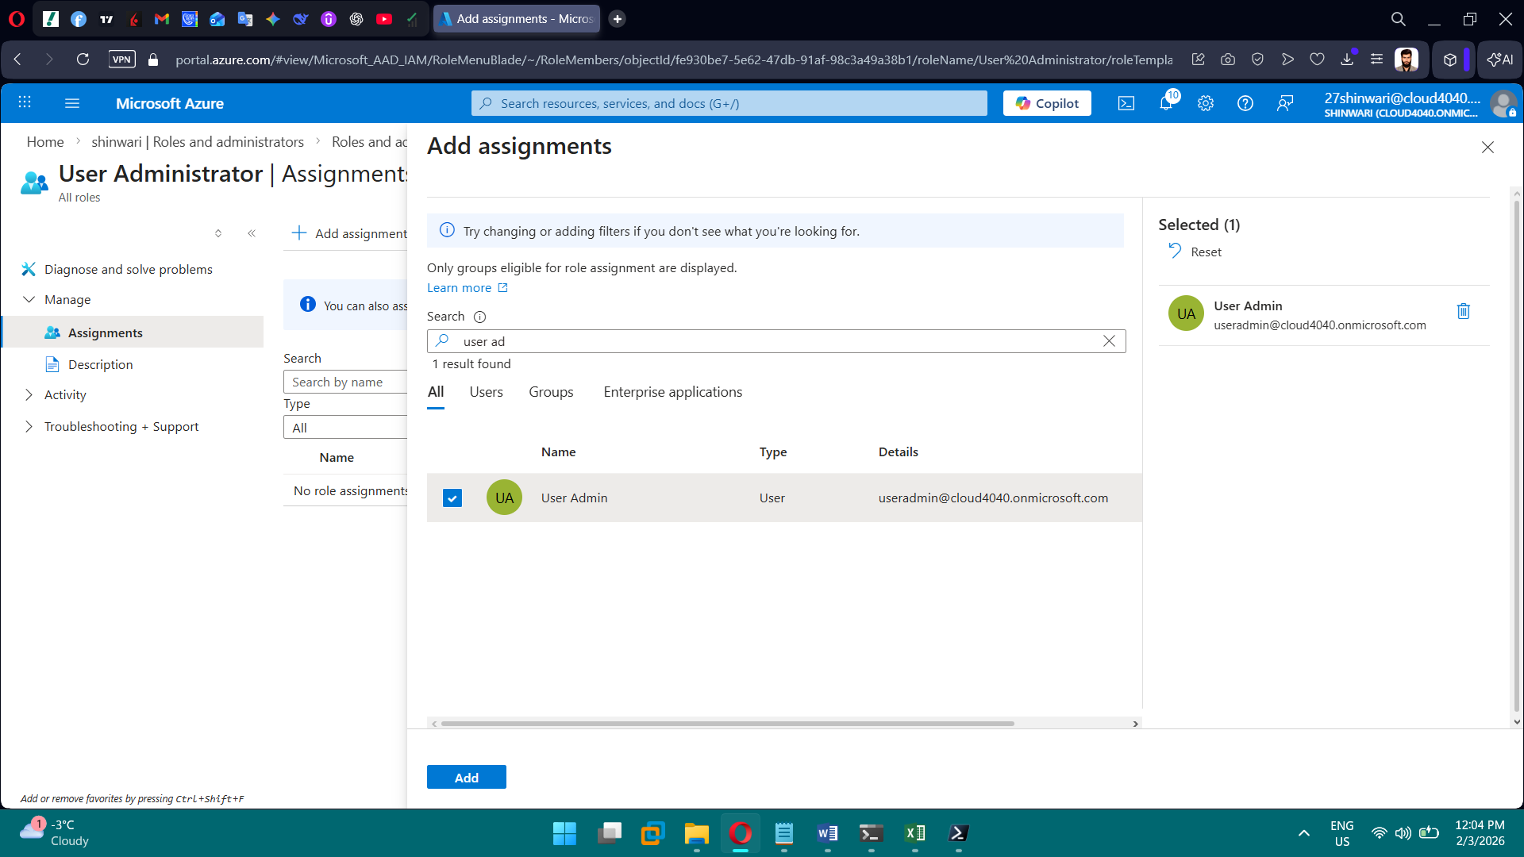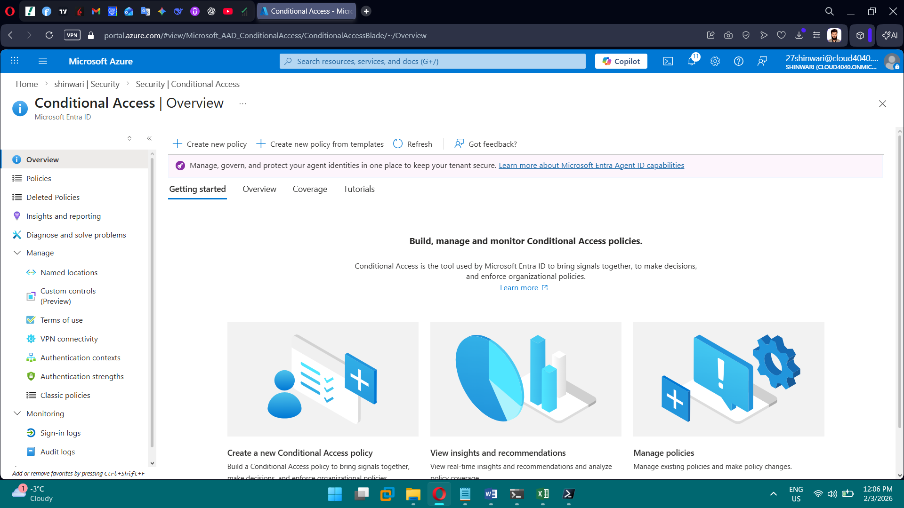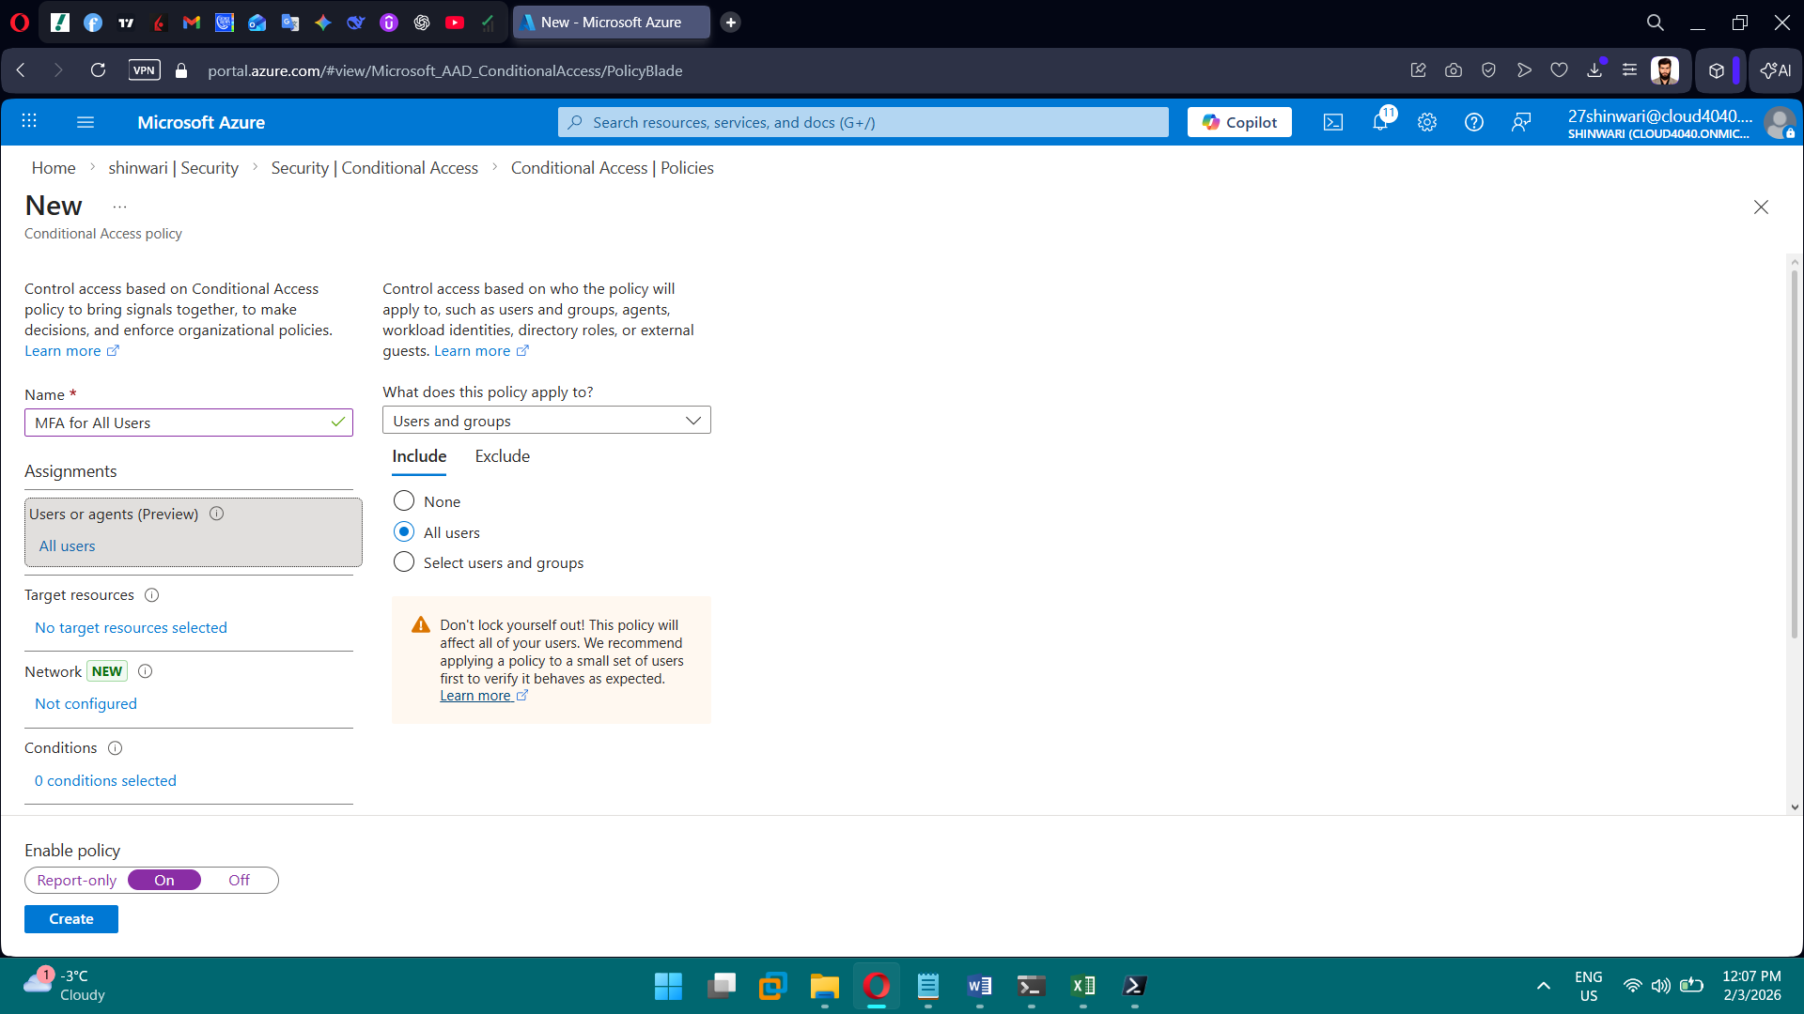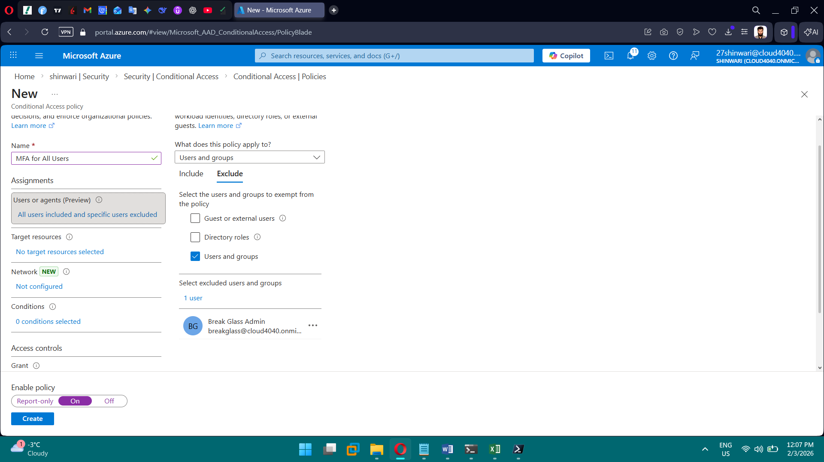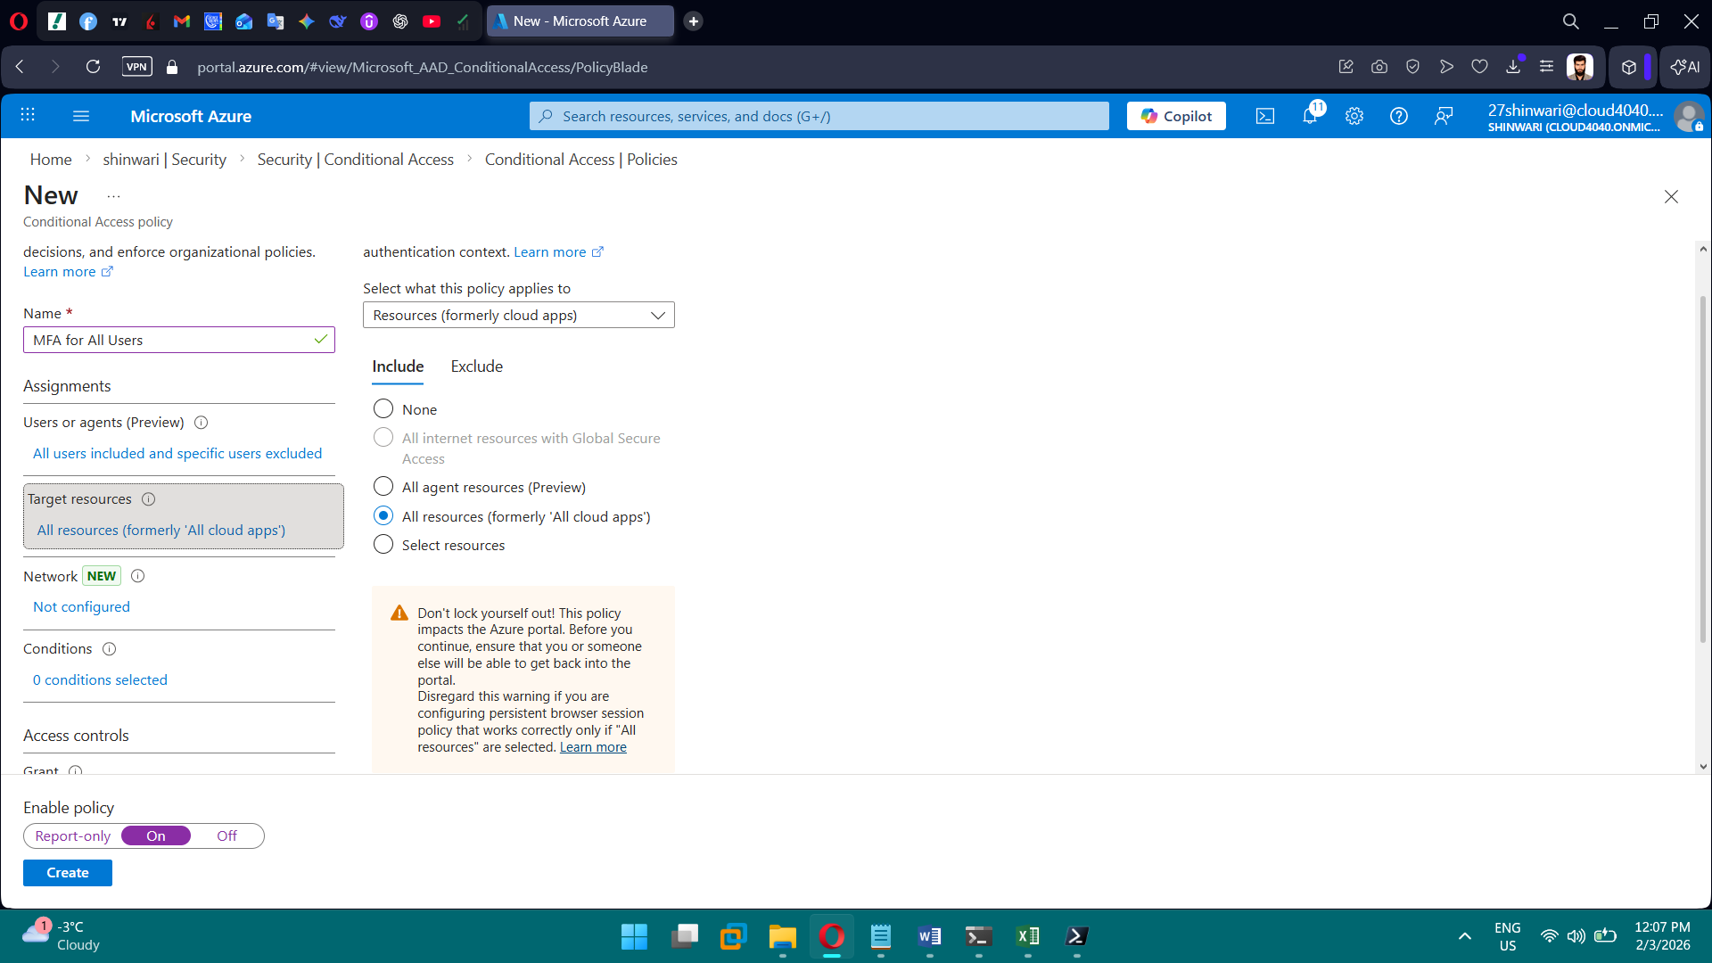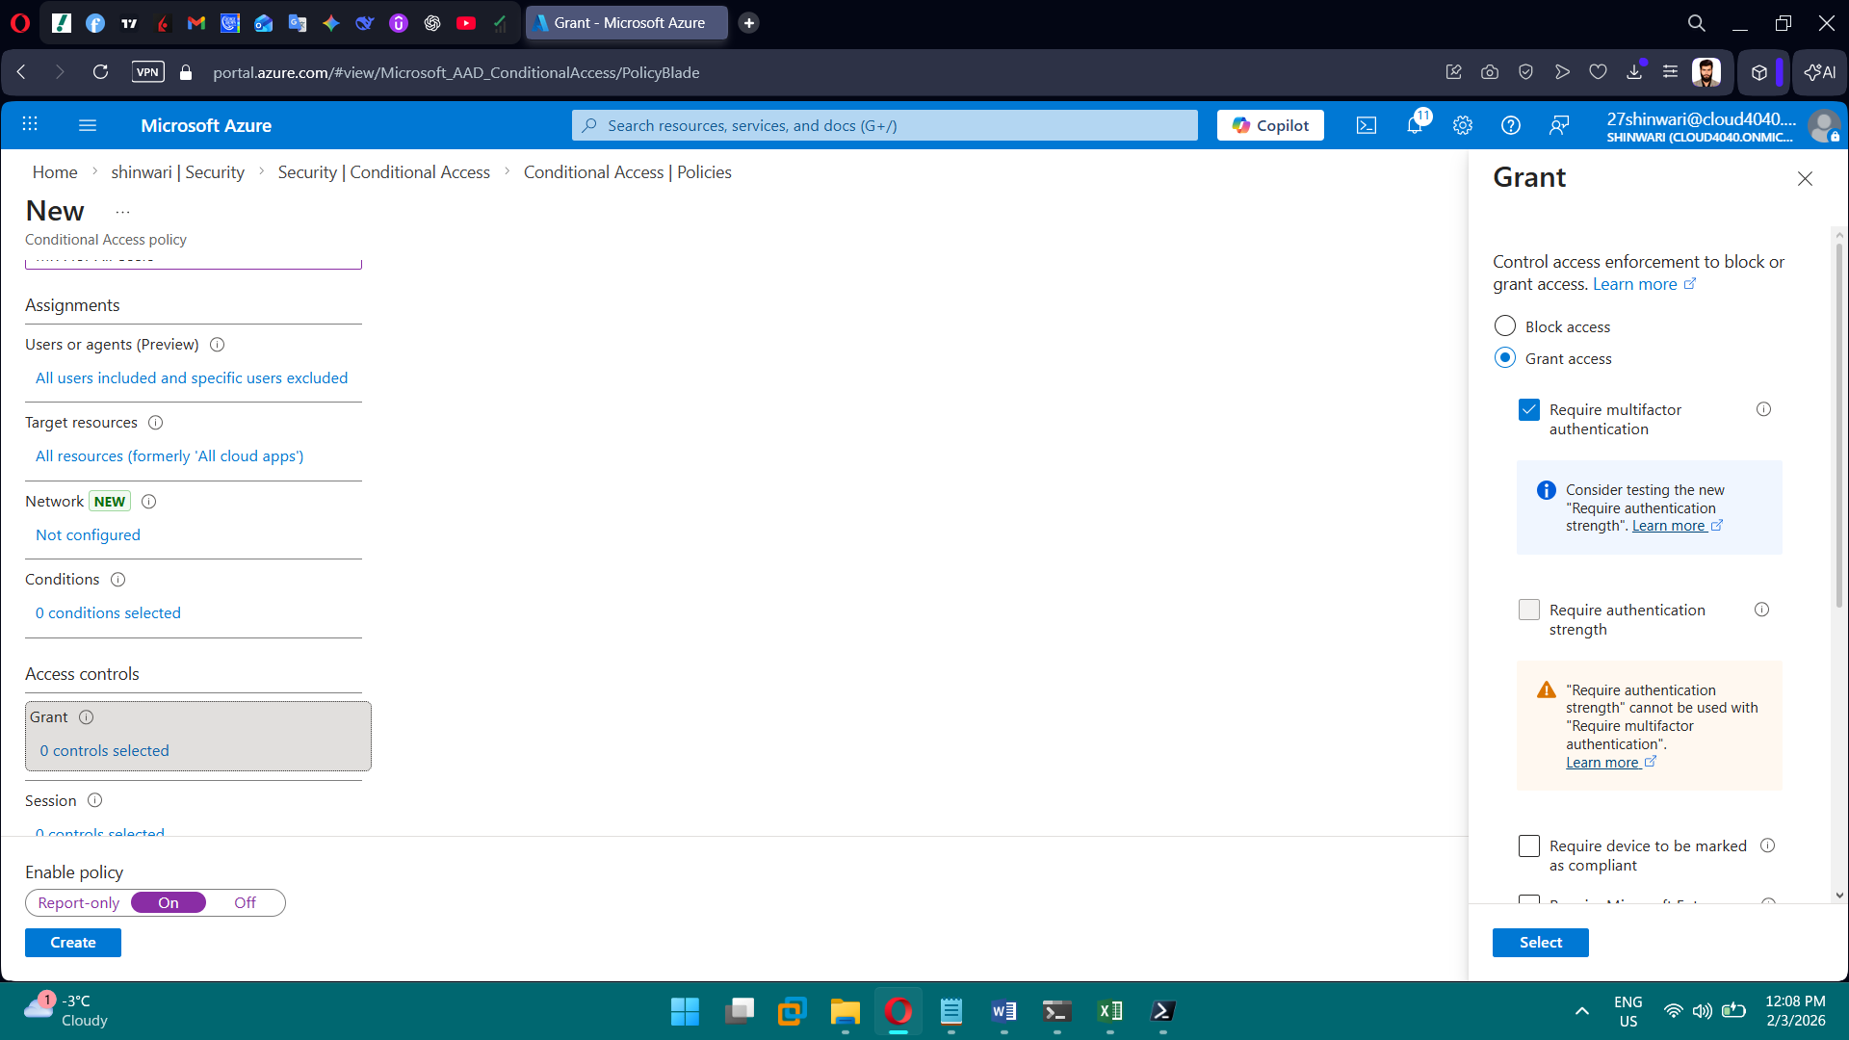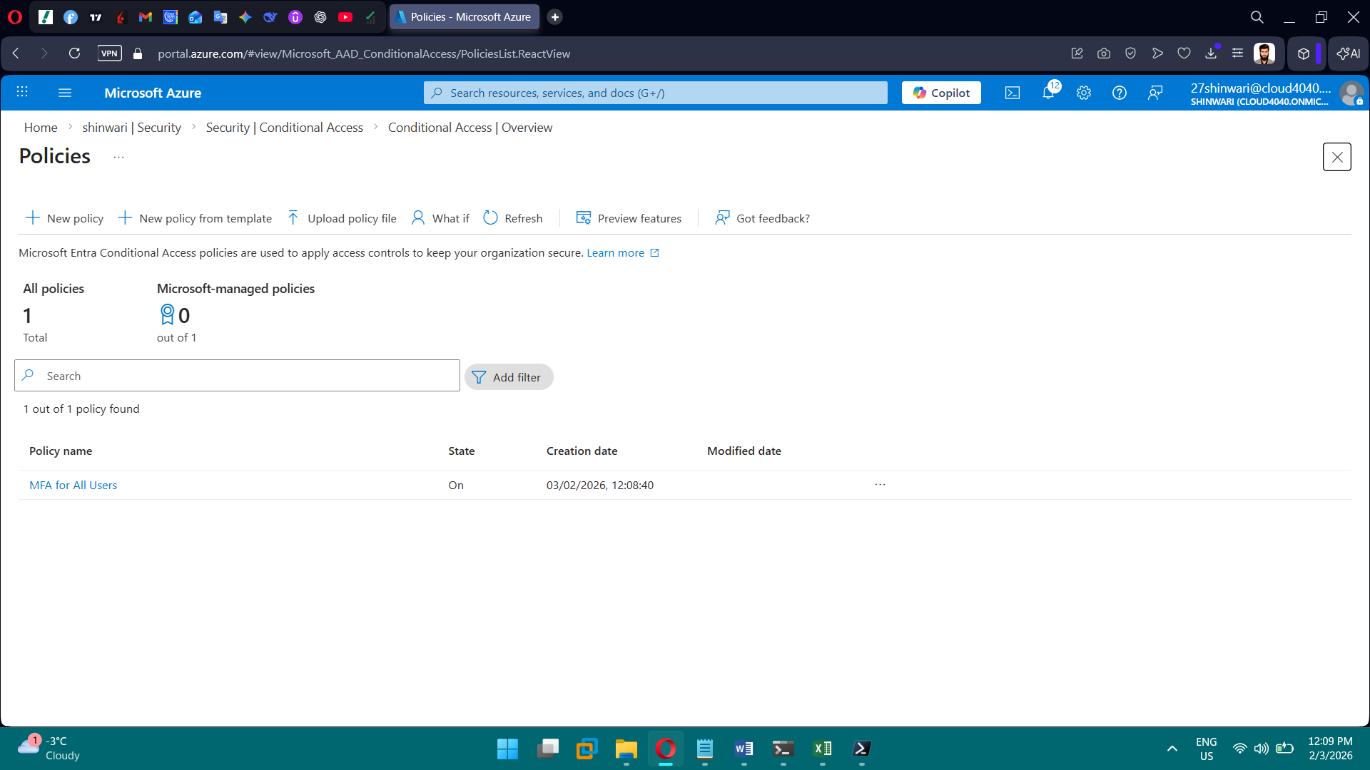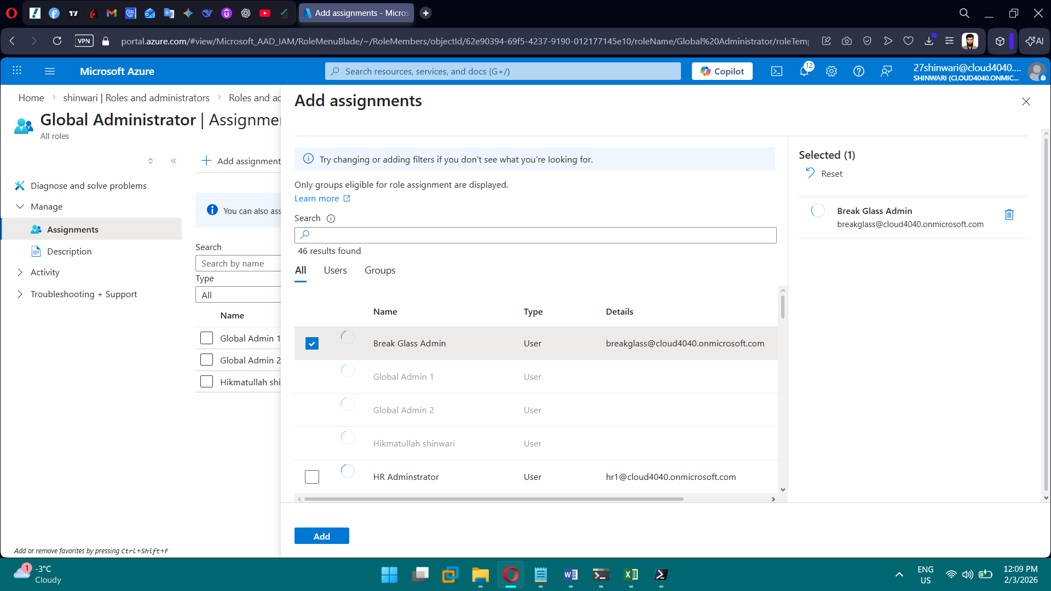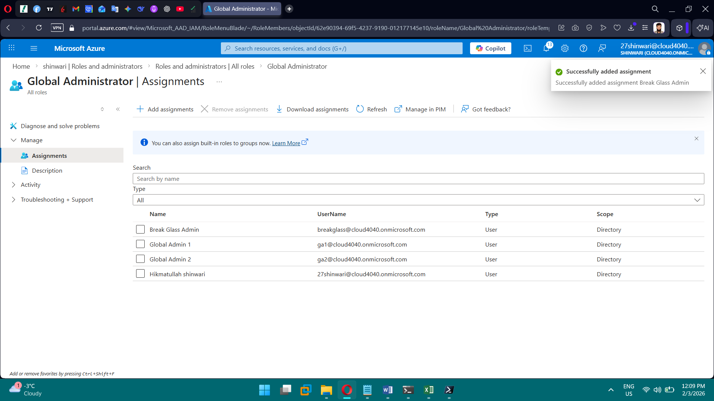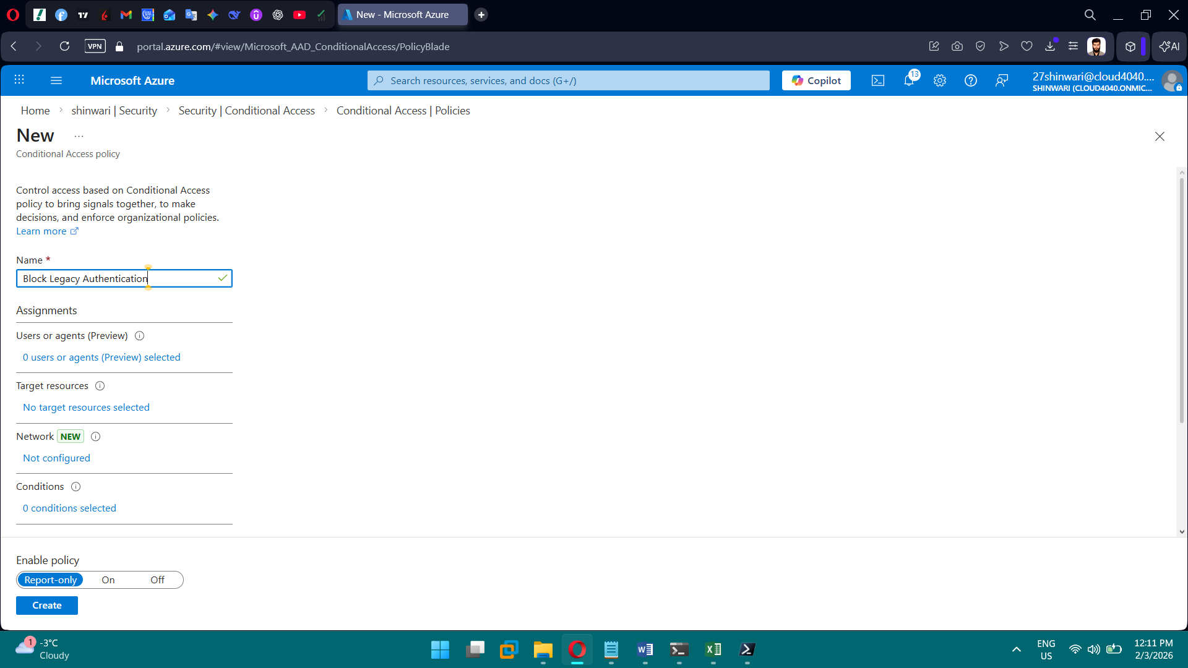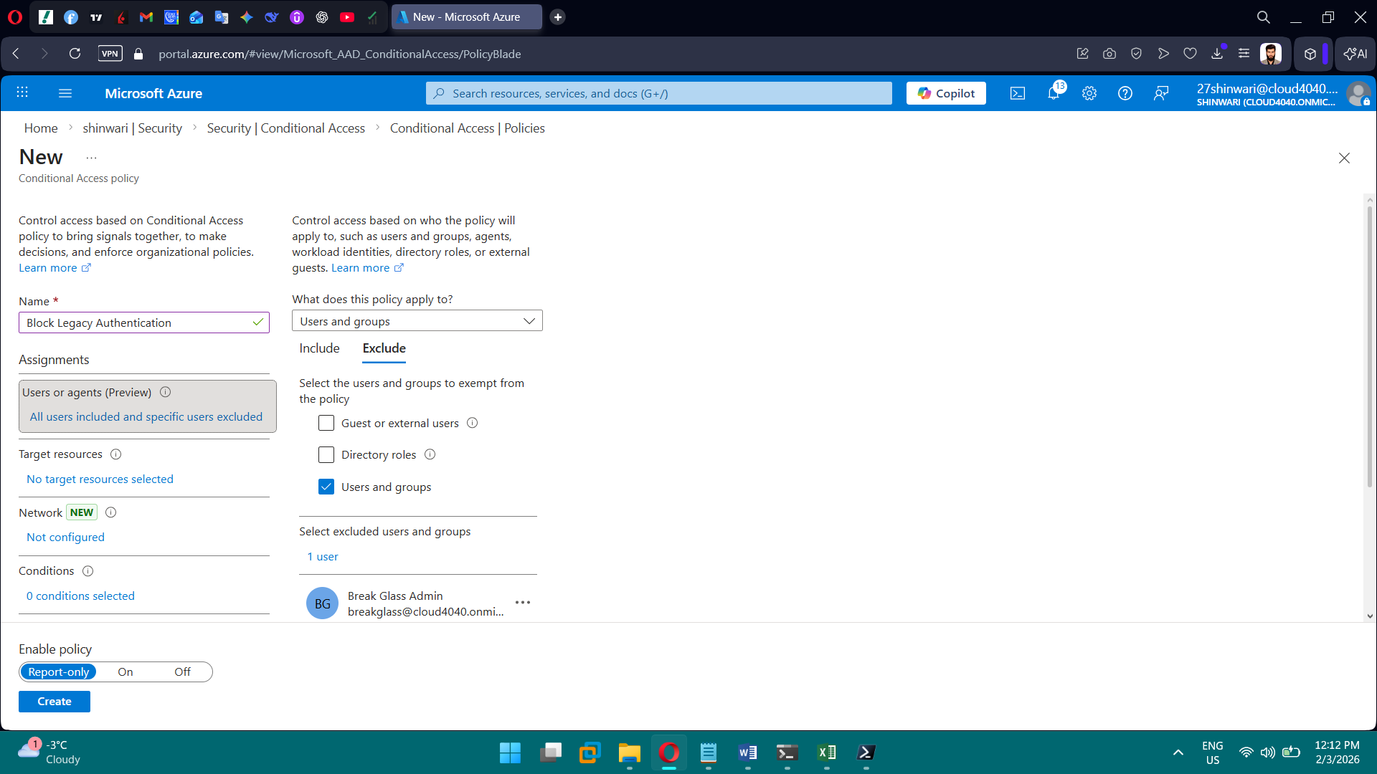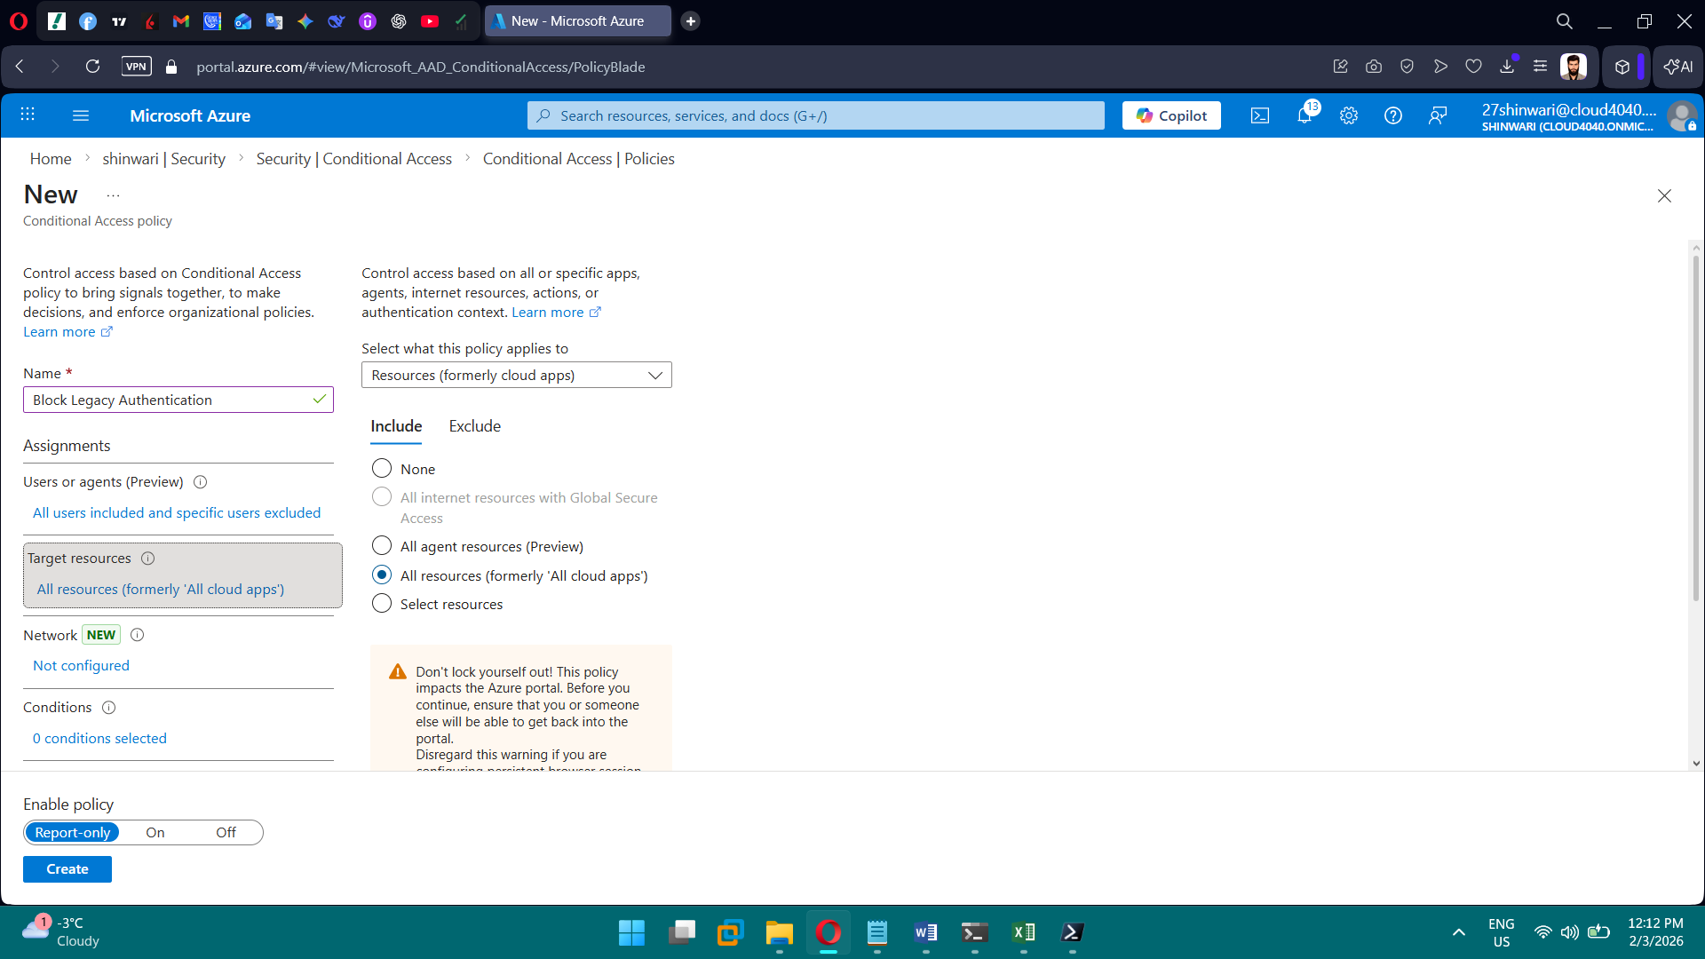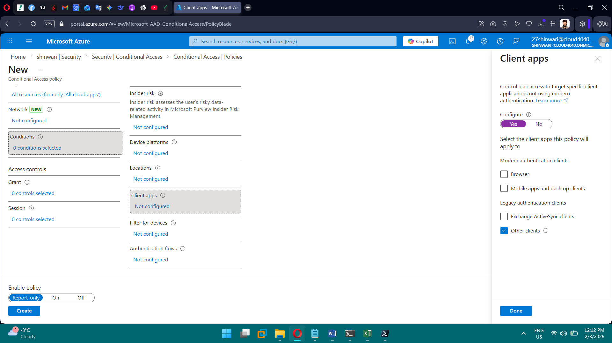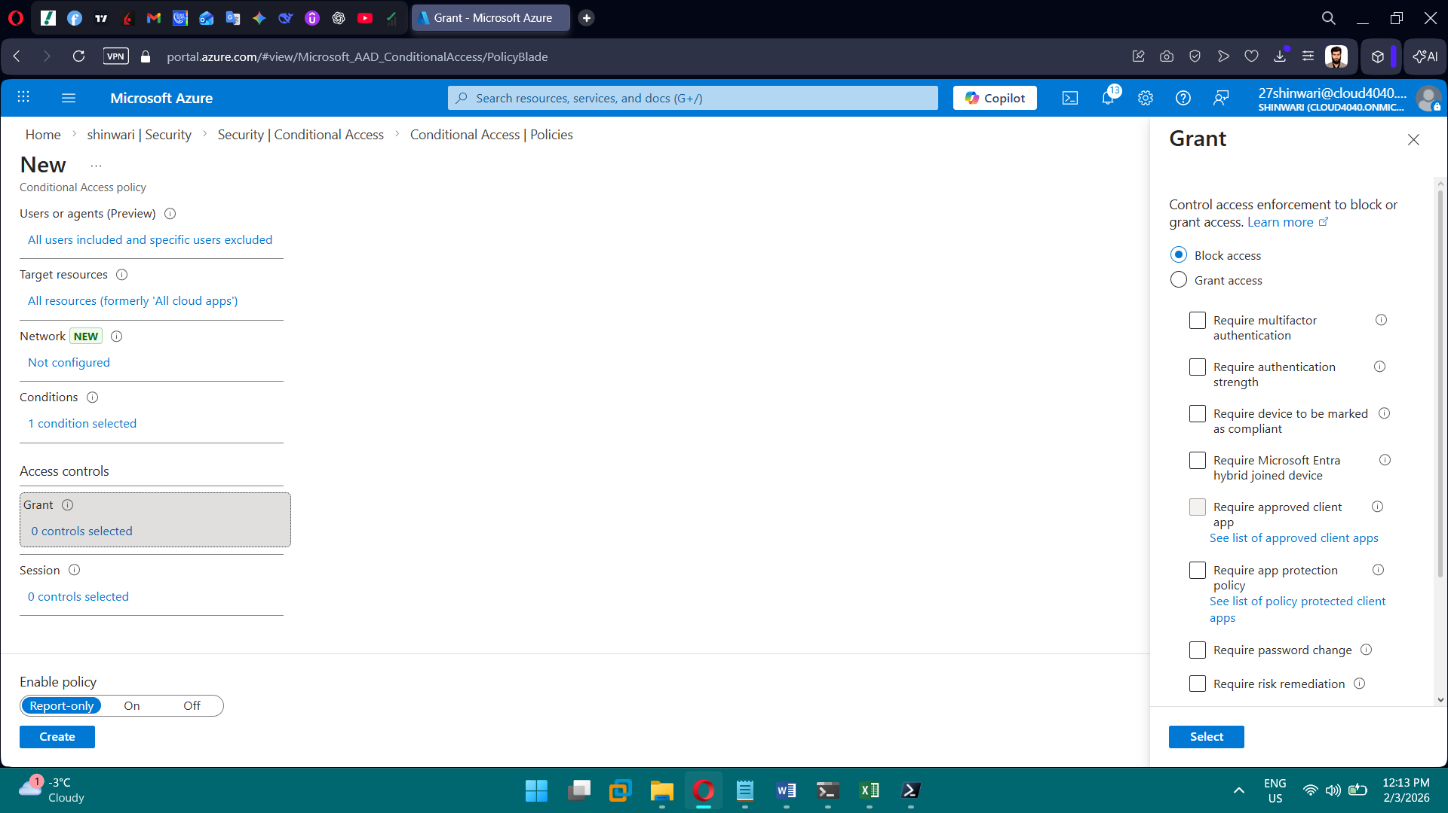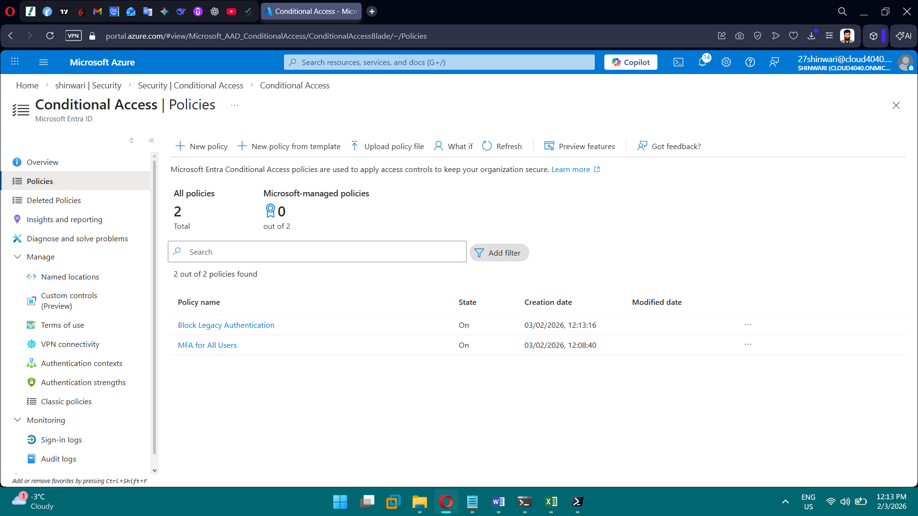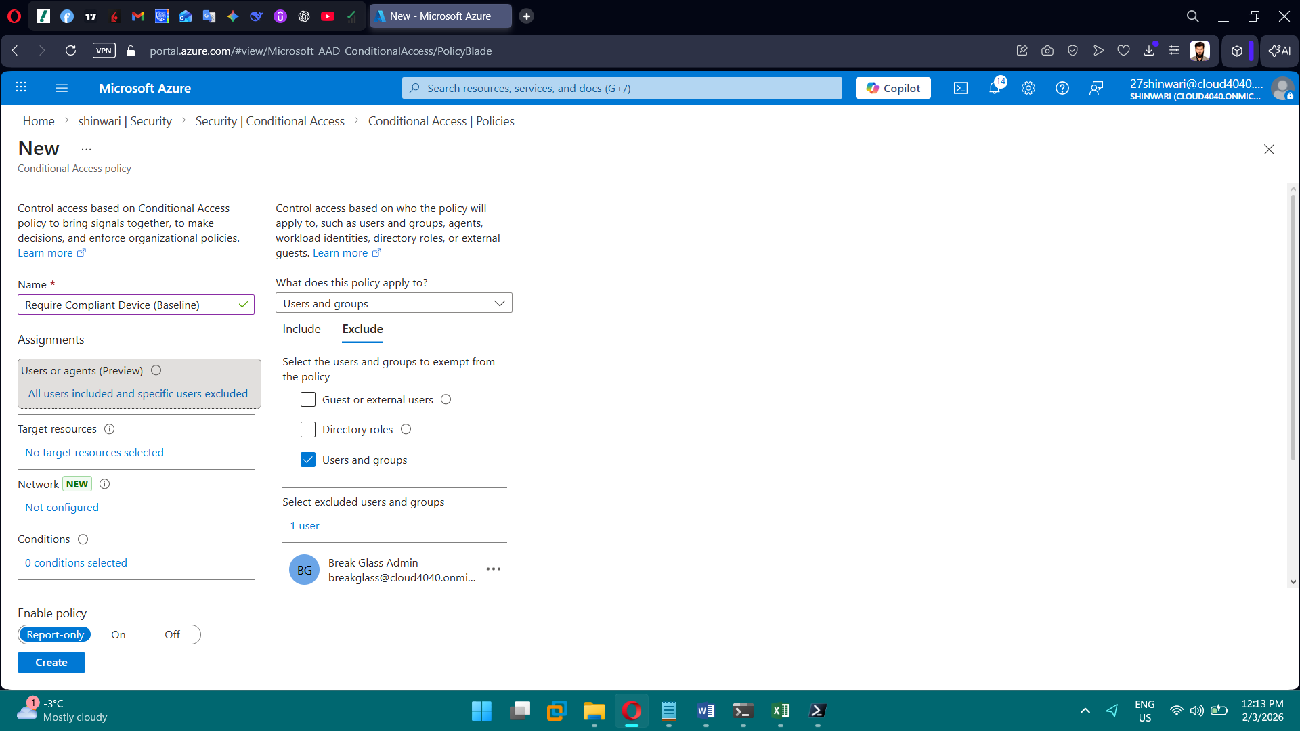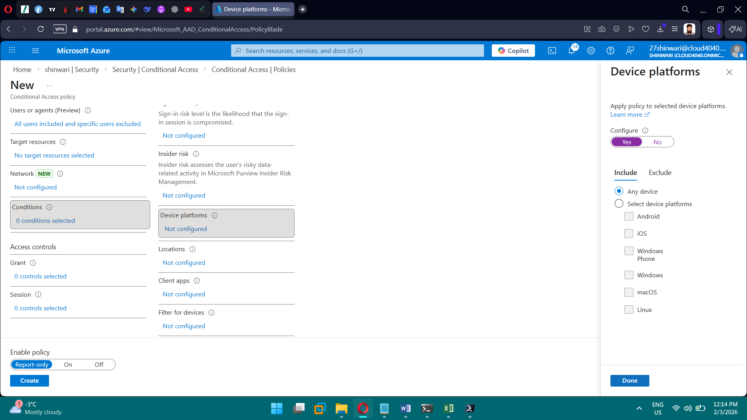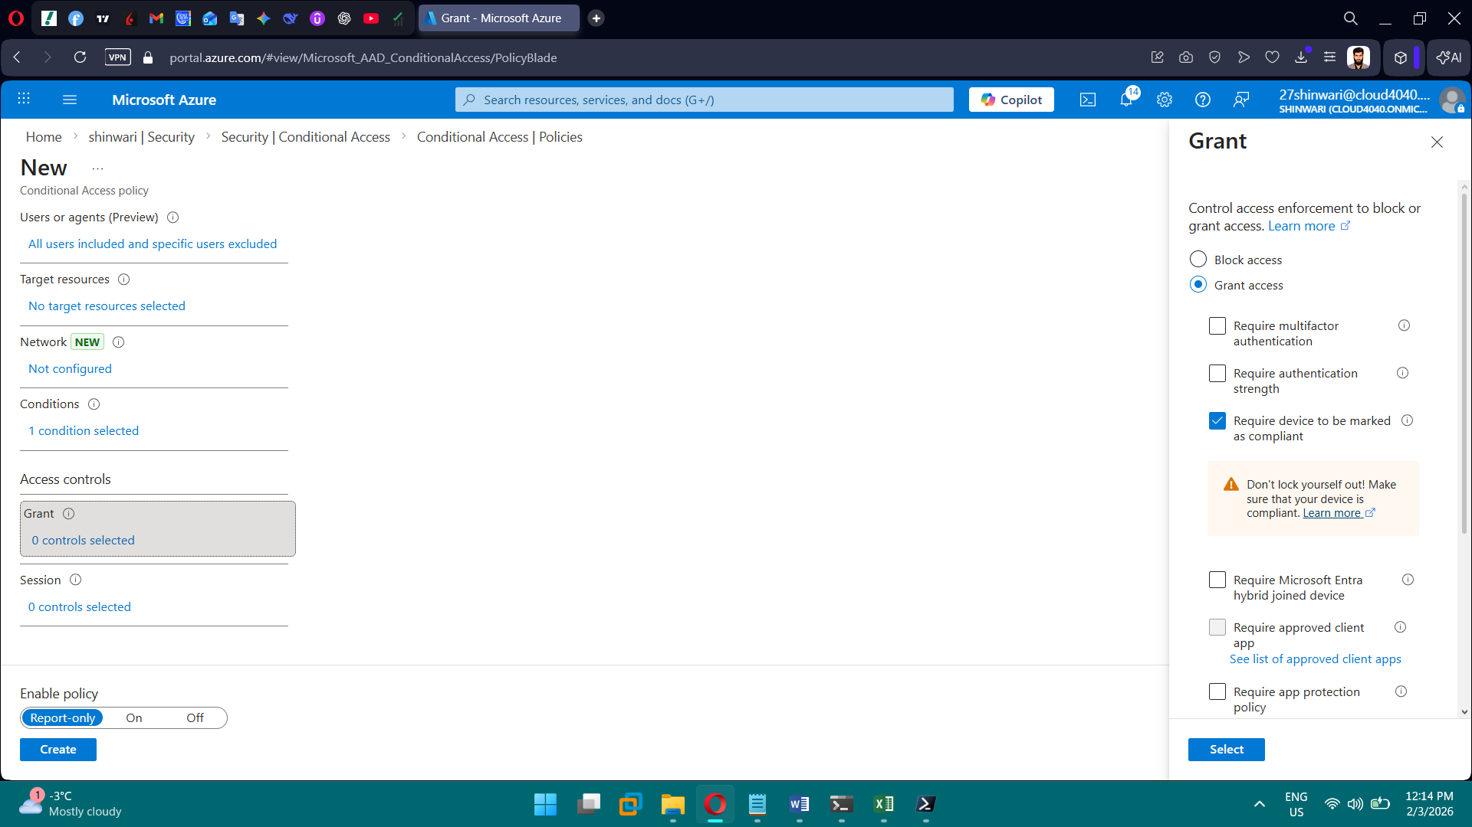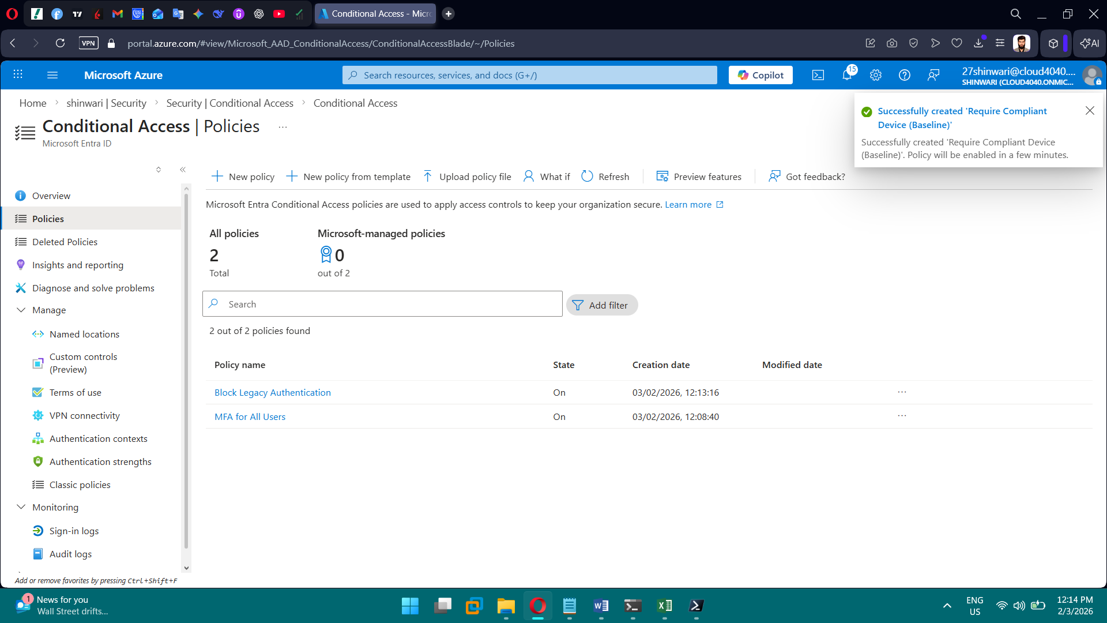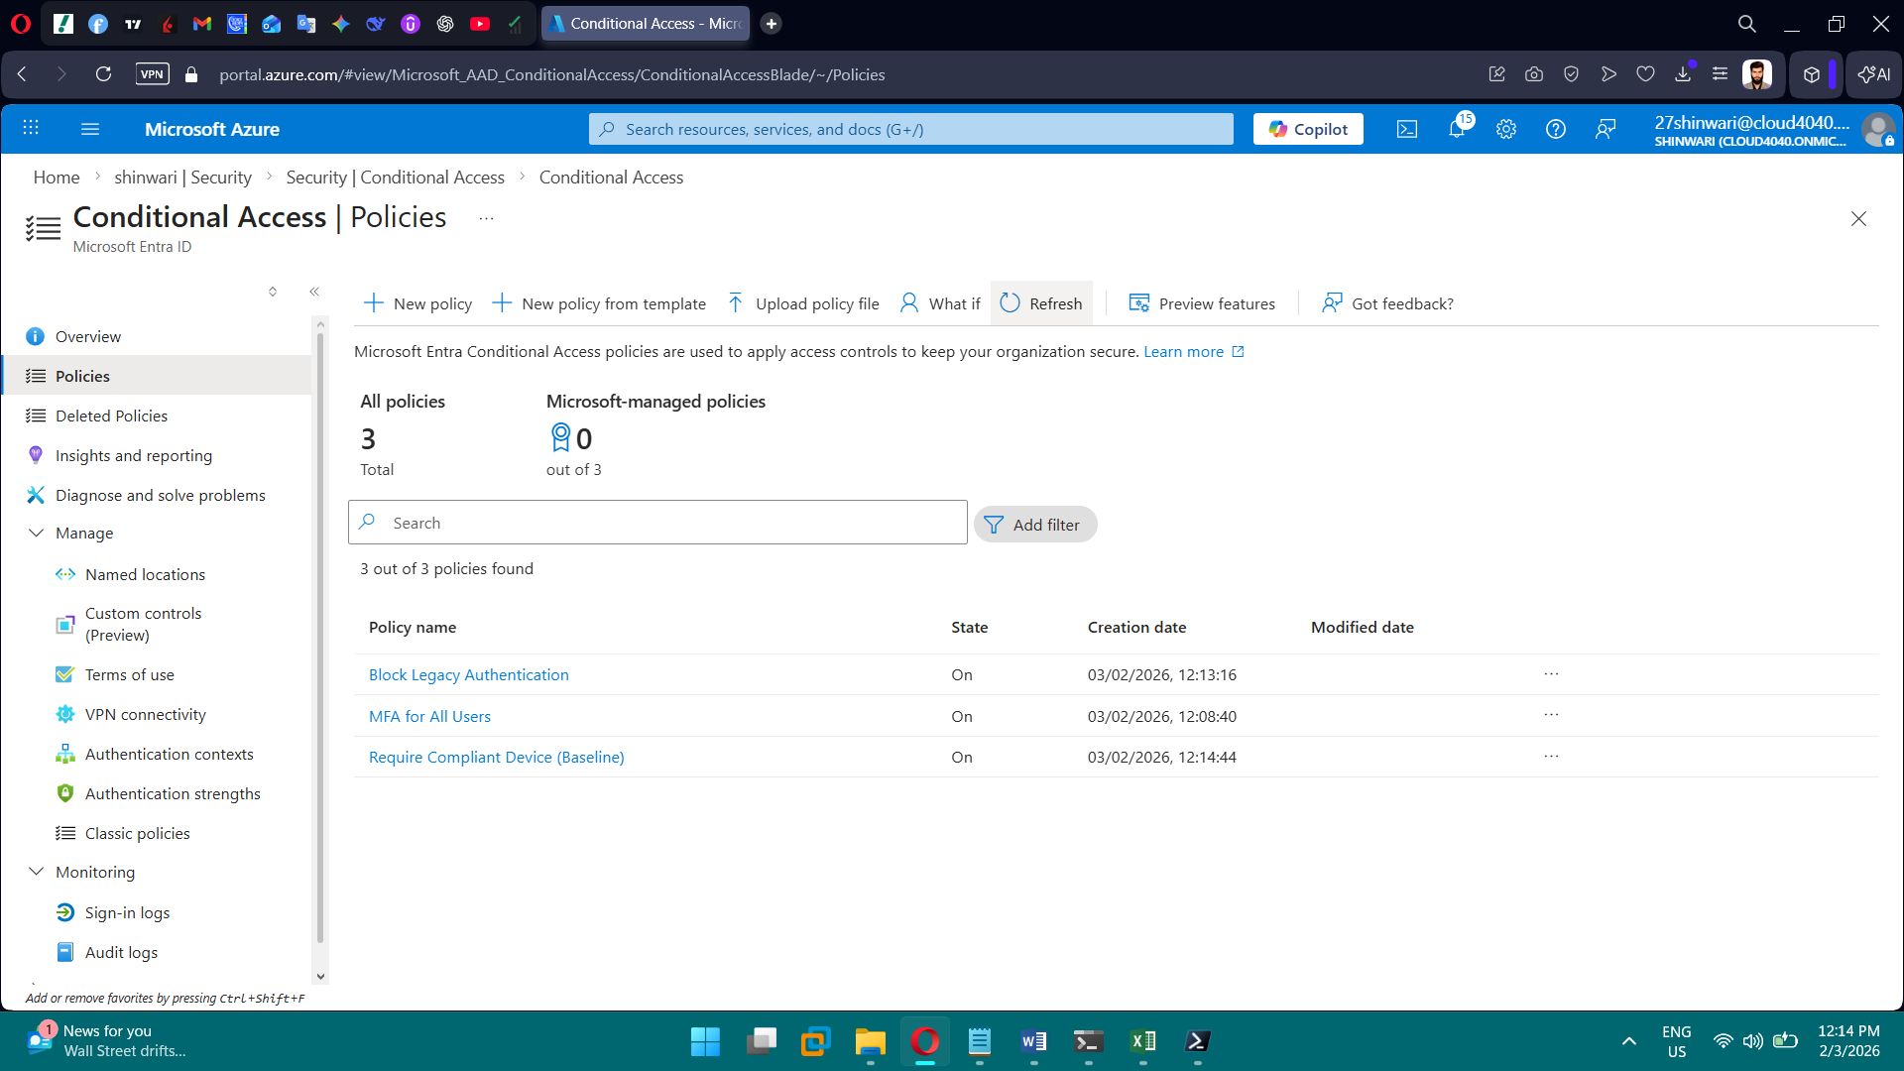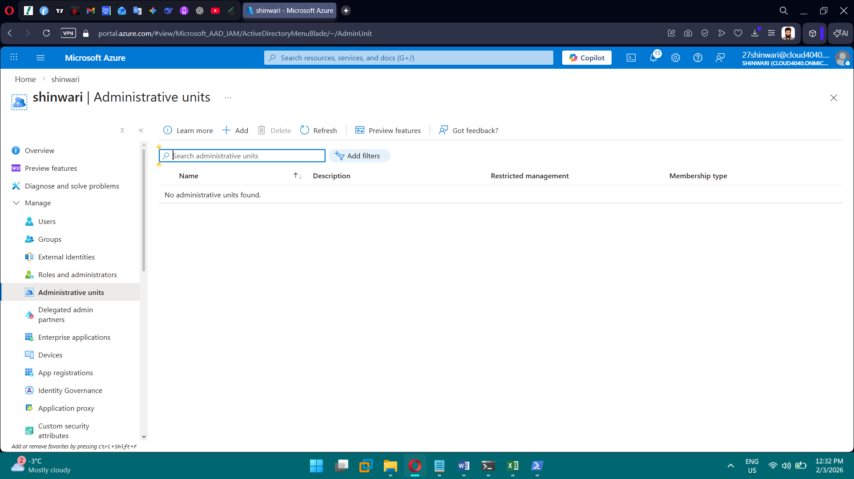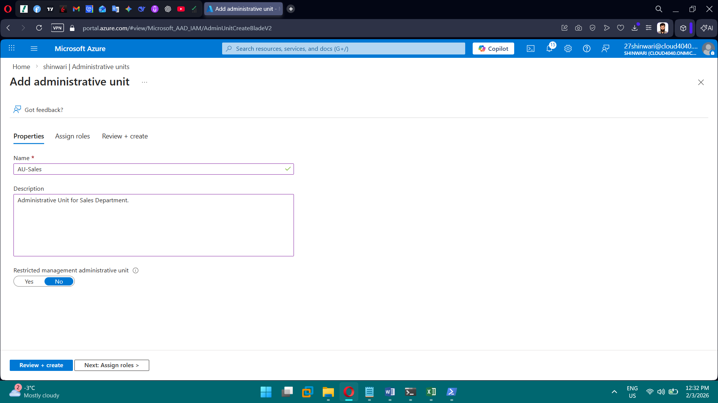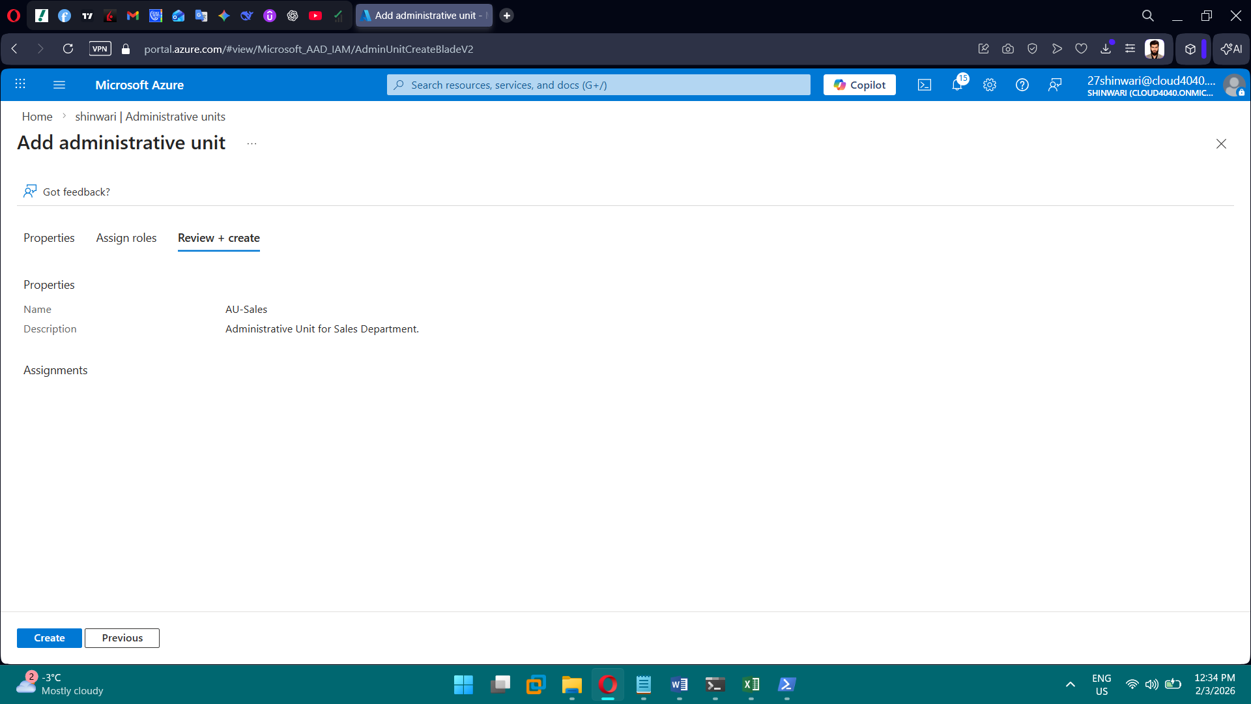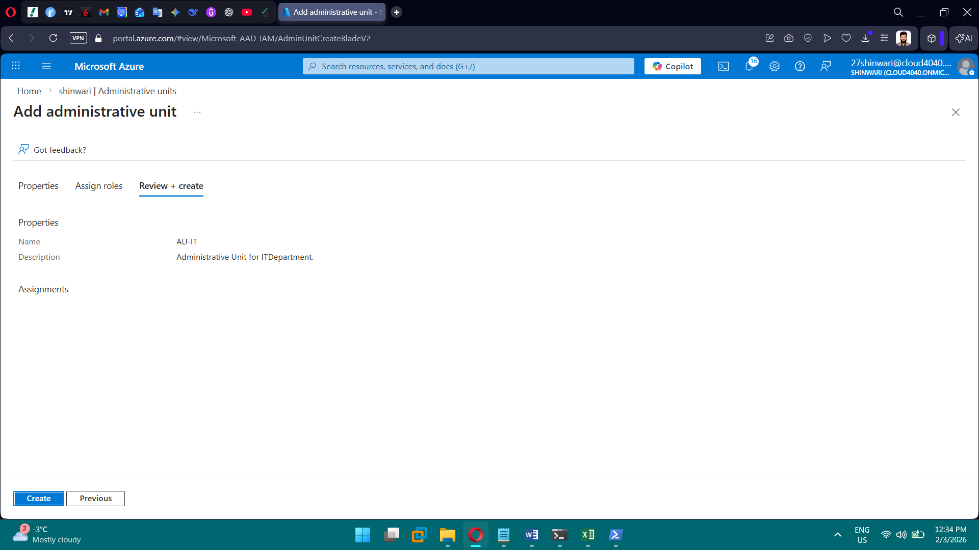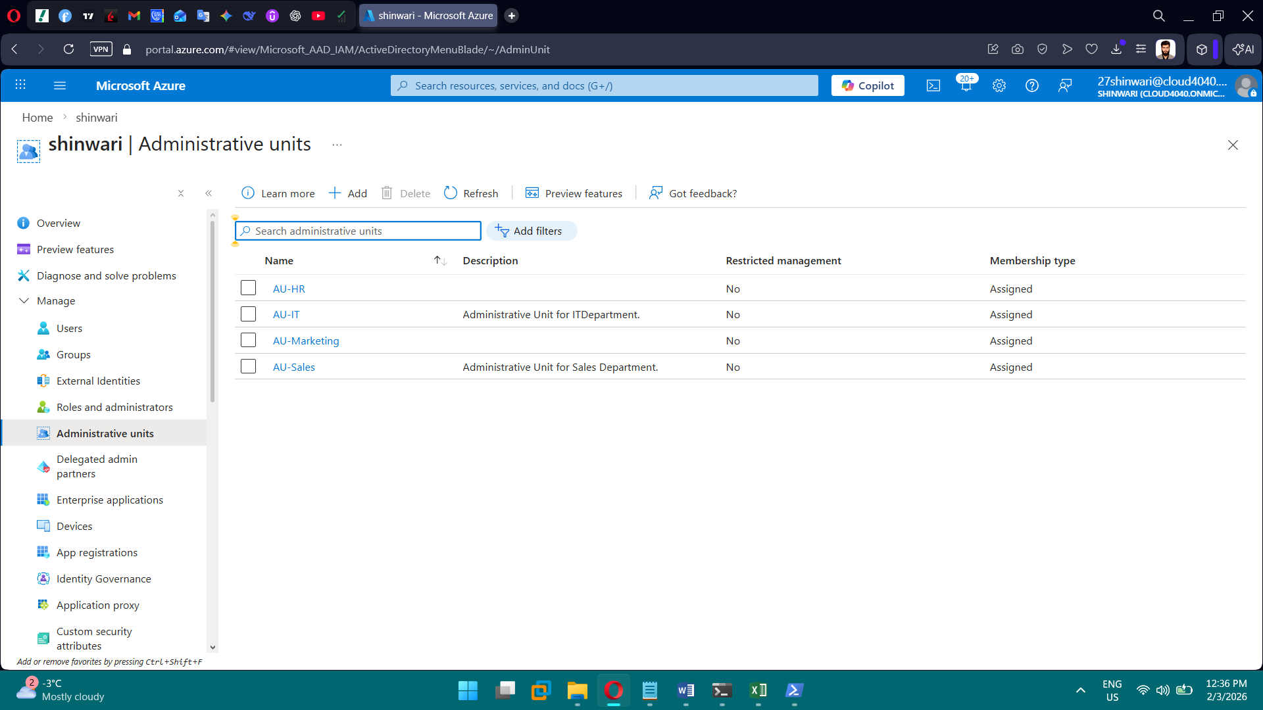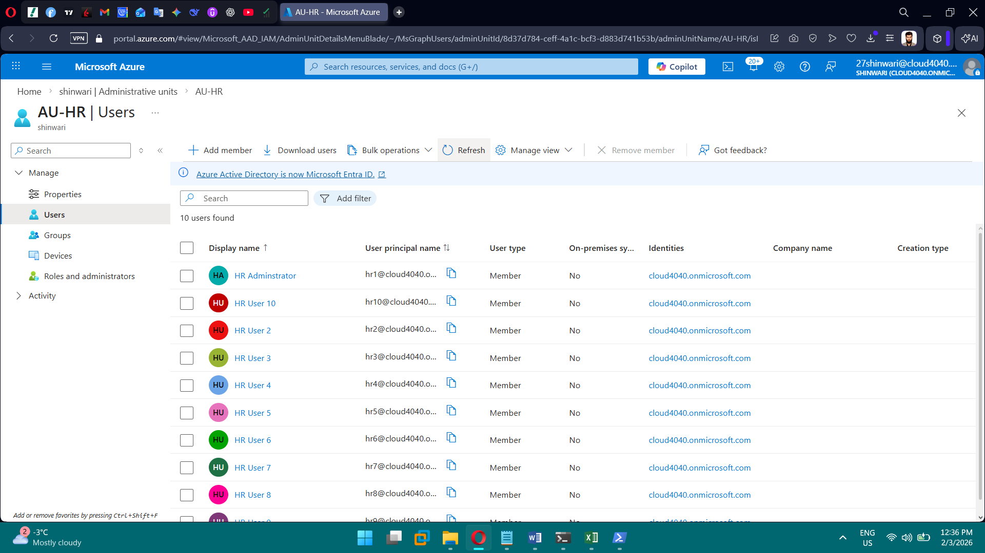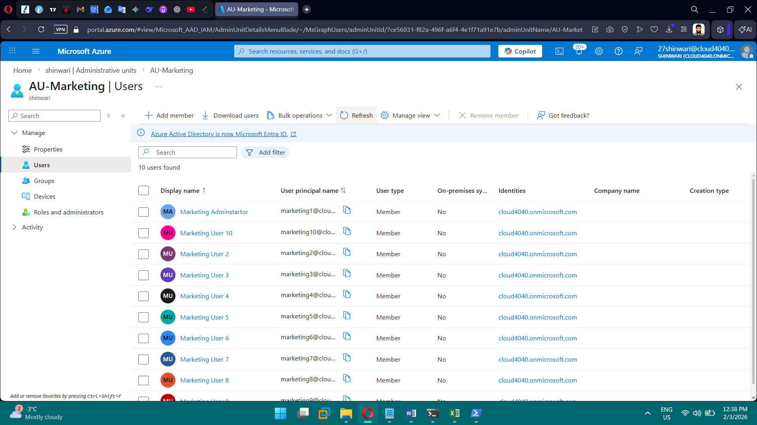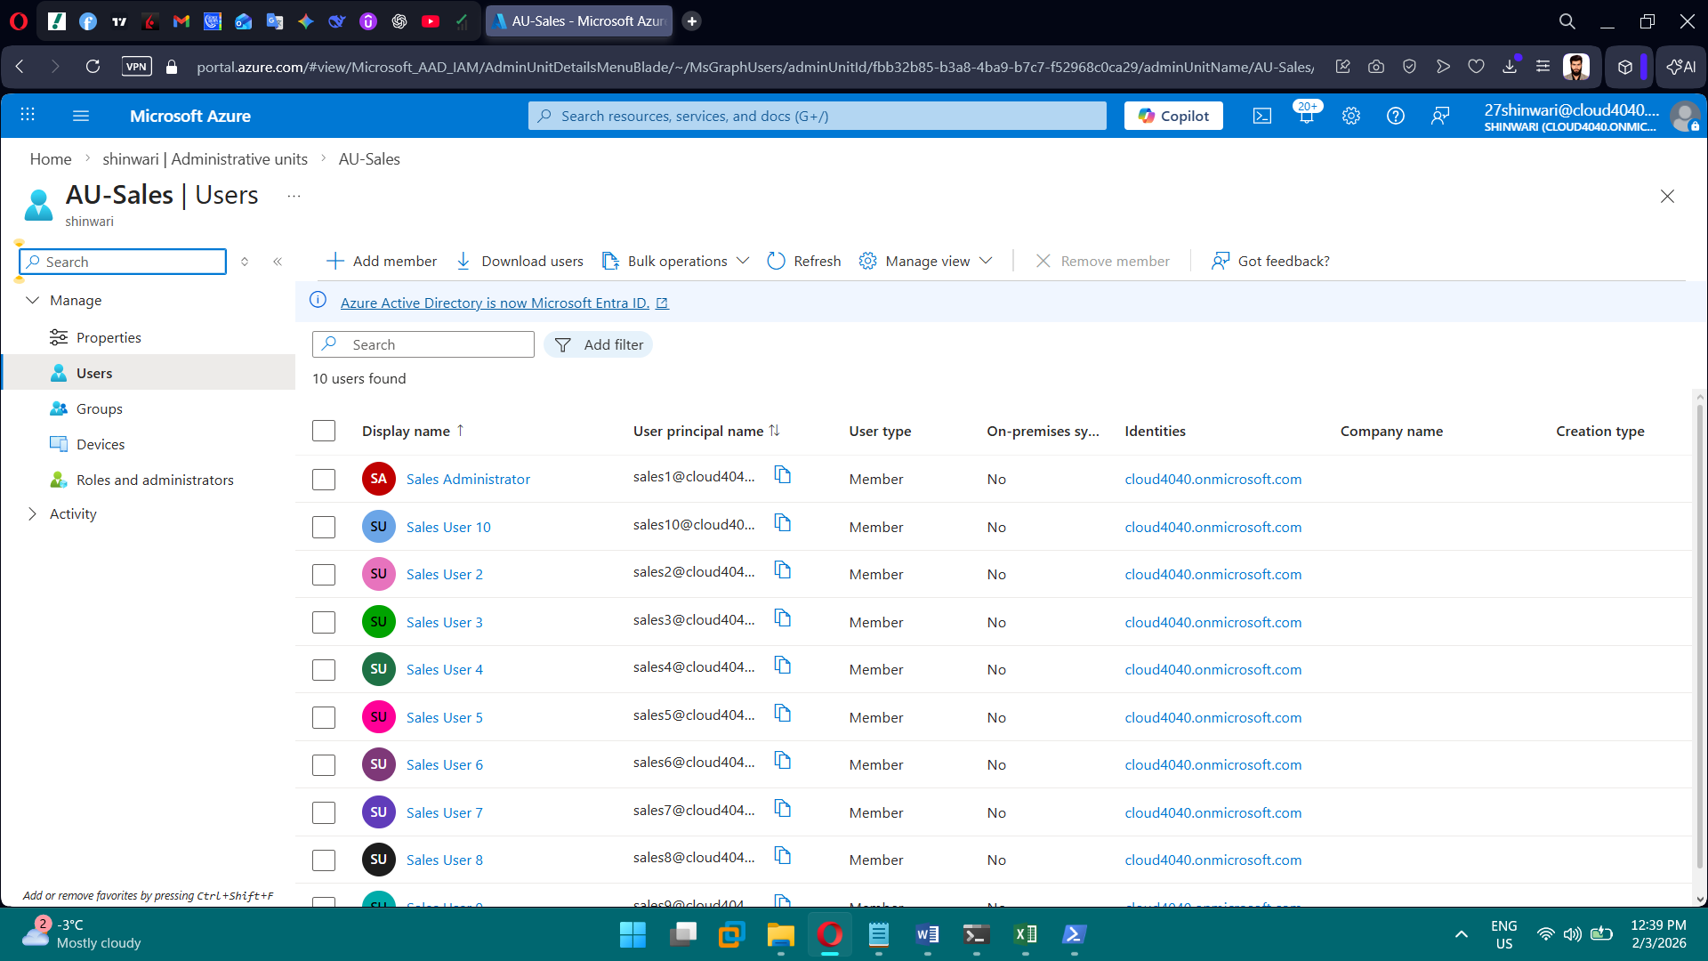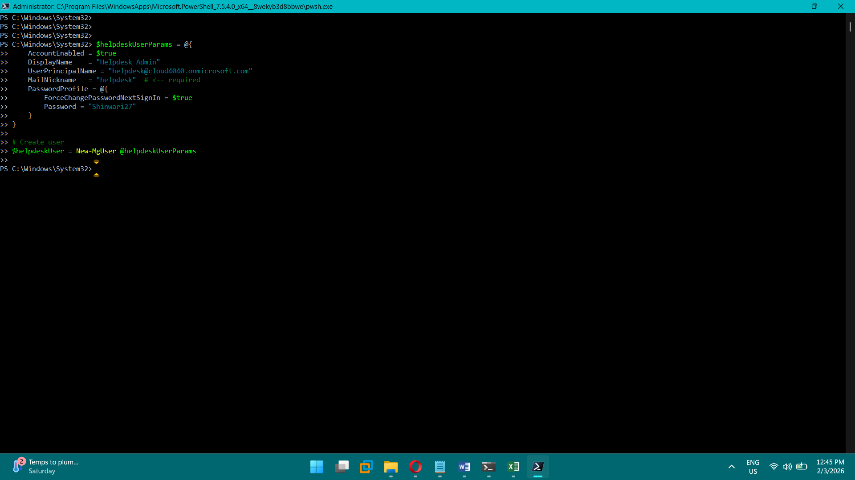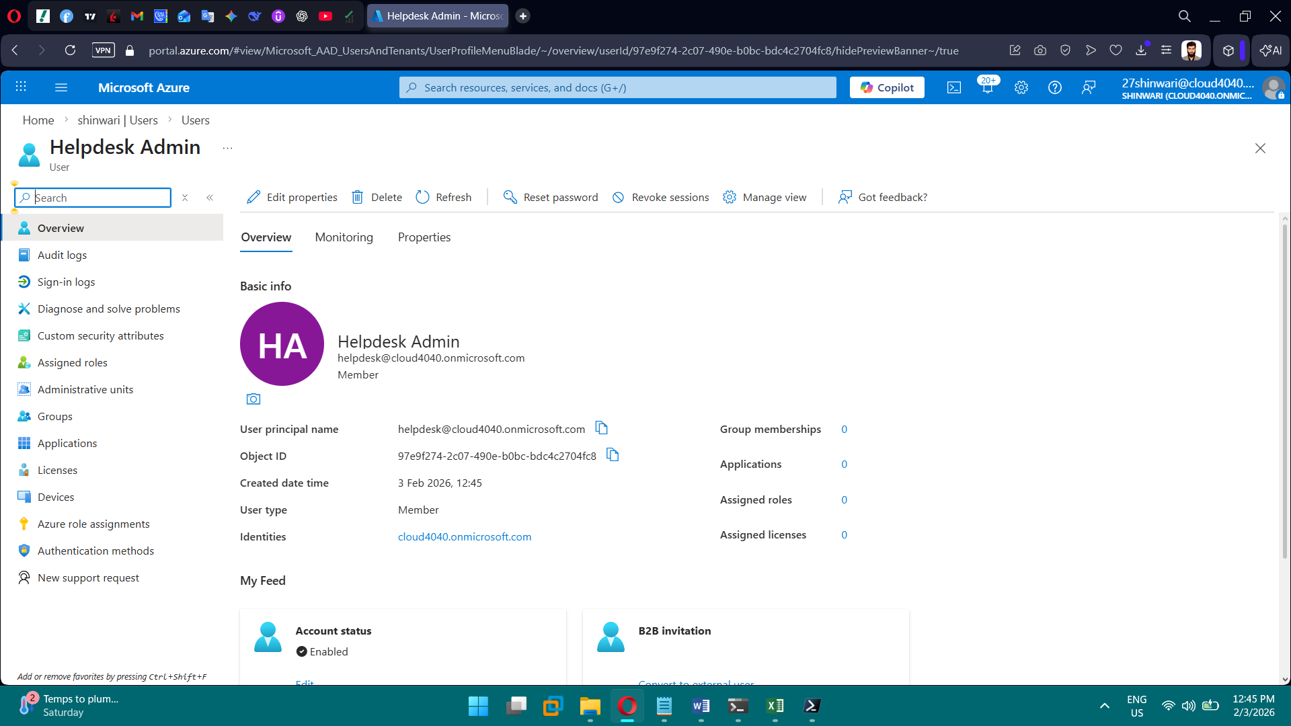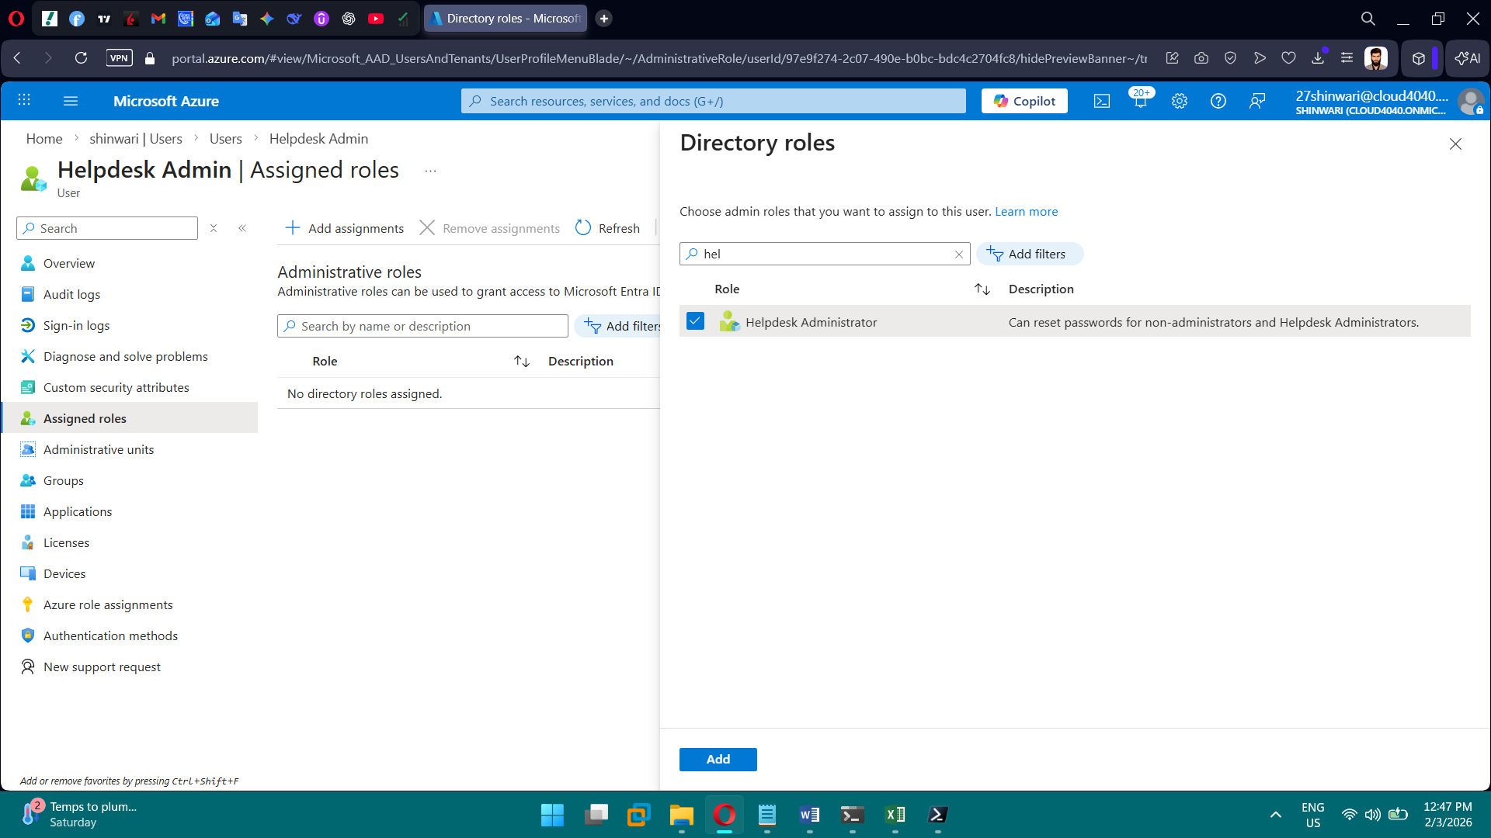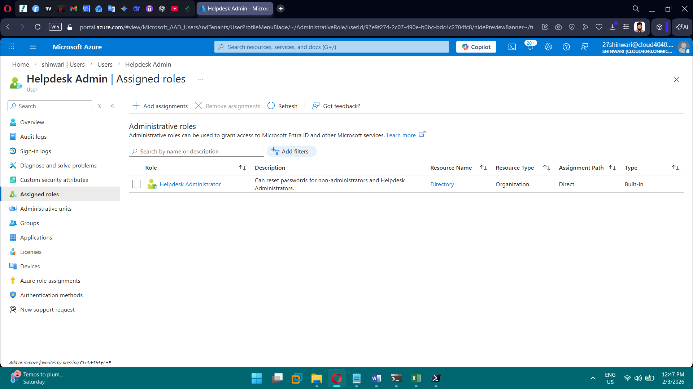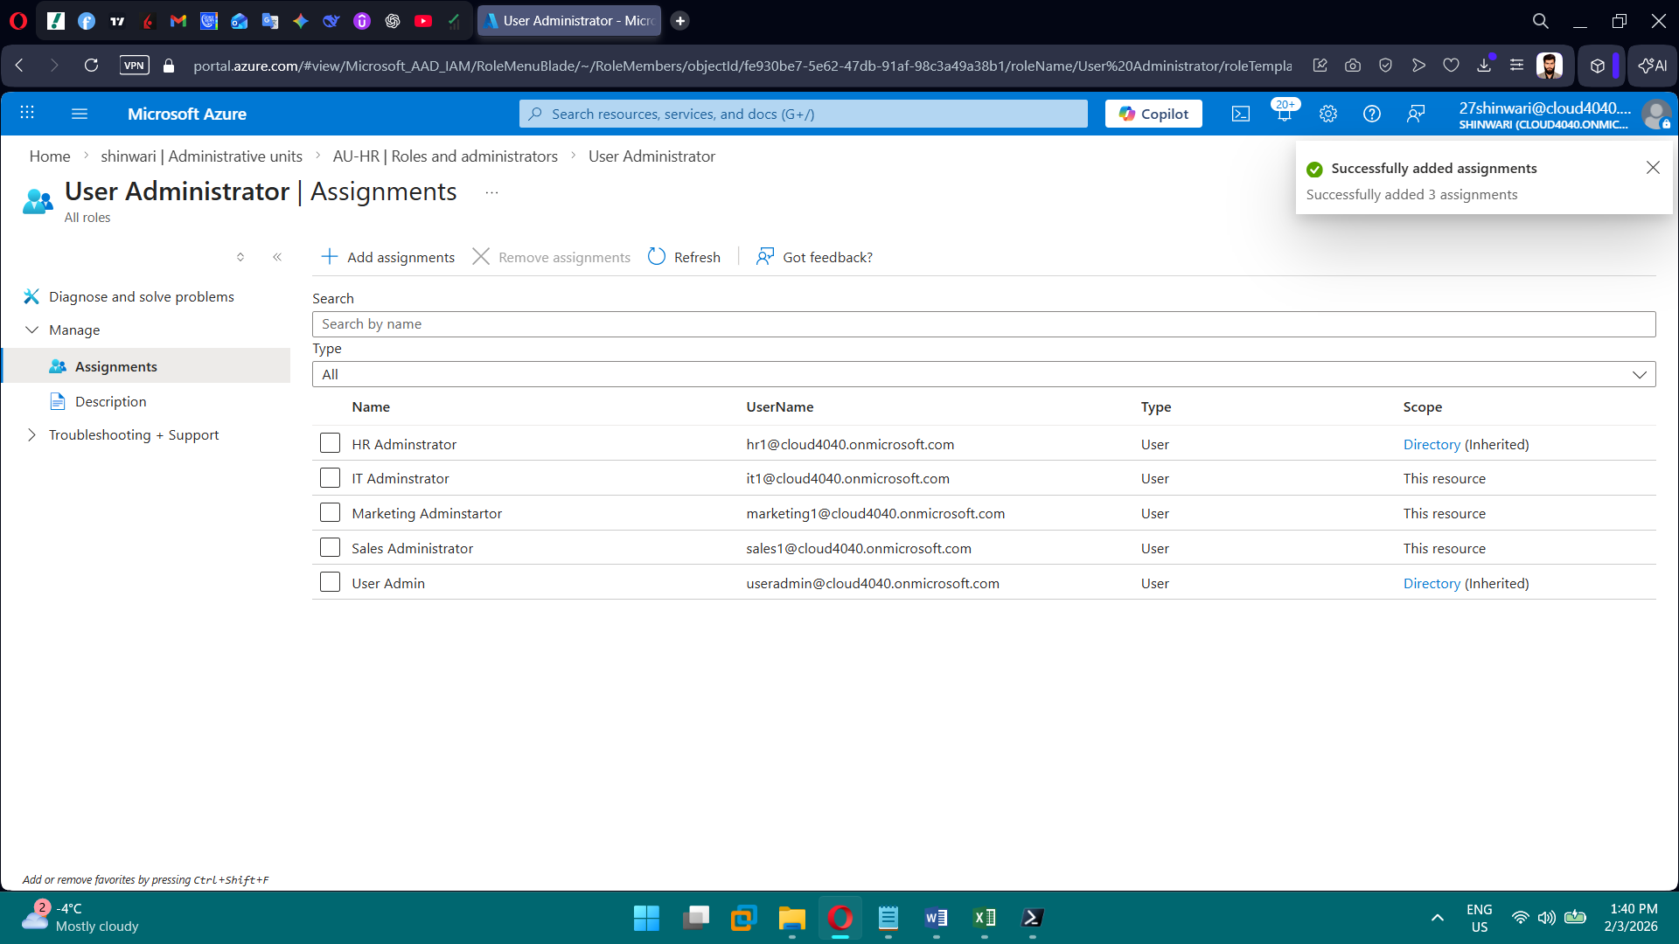

**PHASE 2 — Management Groups & Subscriptions**

**Goal:** Enterprise governance hierarchy.

**Tasks**

1. Create Root Management Group
2. Create child MGs (Platform, Security, Prod, Non-Prod, Sandbox)
3. Move subscriptions into MGs
4. Assign RBAC at MG level
5. Validate inheritance

**Brief Explanation of Phase 2:**

We used Management Groups to centralize governance, assigned RBAC at the MG level to enforce least privilege through inheritance, and placed the subscription in Sandbox to separate non-production workloads safely.

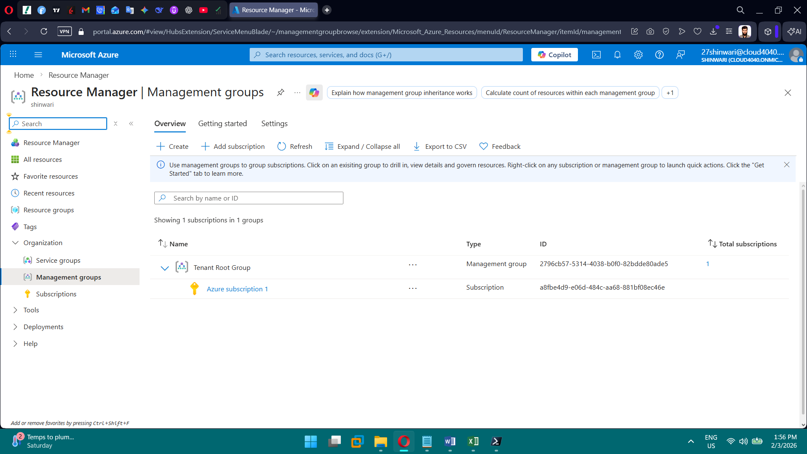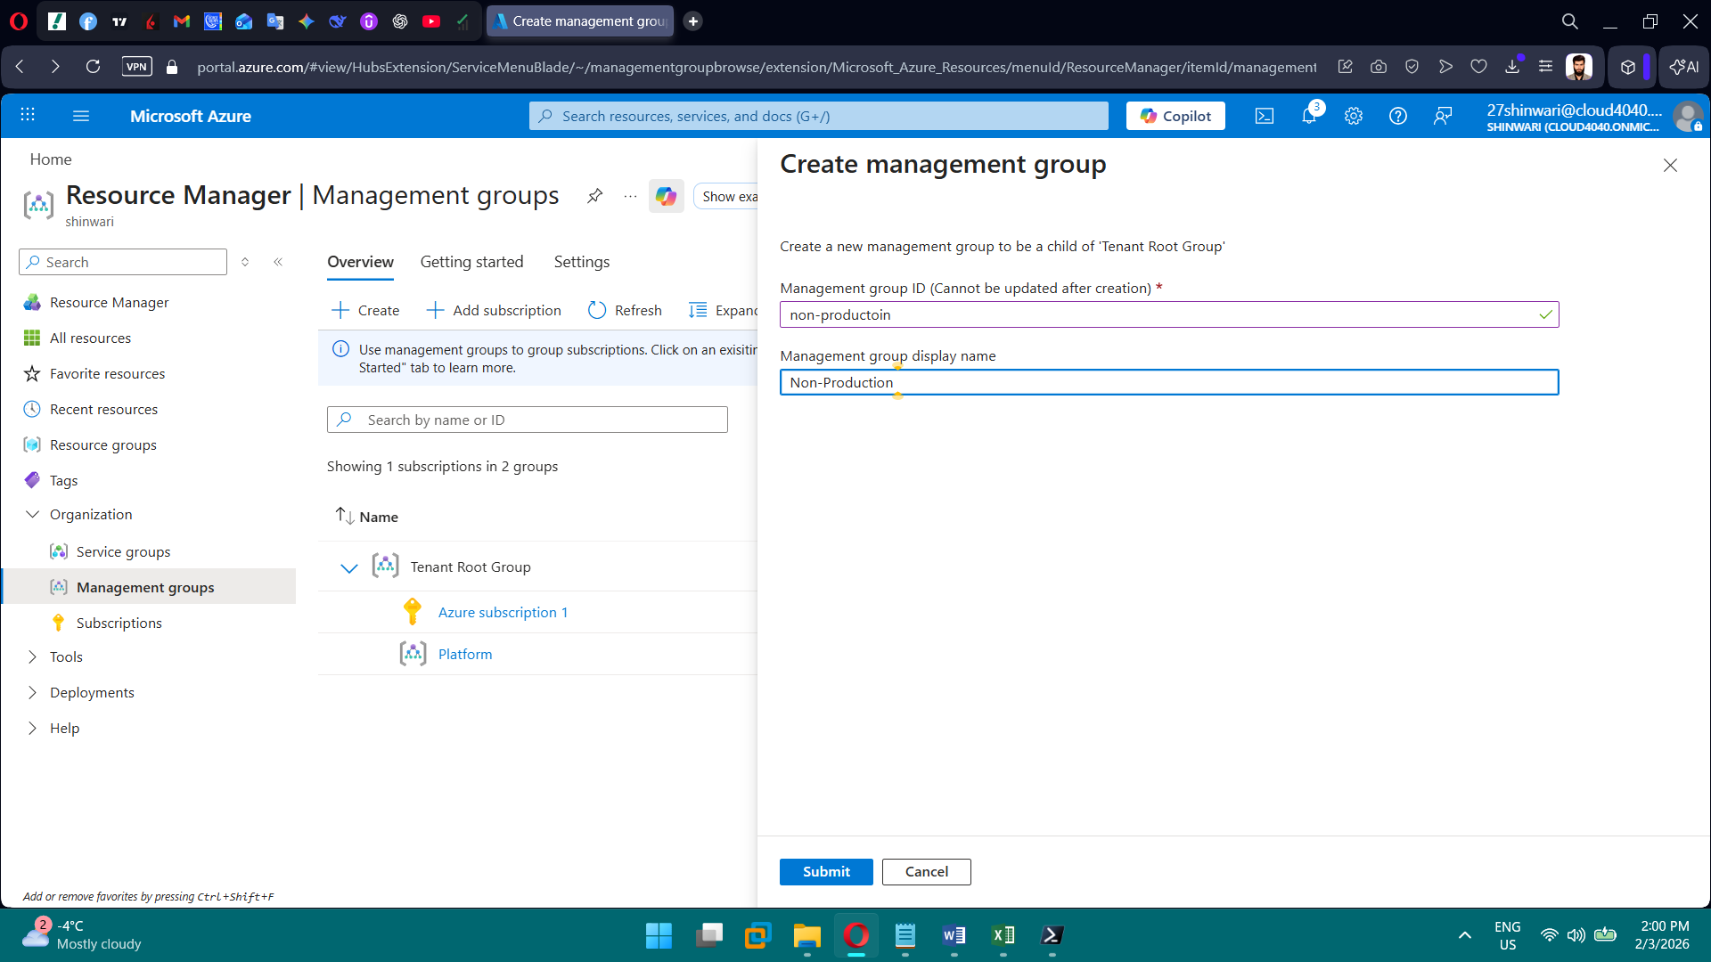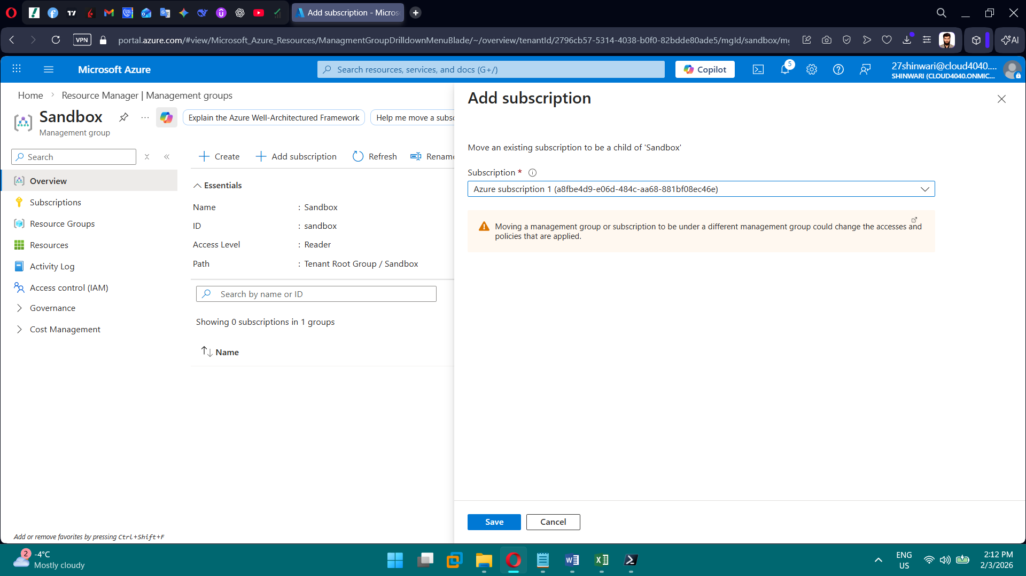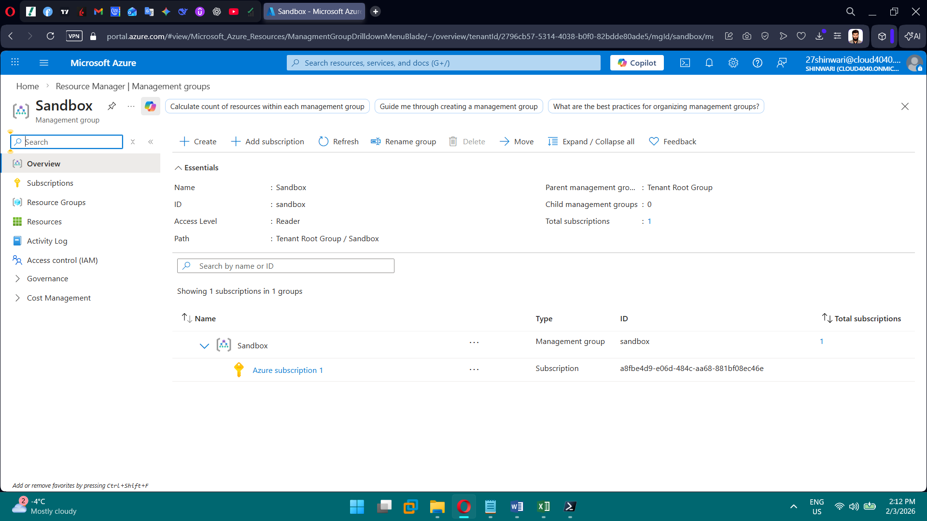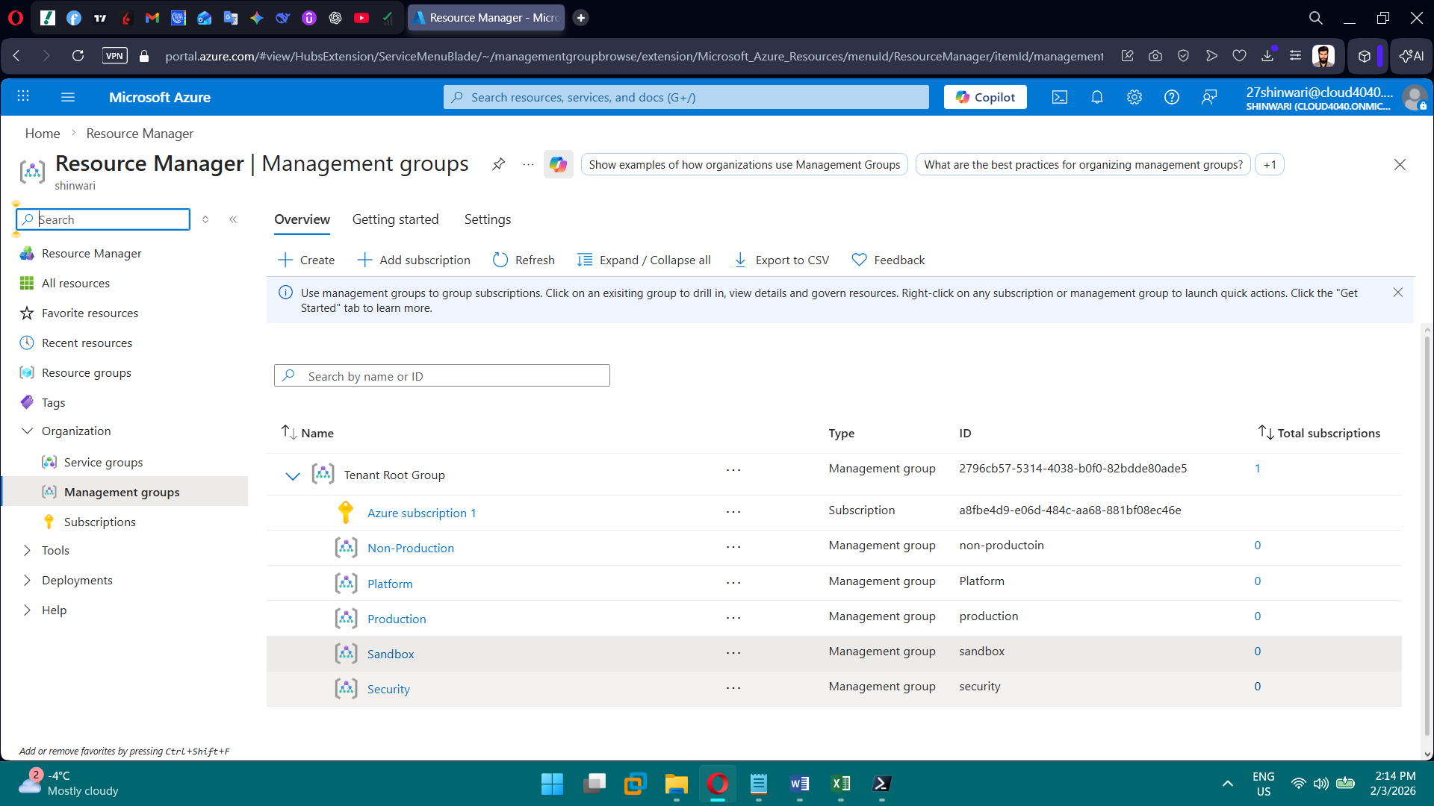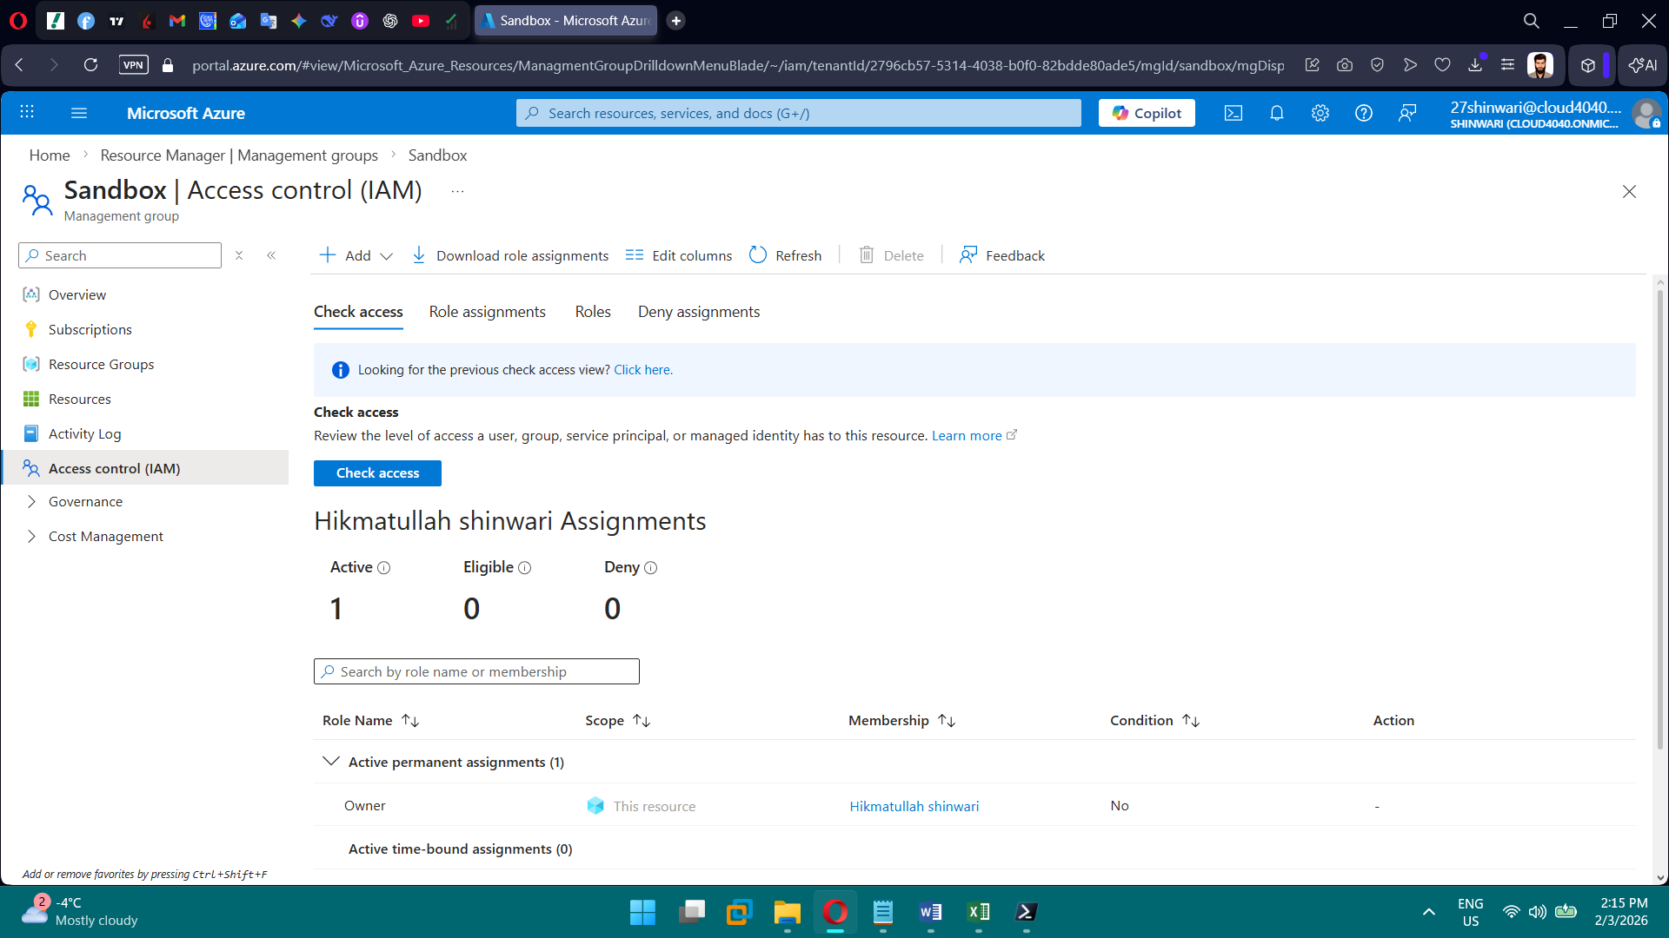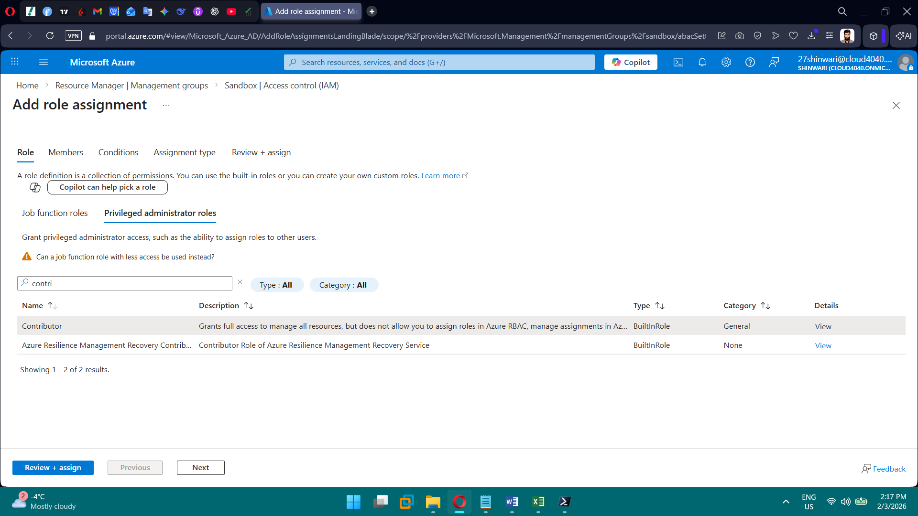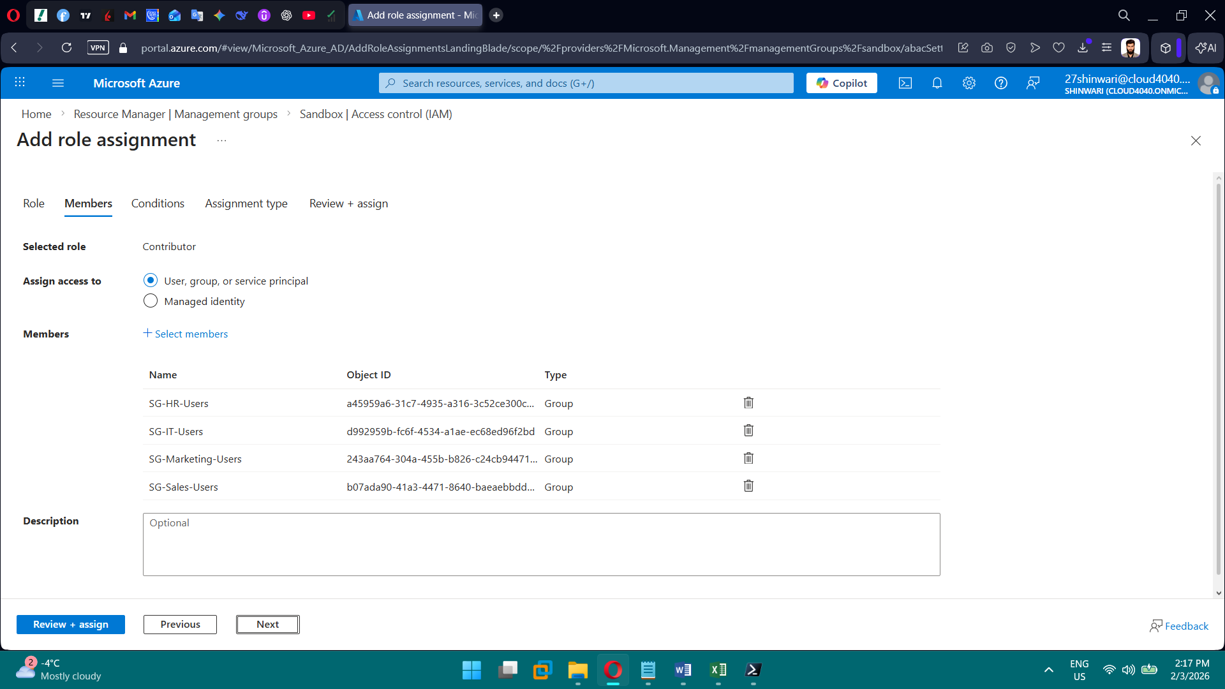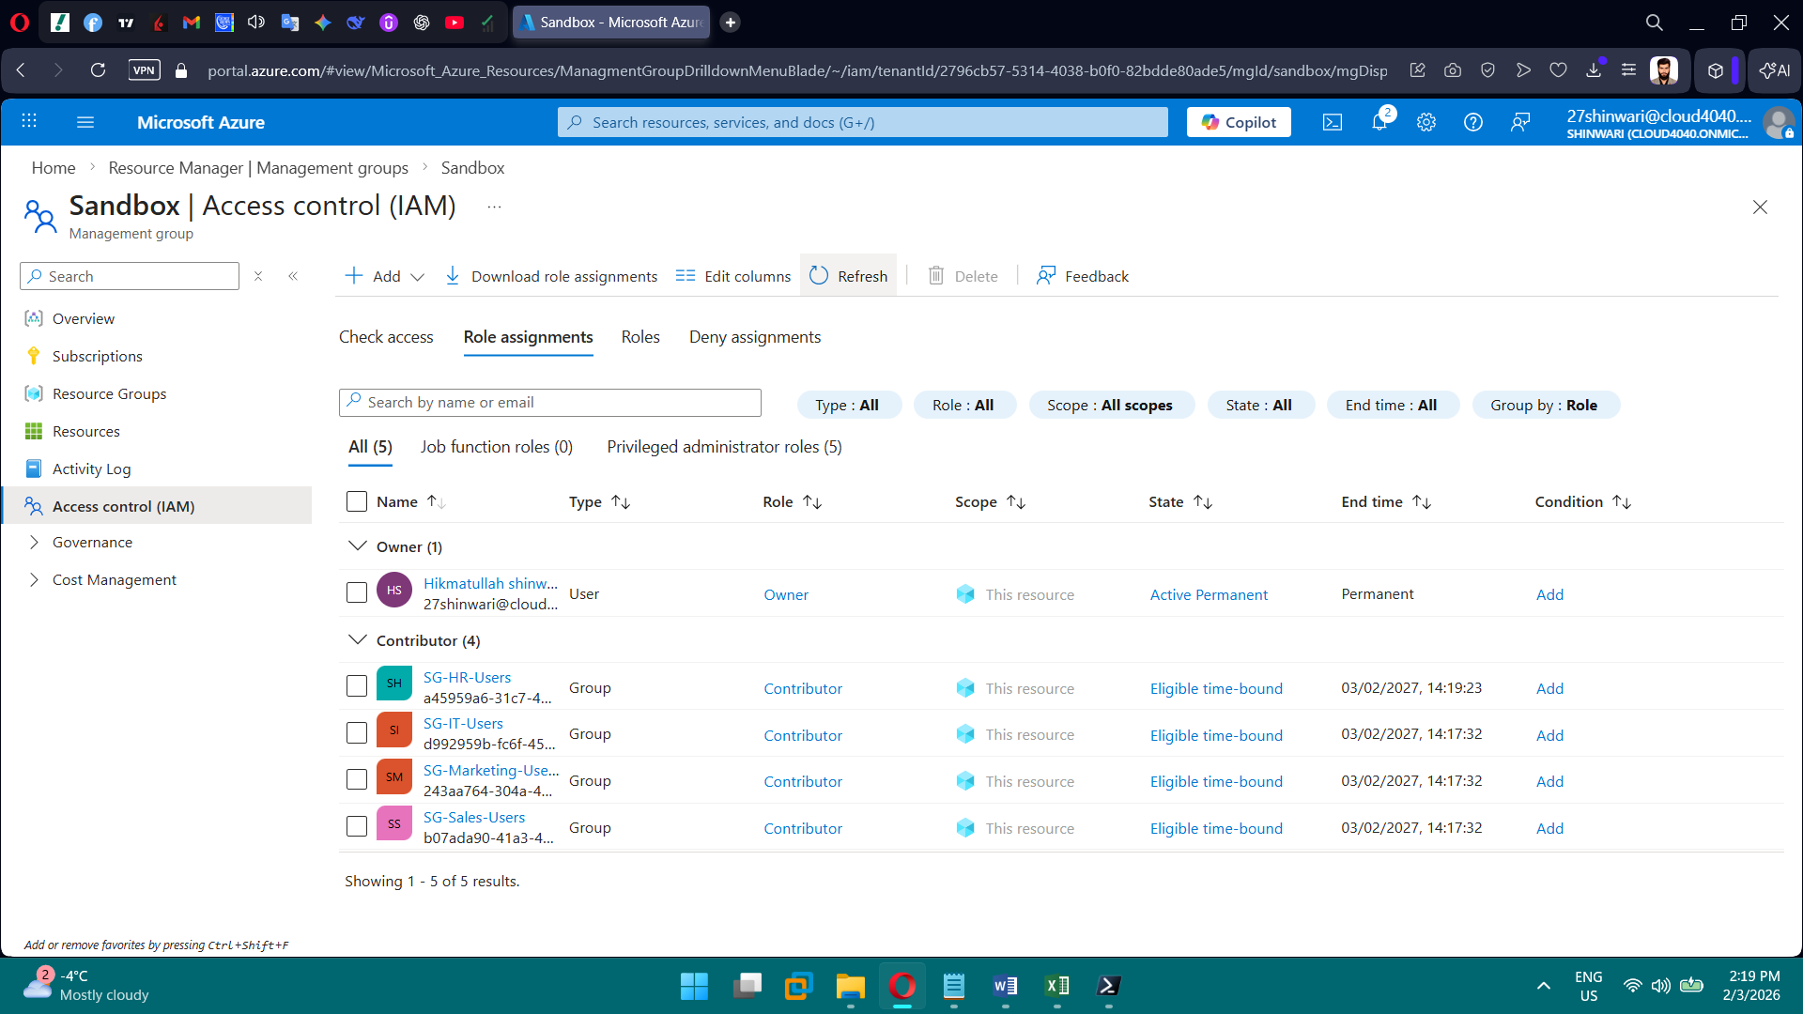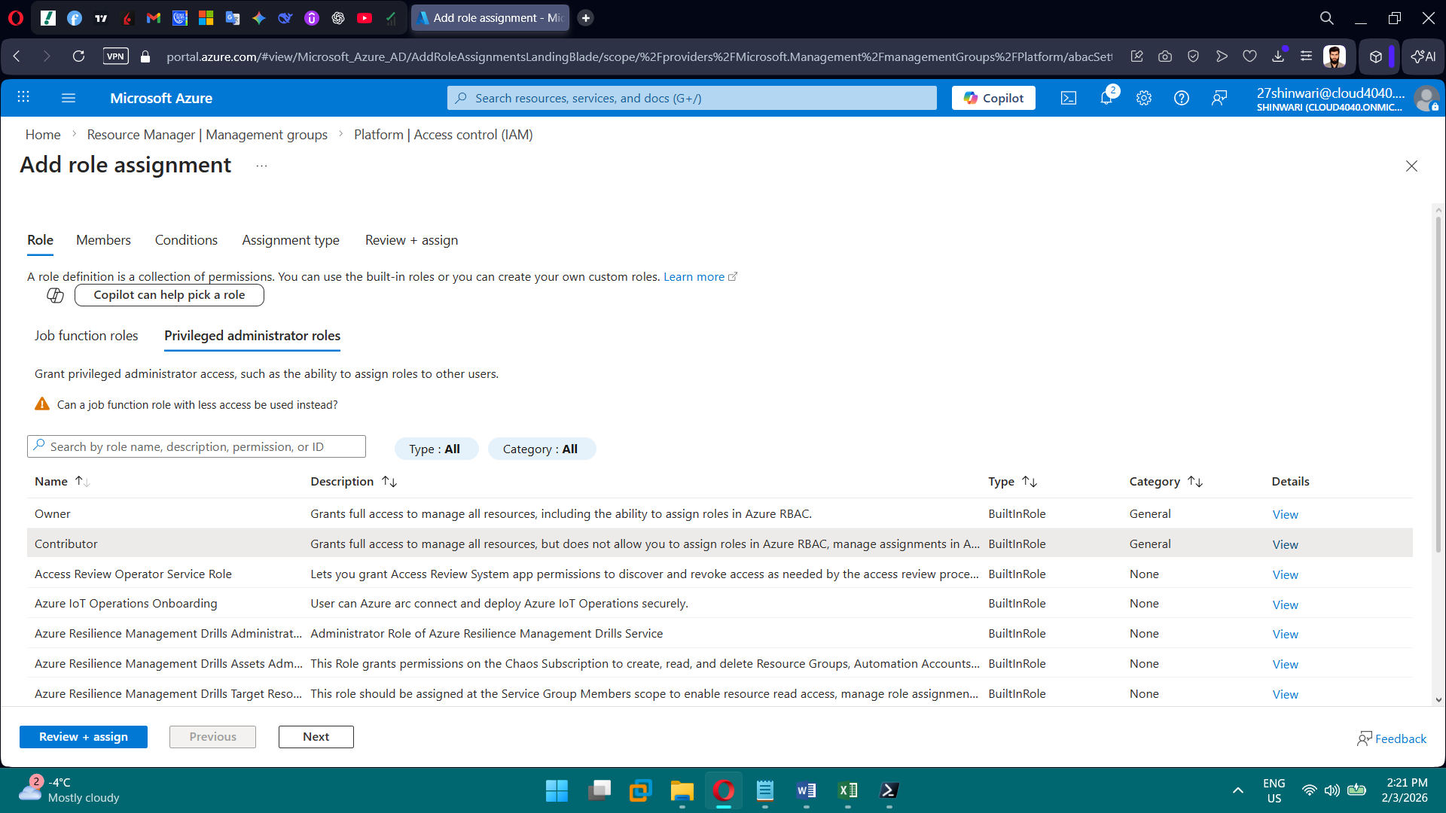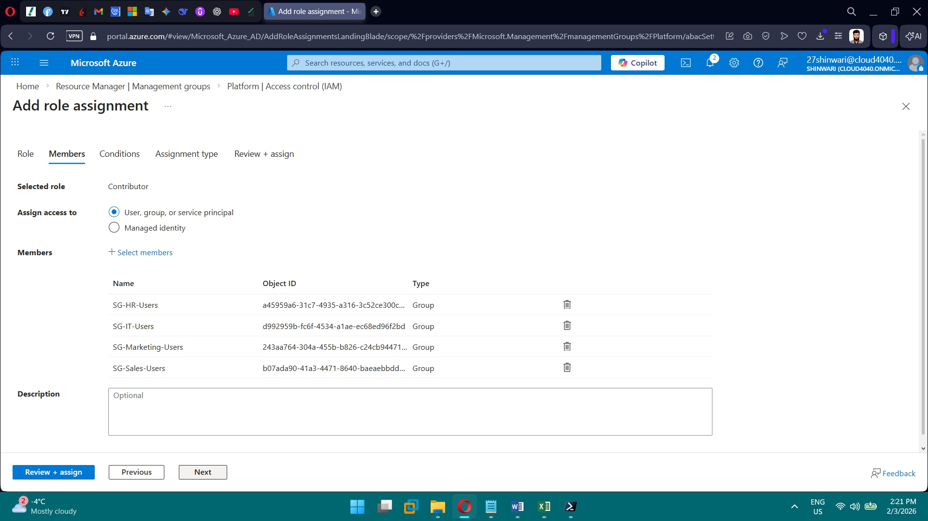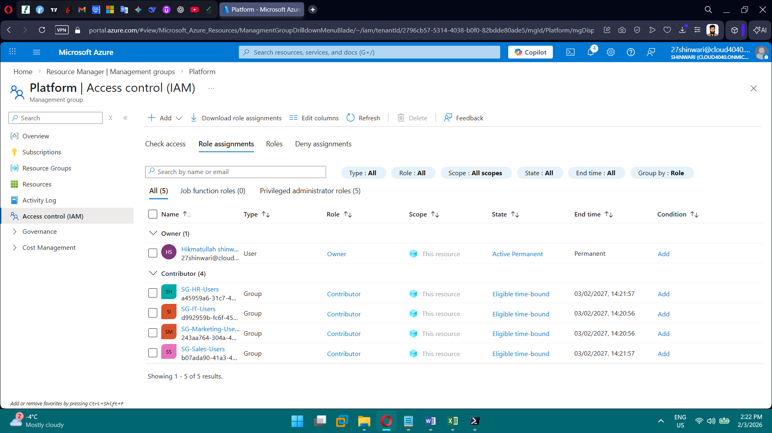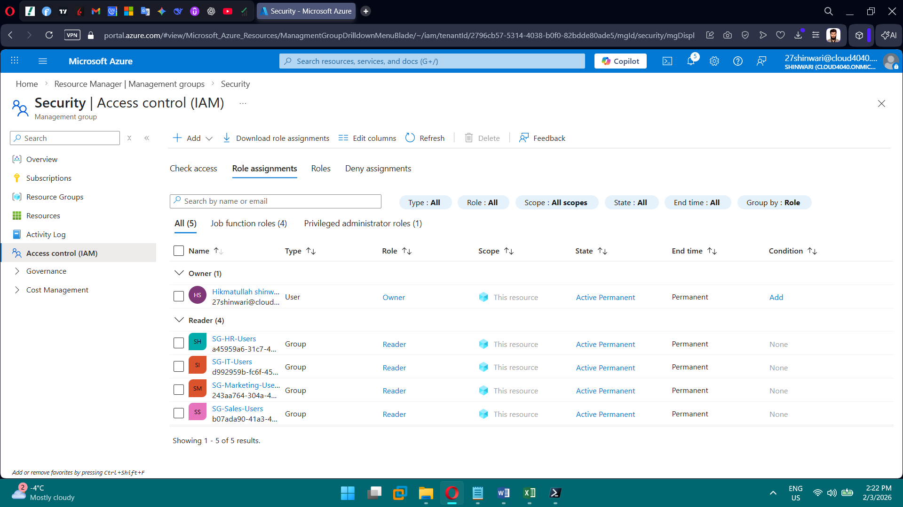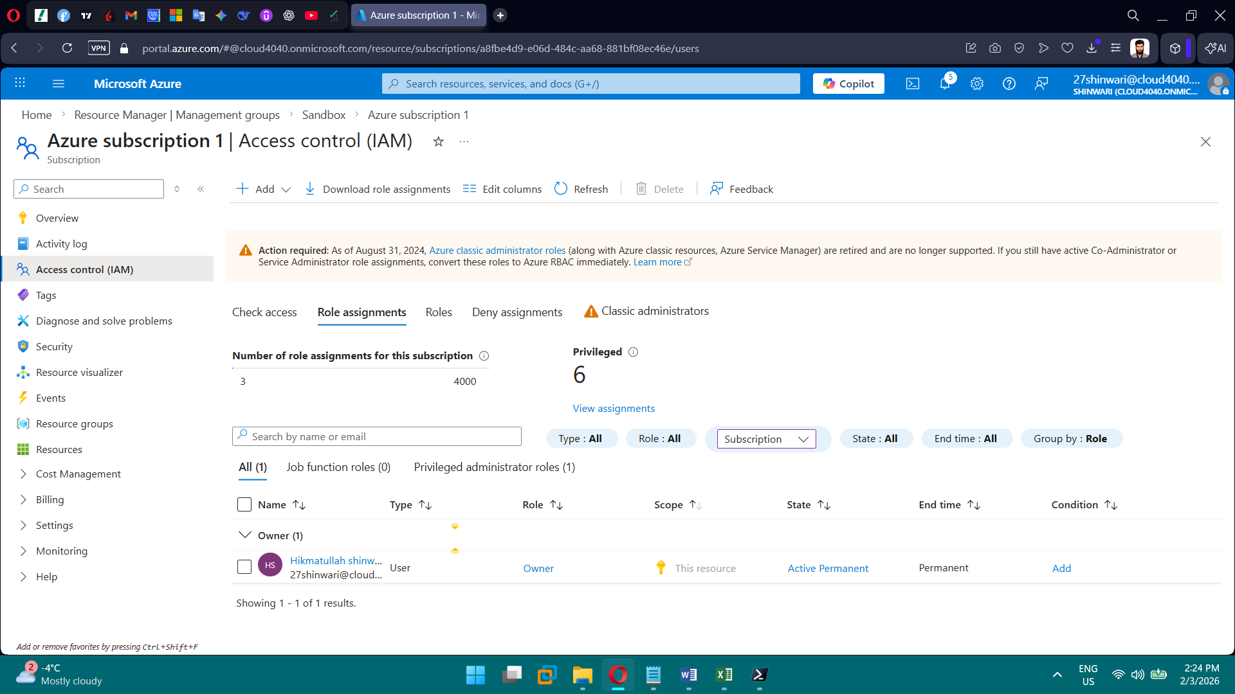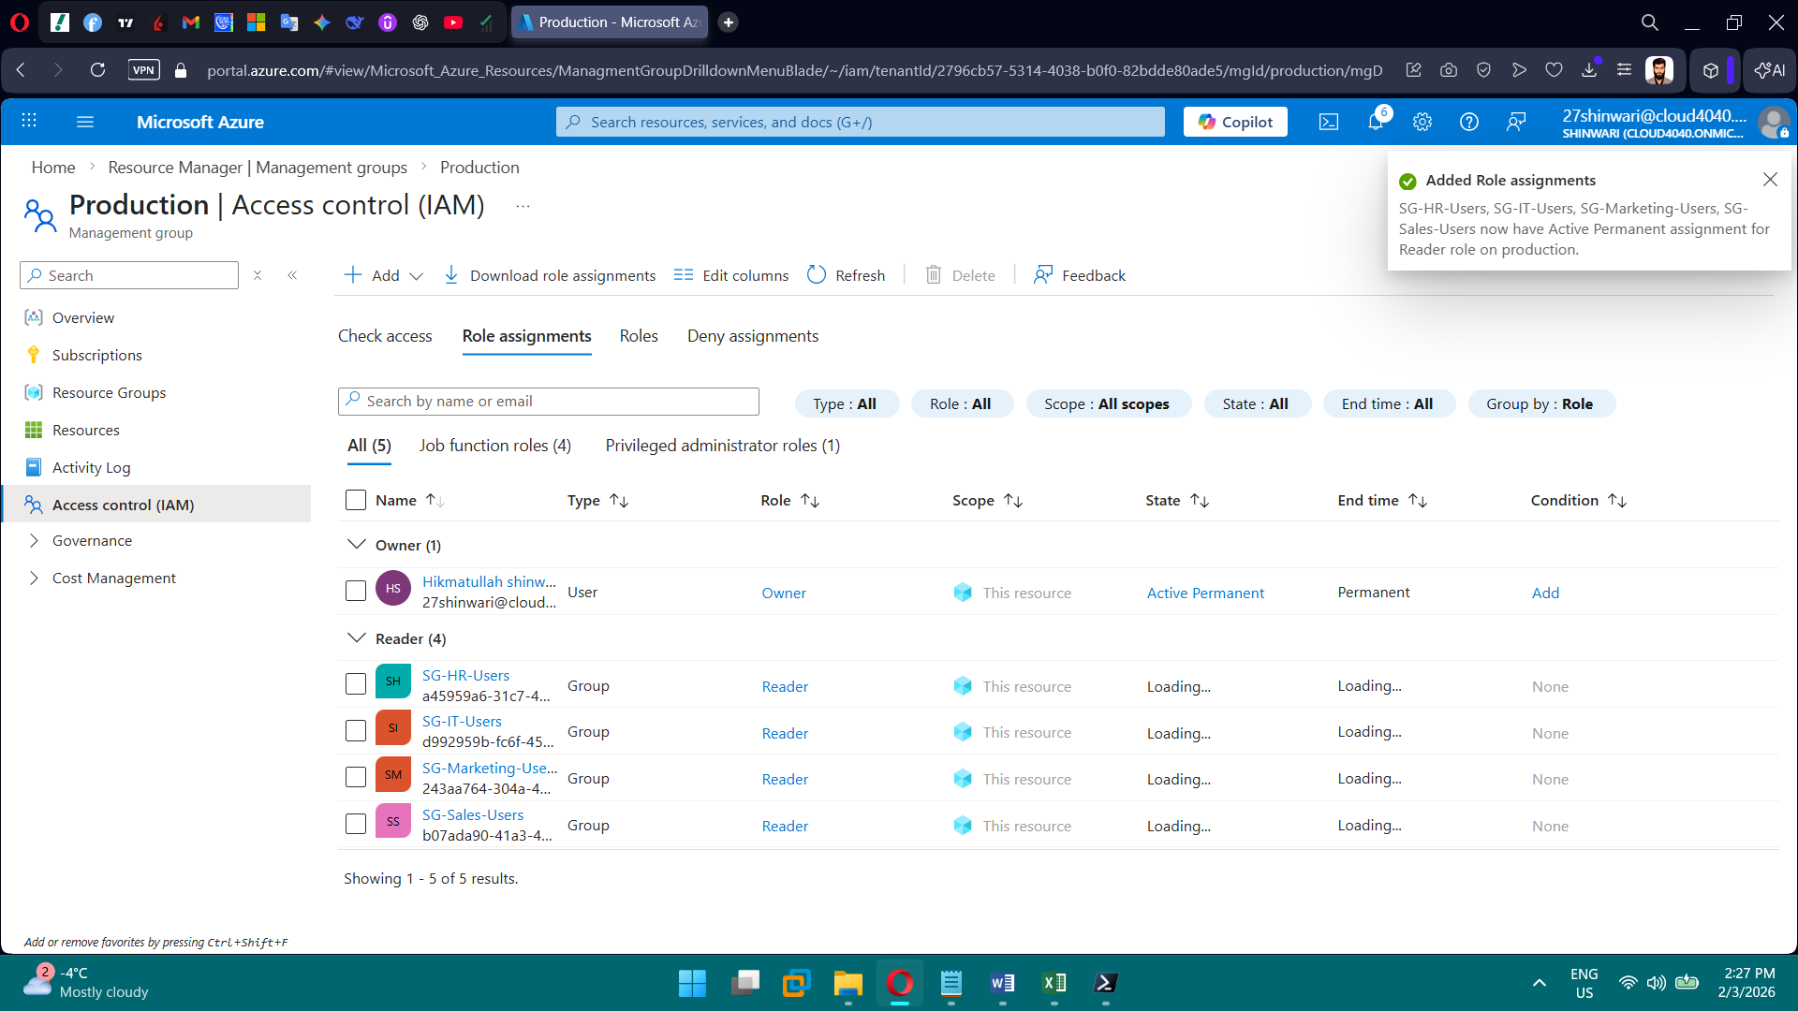

**PHASE 3 — Governance & Azure Policy**

**Tasks**

1. Create naming policy
2. Create mandatory tag policy
3. Restrict regions
4. Restrict VM SKUs
5. Enforce encryption
6. Assign initiatives (ASB, CIS)
7. Validate compliance

**Brief Explanation of Phase 3:** In Phase 3, we implemented governance using Azure Policy to enforce tagging, allowed locations, allowed VM SKUs, encryption, and network security. Custom policies were defined in JSON with portal-ready parameters for easy assignment. Initiatives like Azure Security Benchmark and CIS baseline were included for auditing. Policies were deployed and assigned to the subscription/resource groups. The compliance dashboard provides evidence that all rules are followed. This phase ensures consistent security, compliance, and organizational standards across Azure resources.

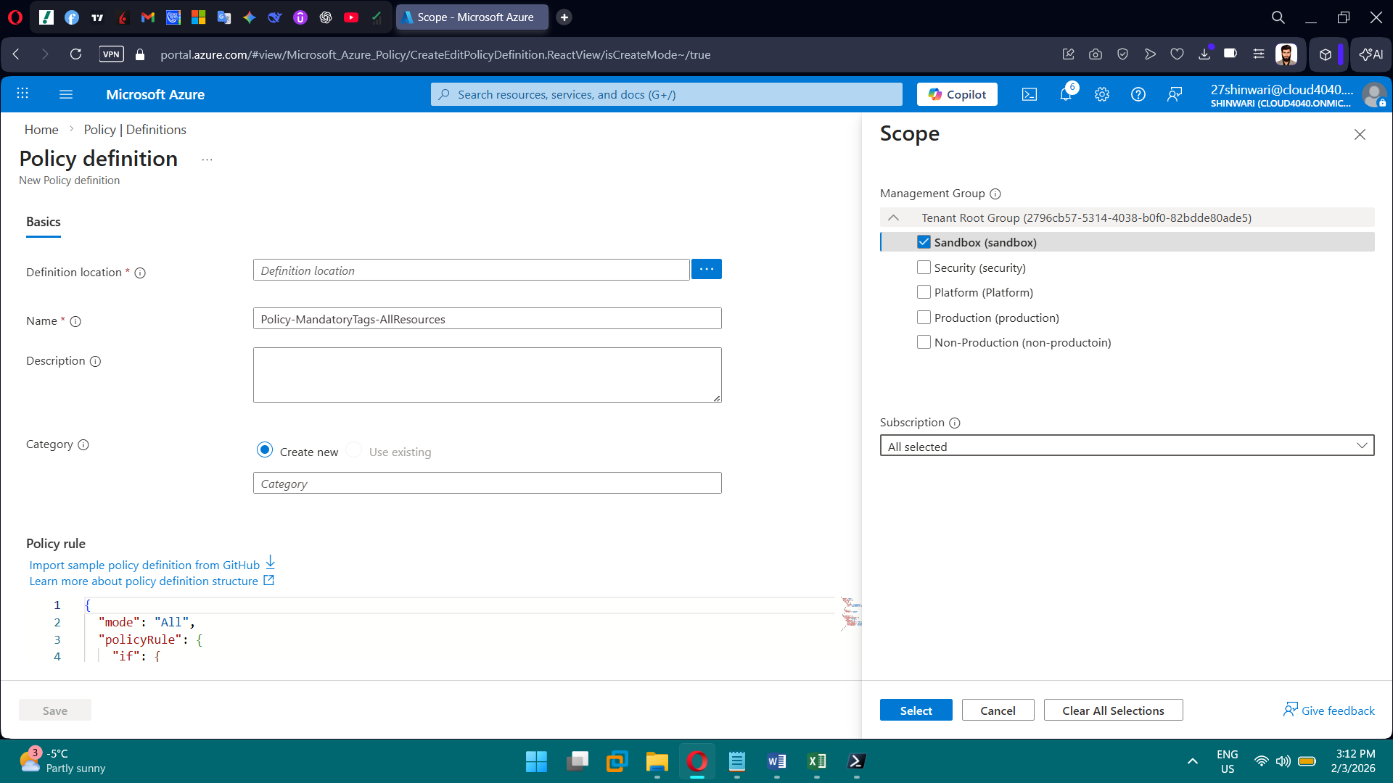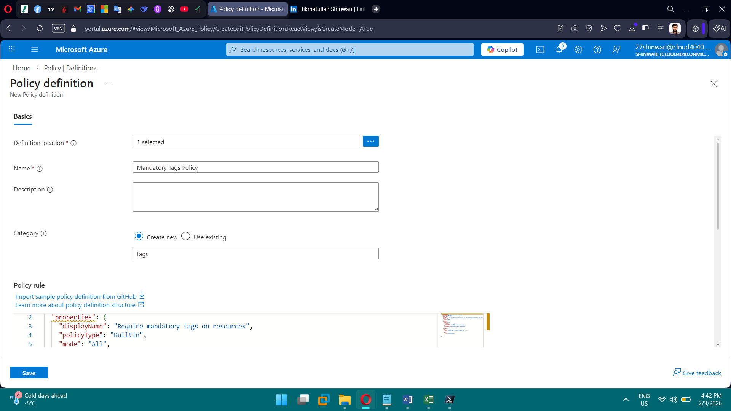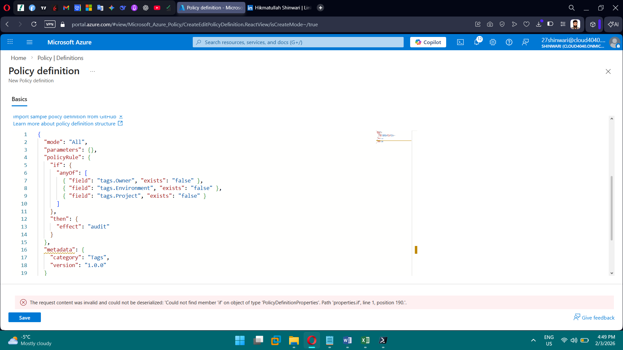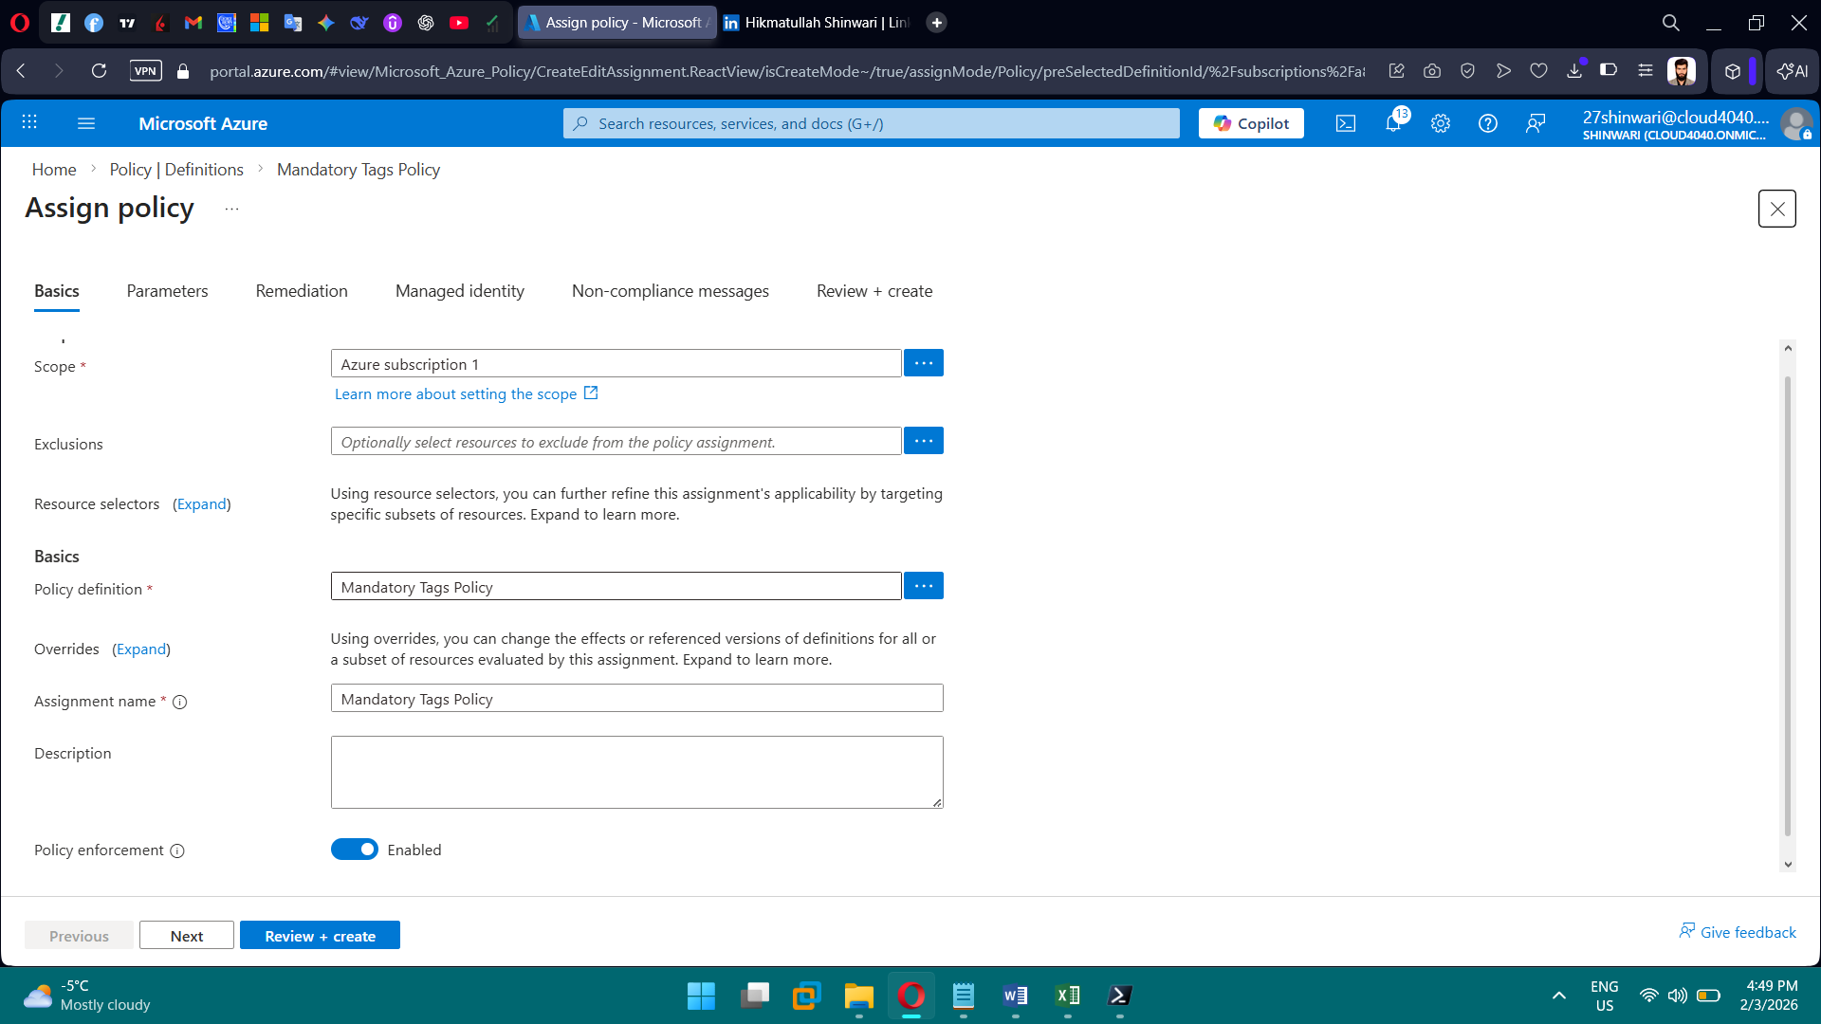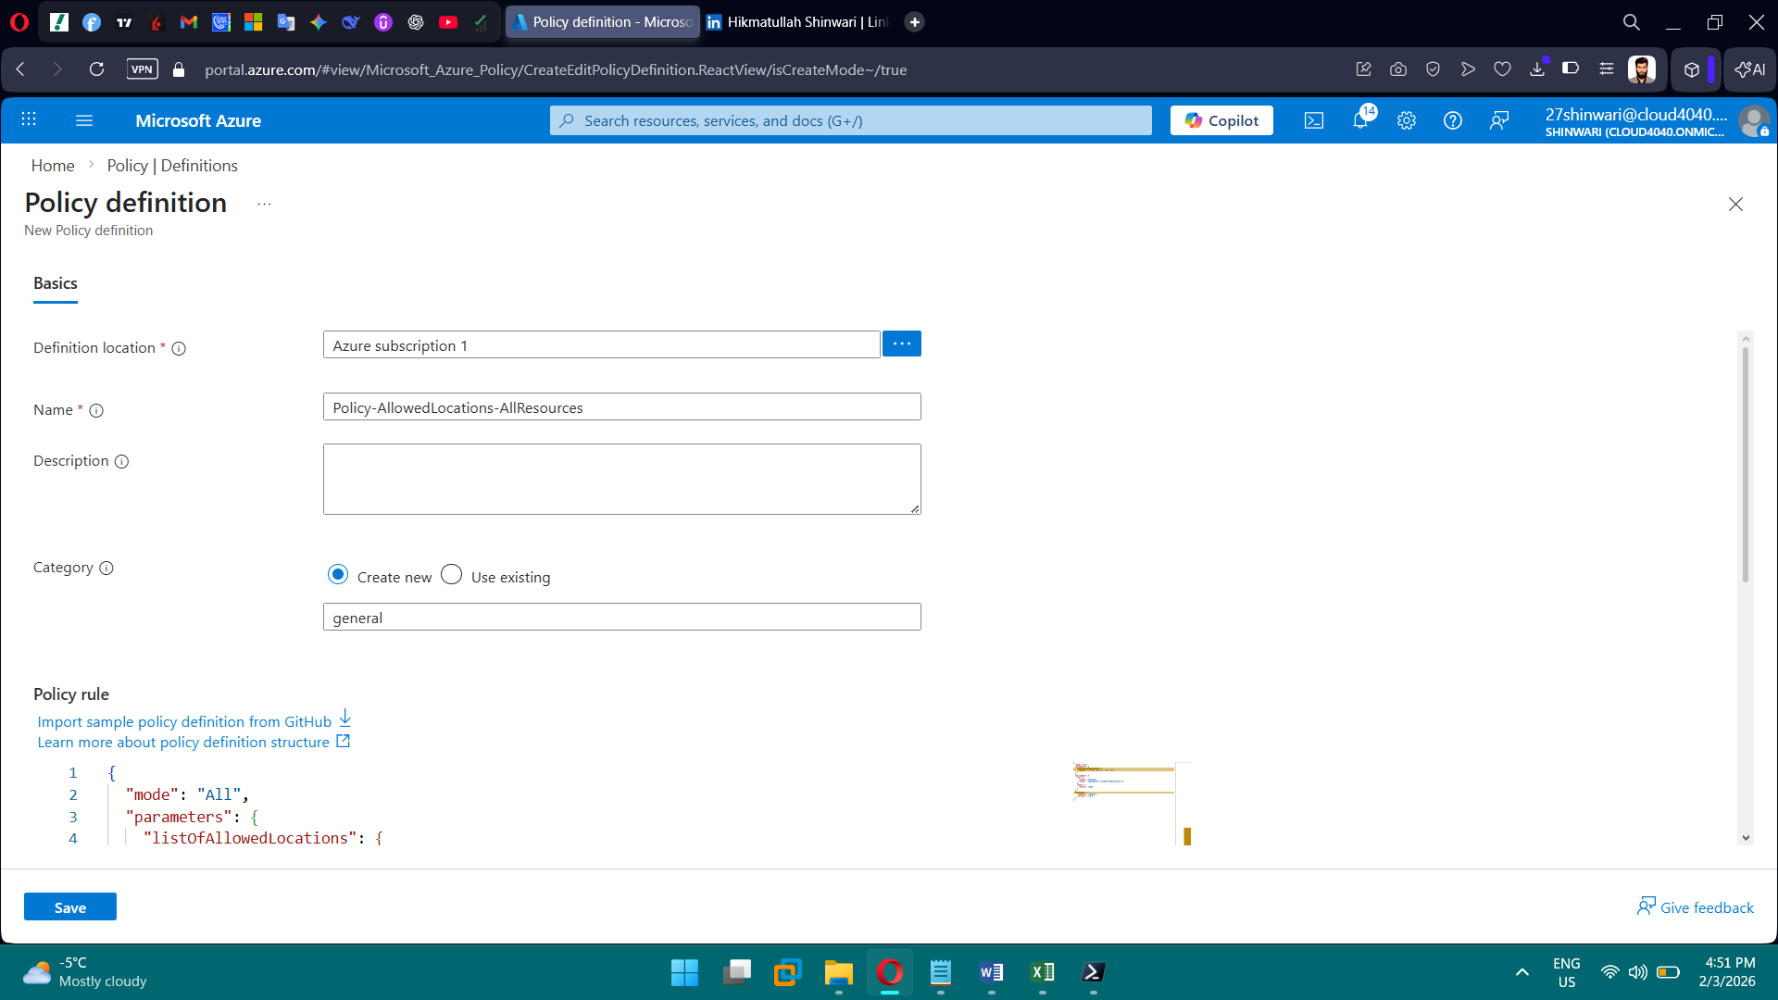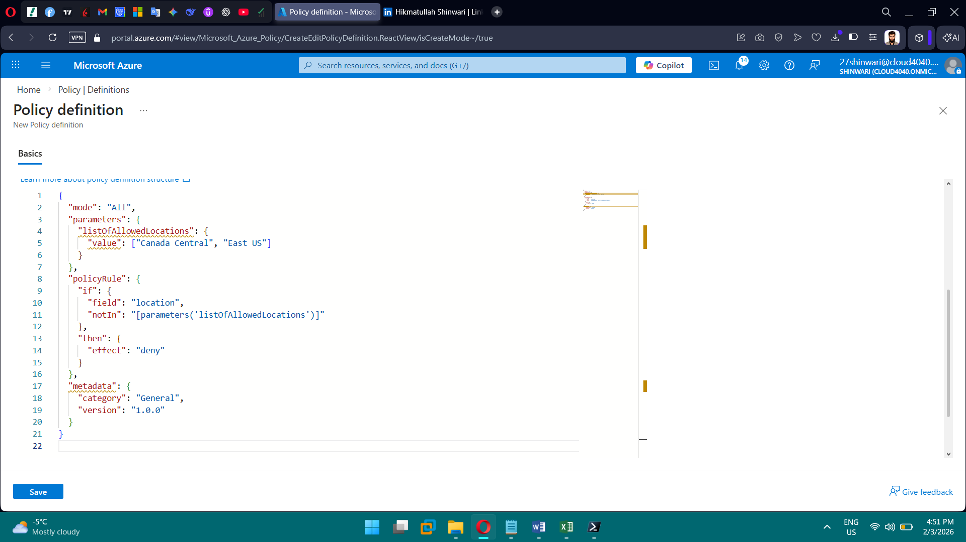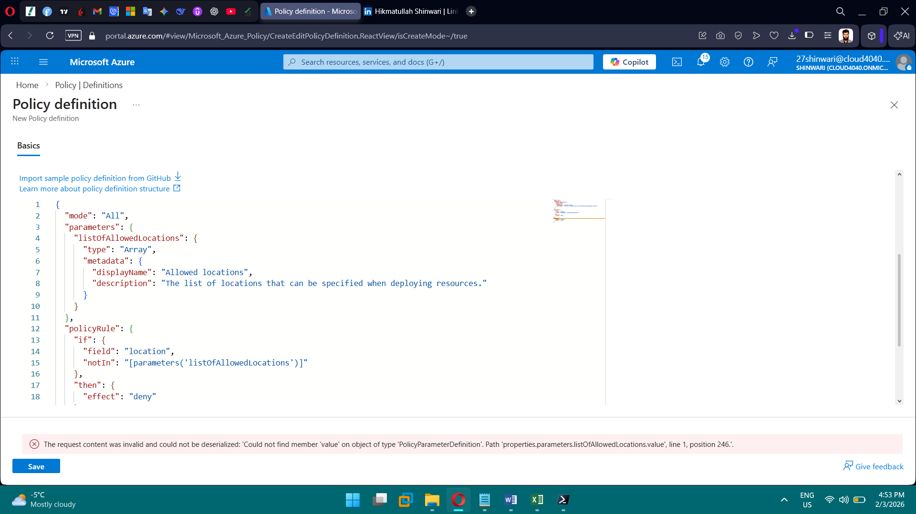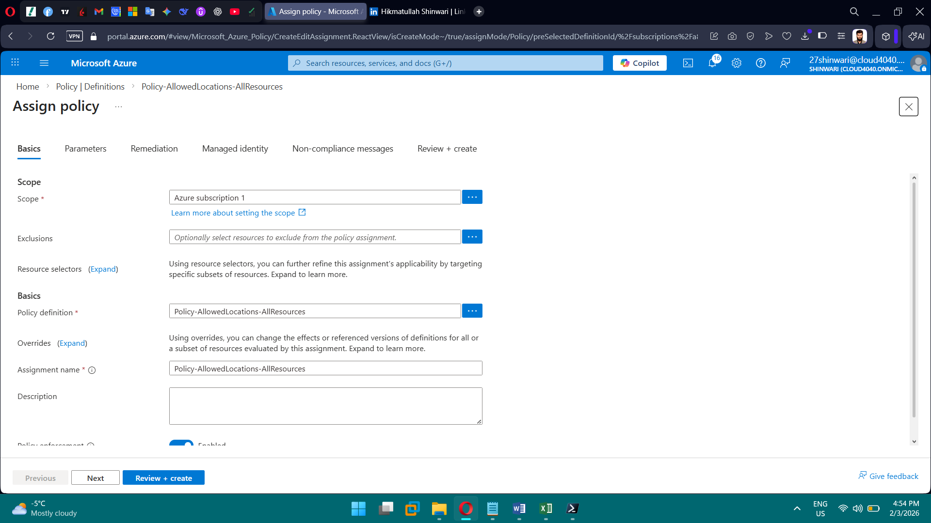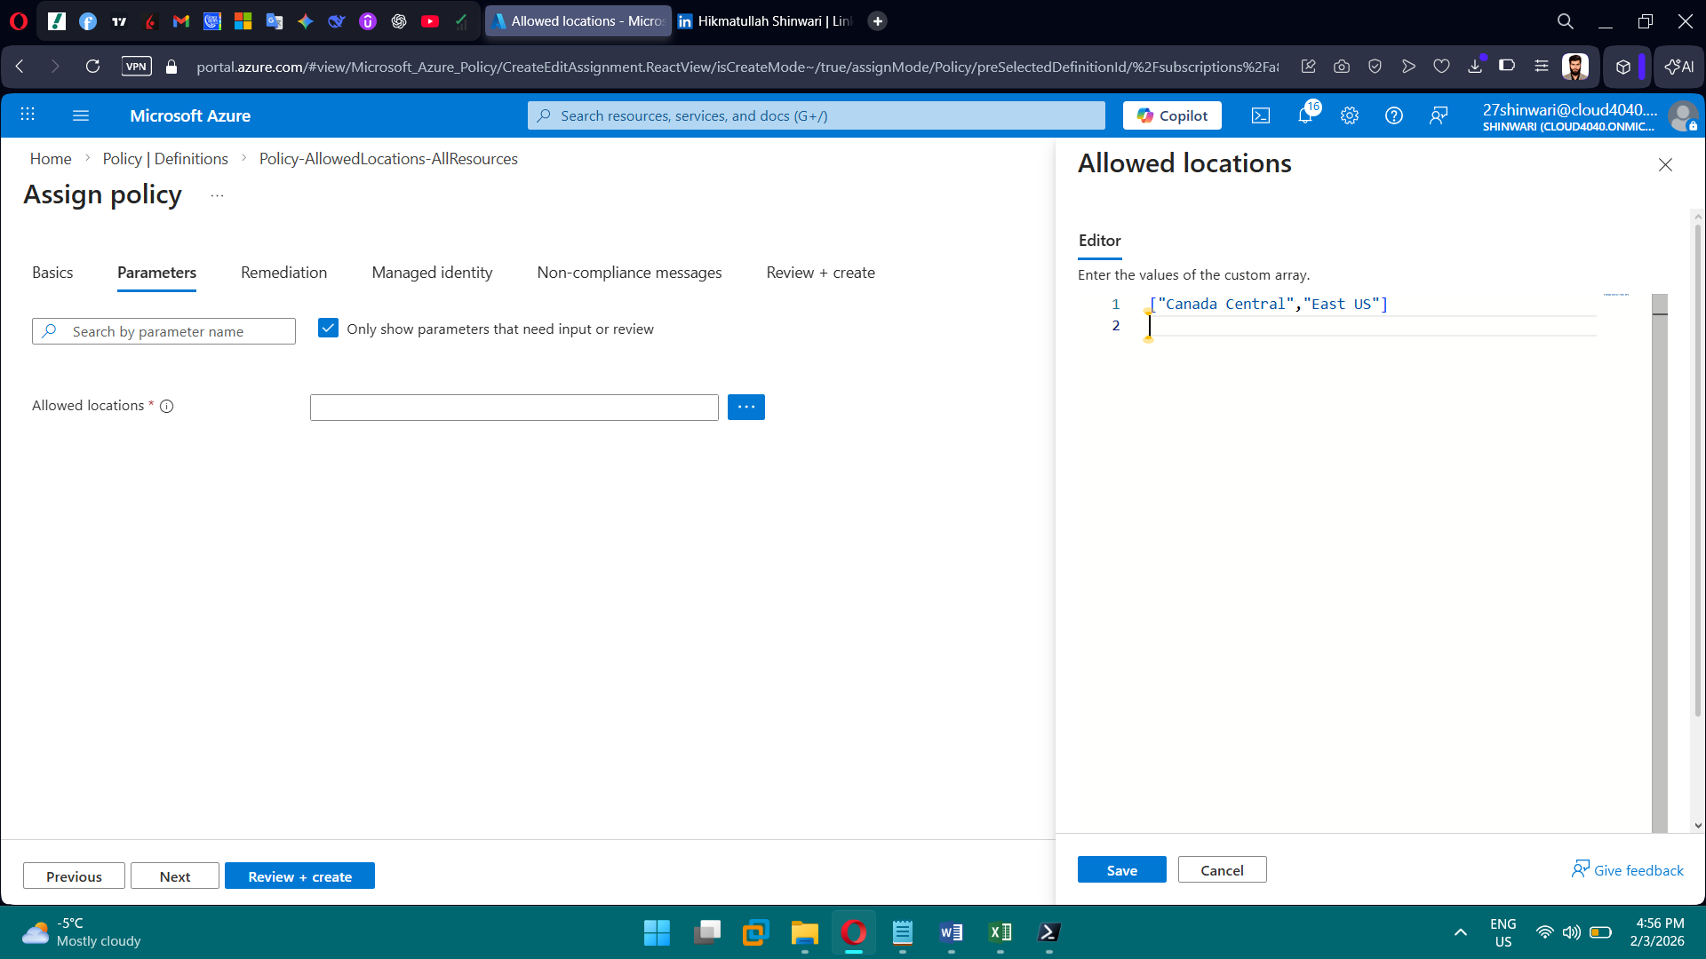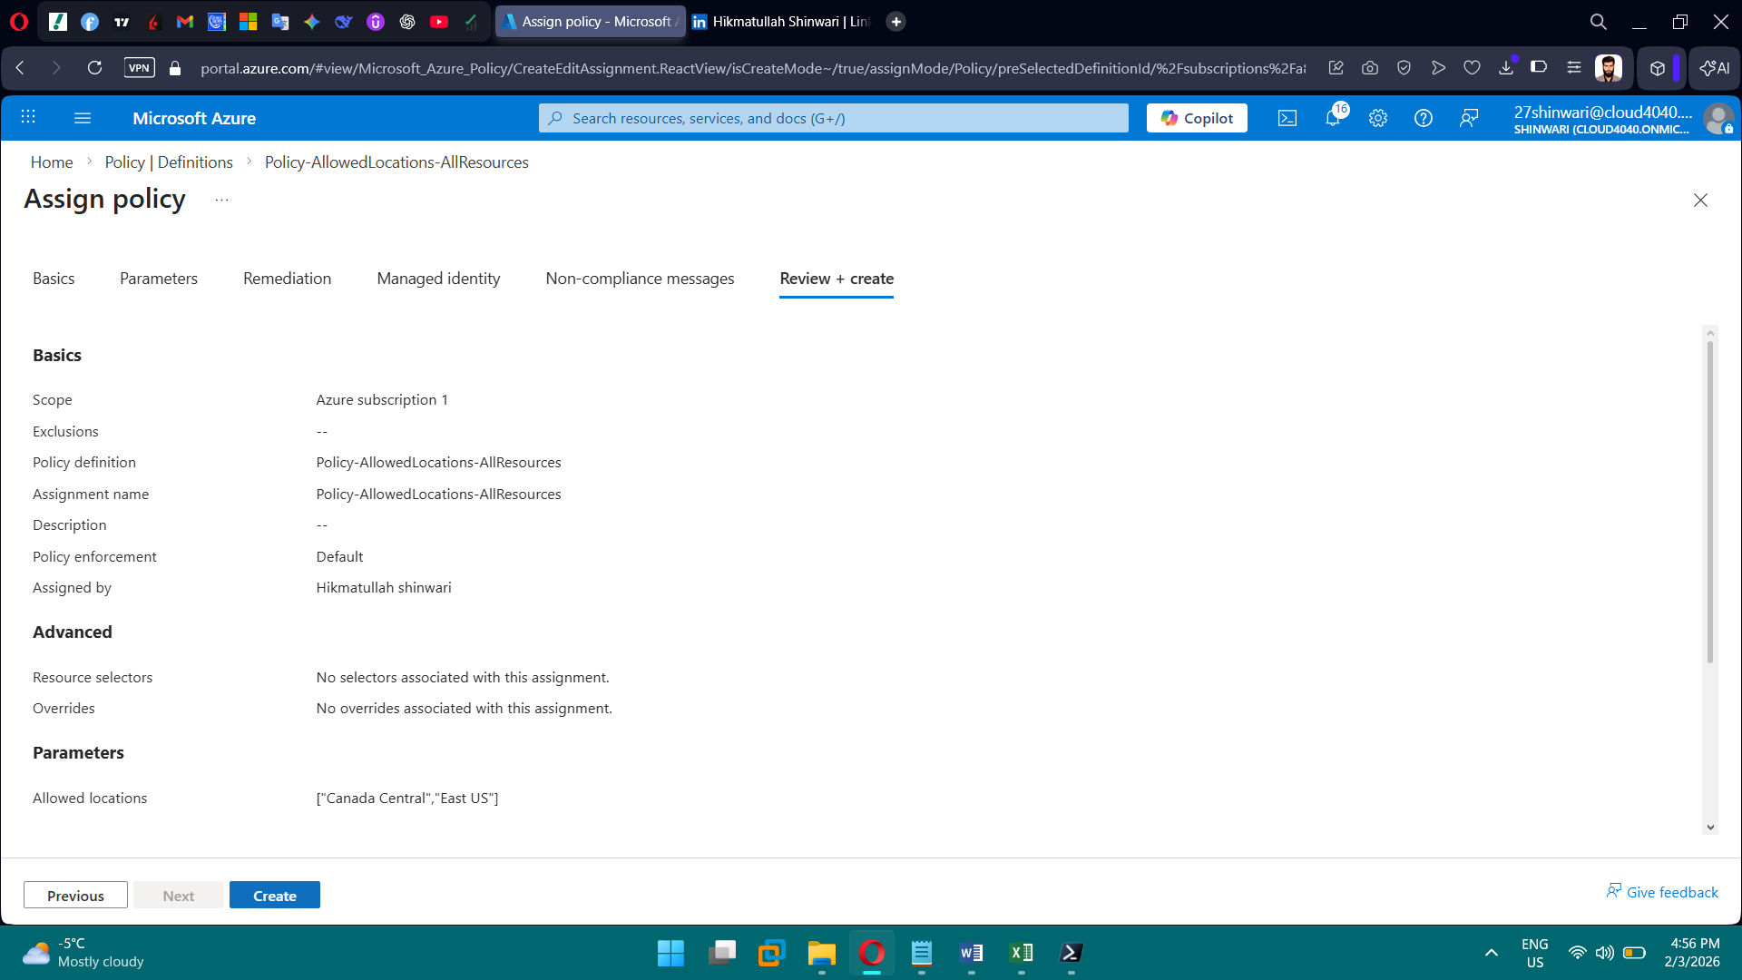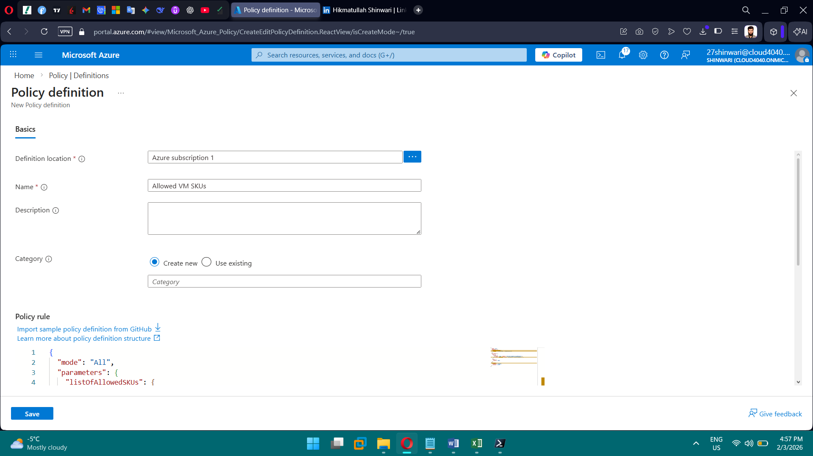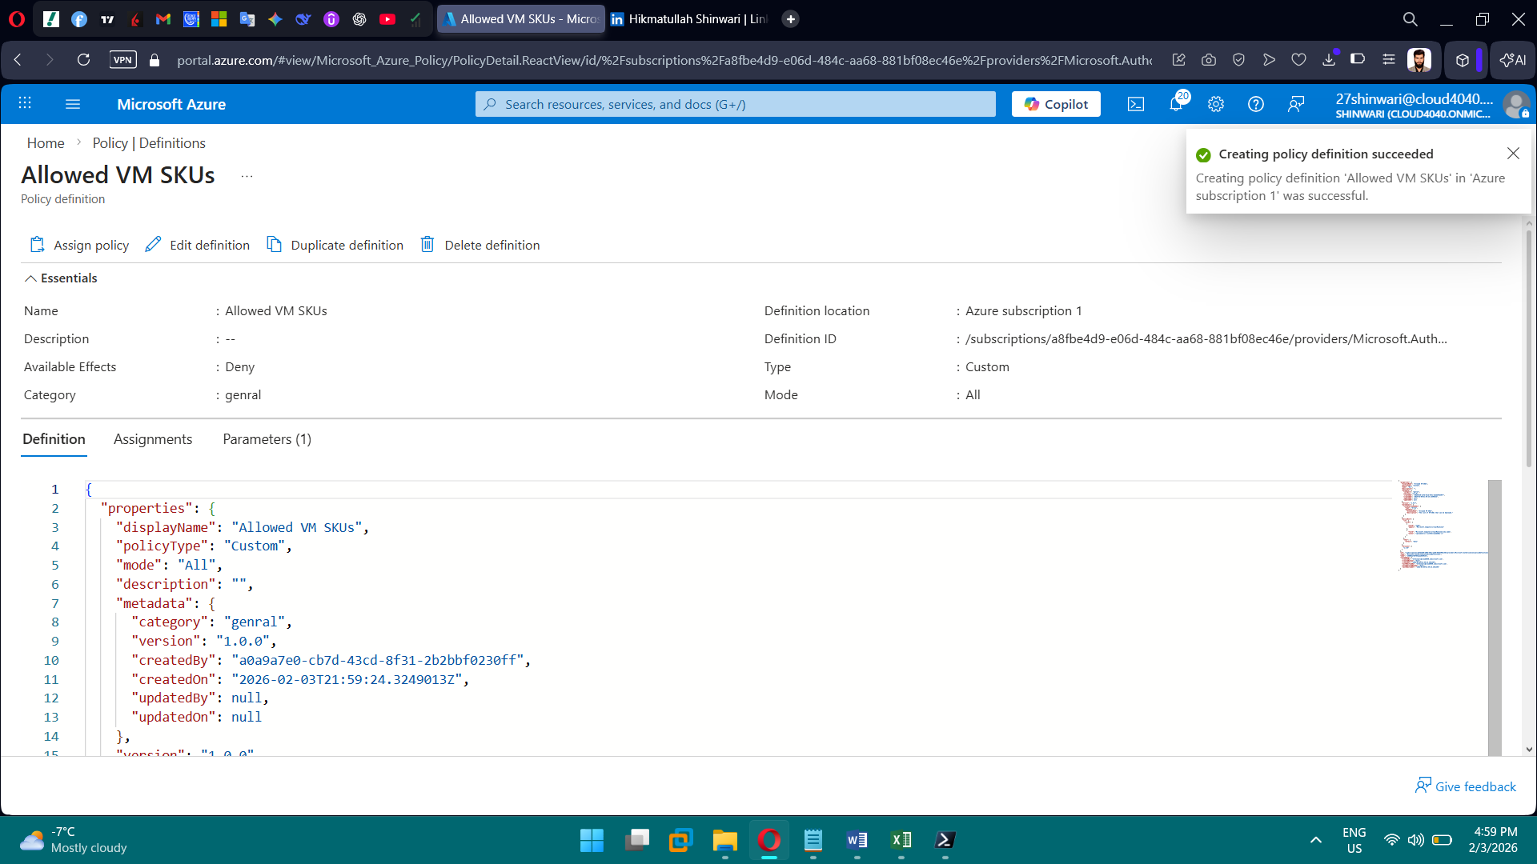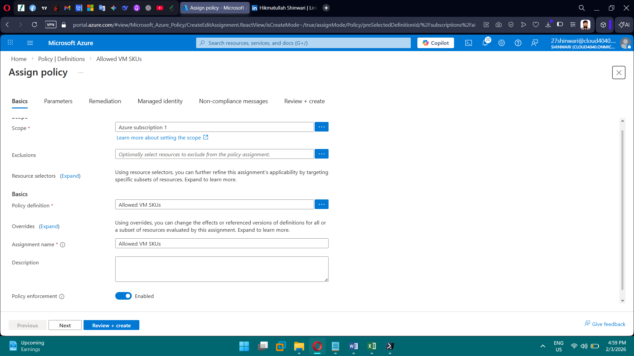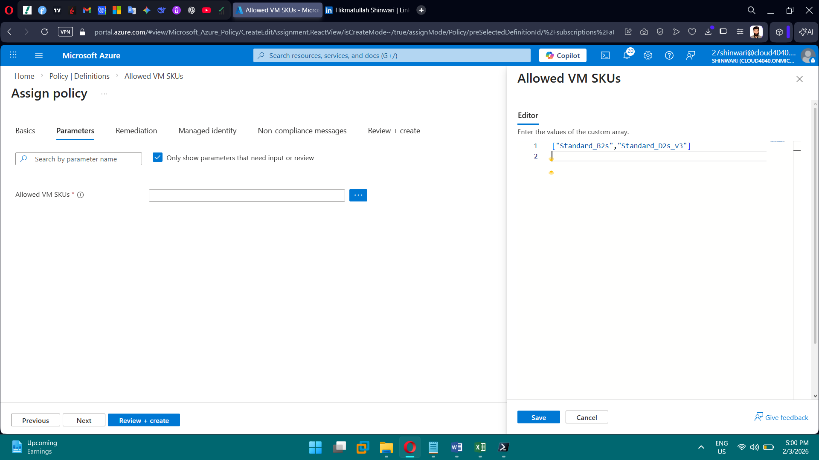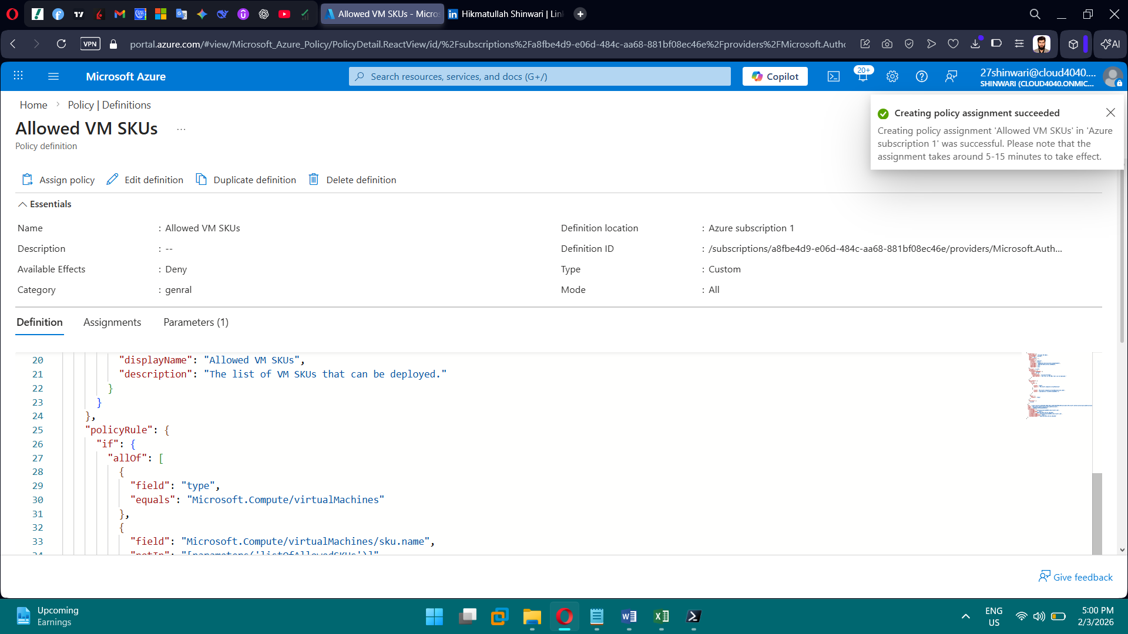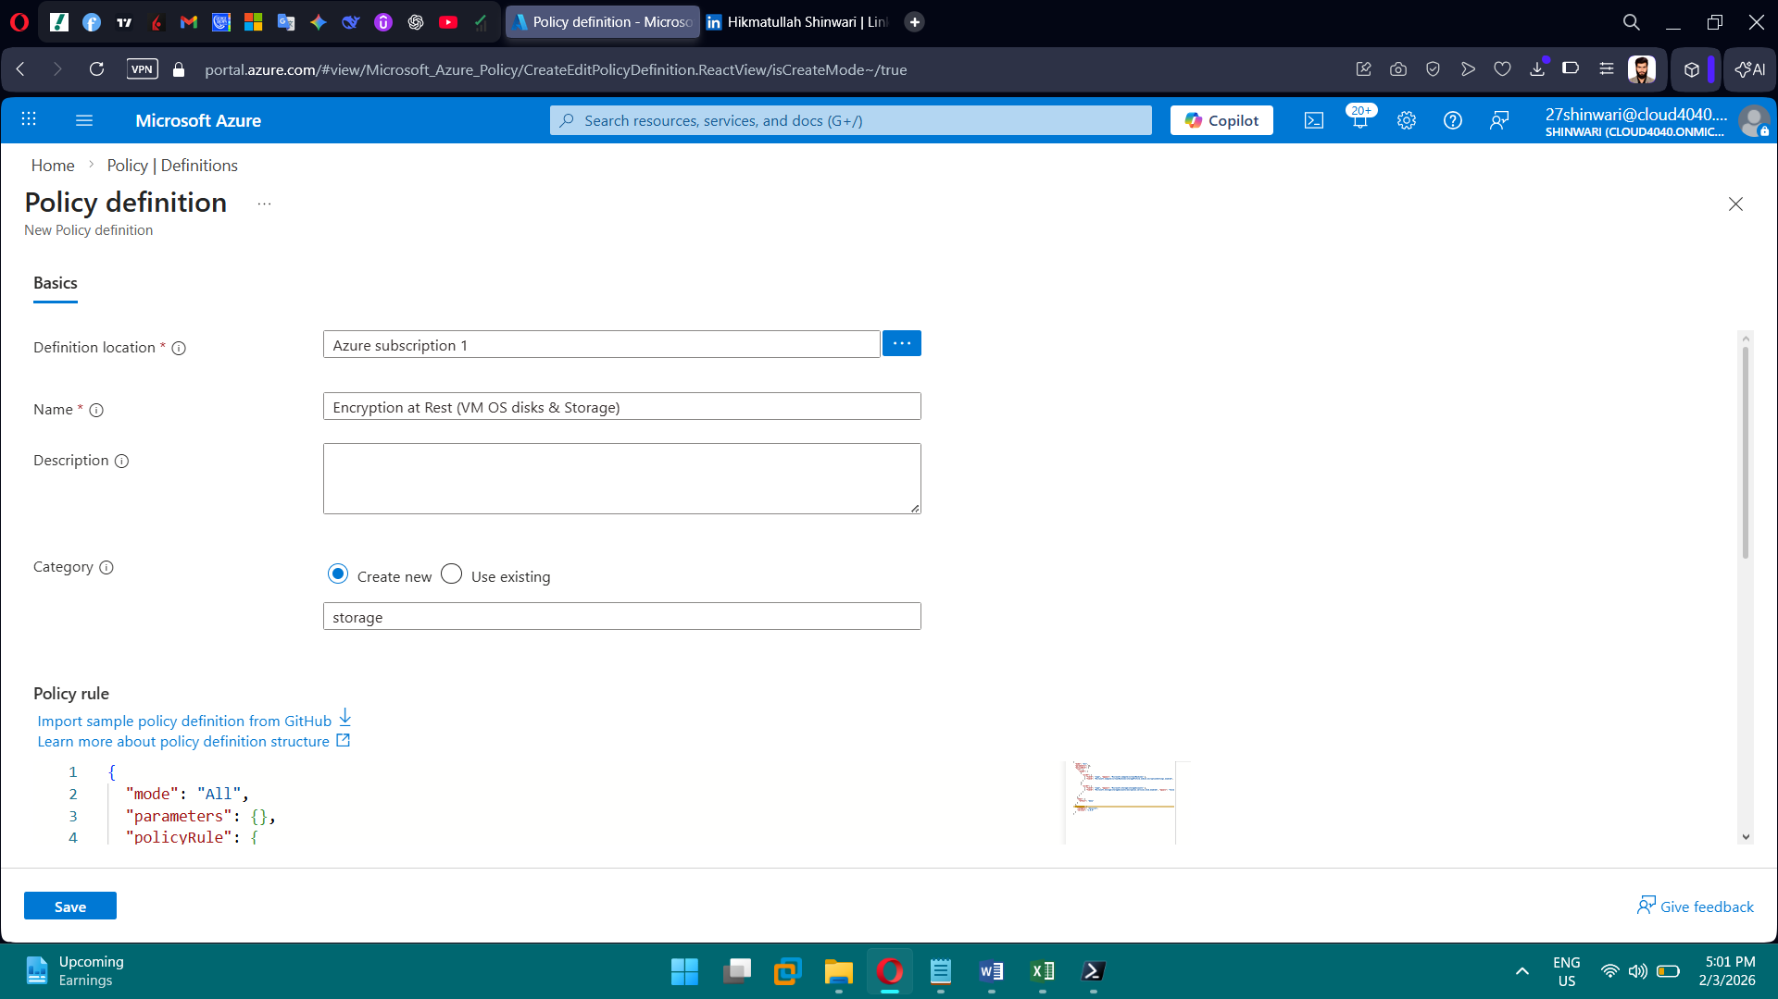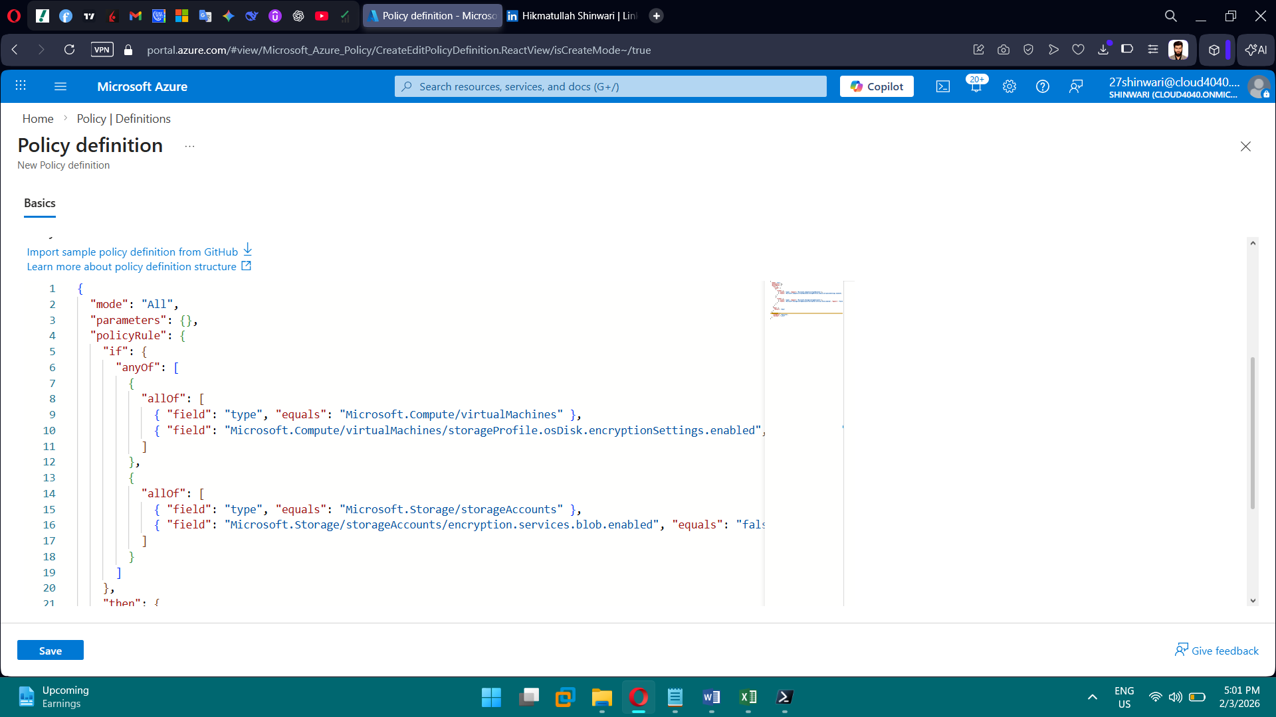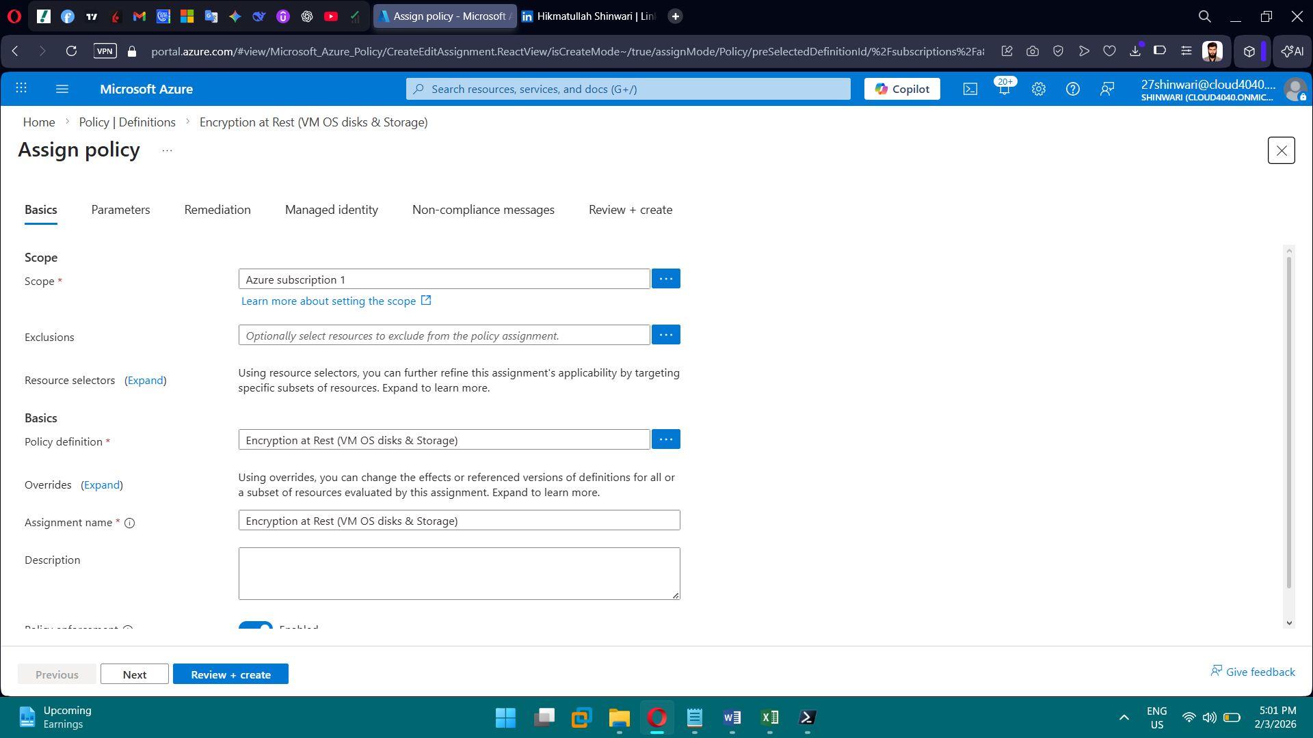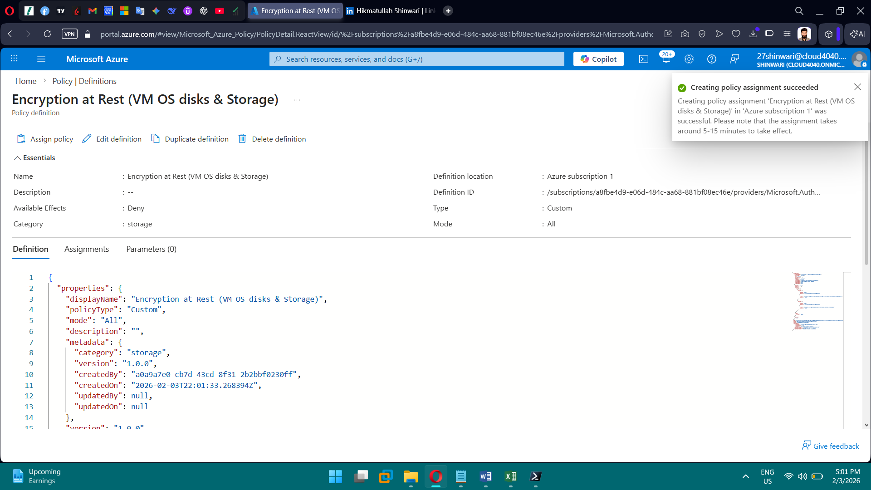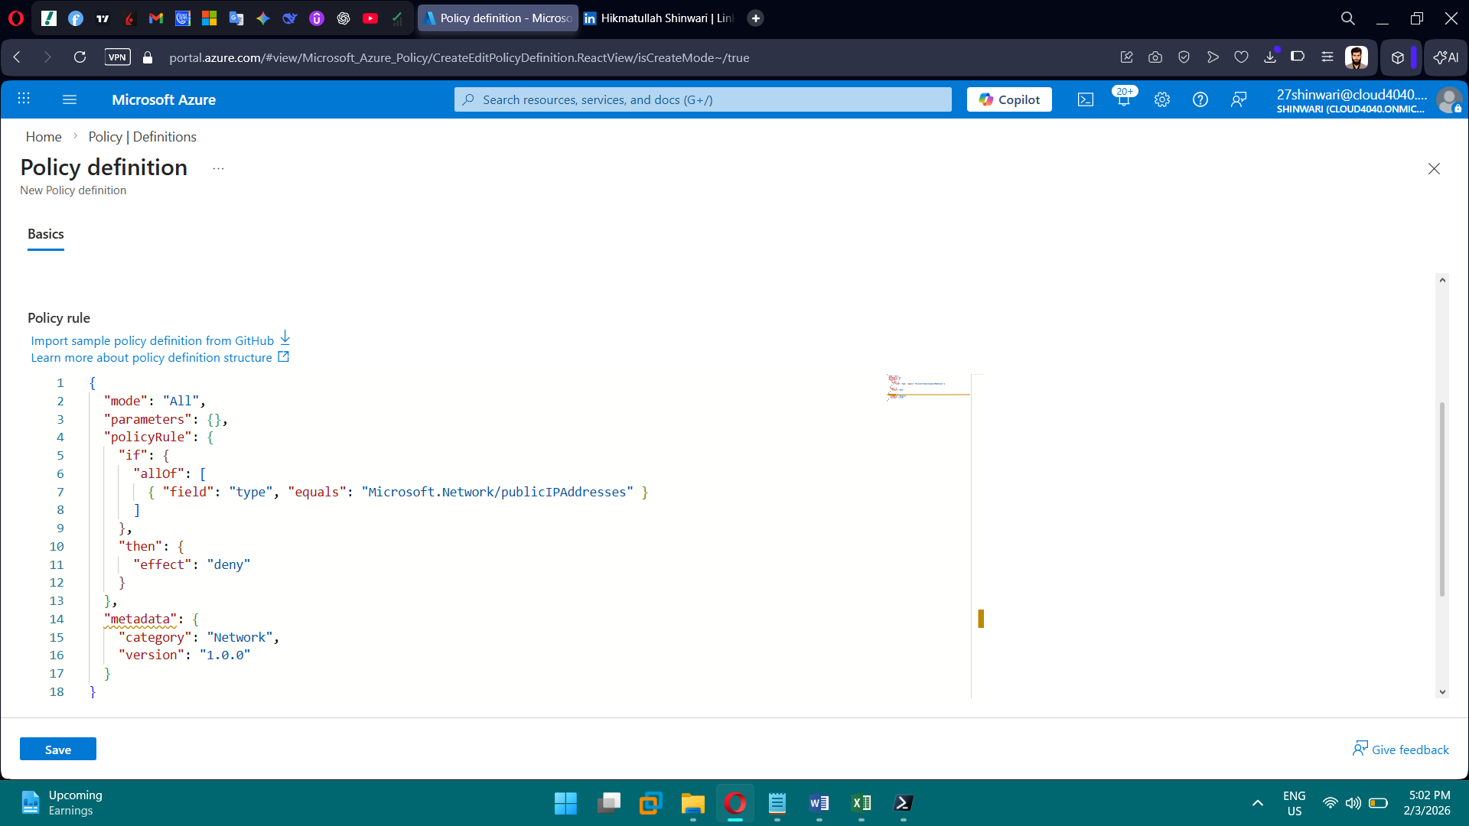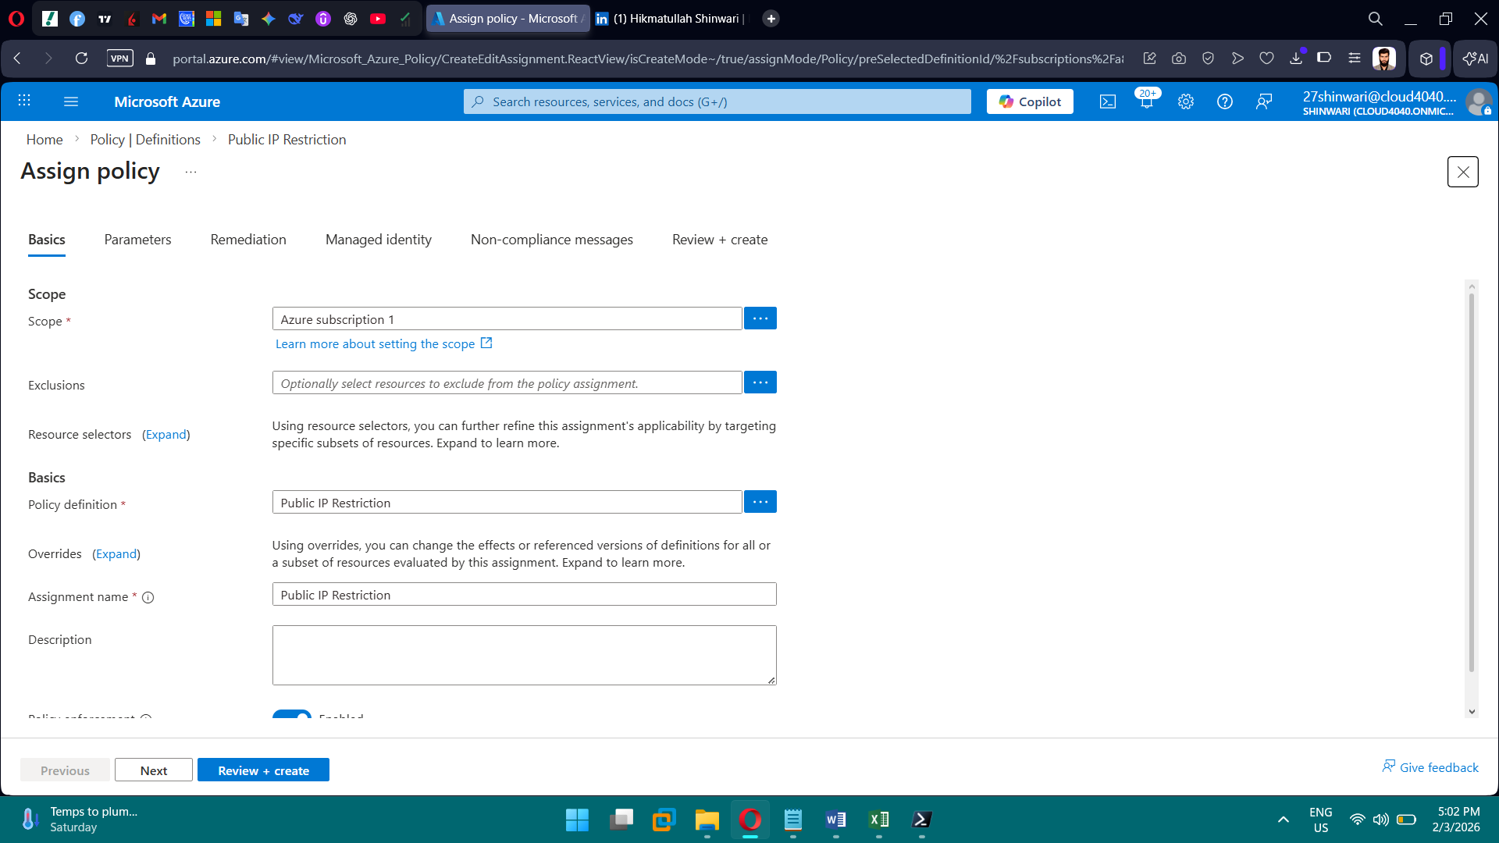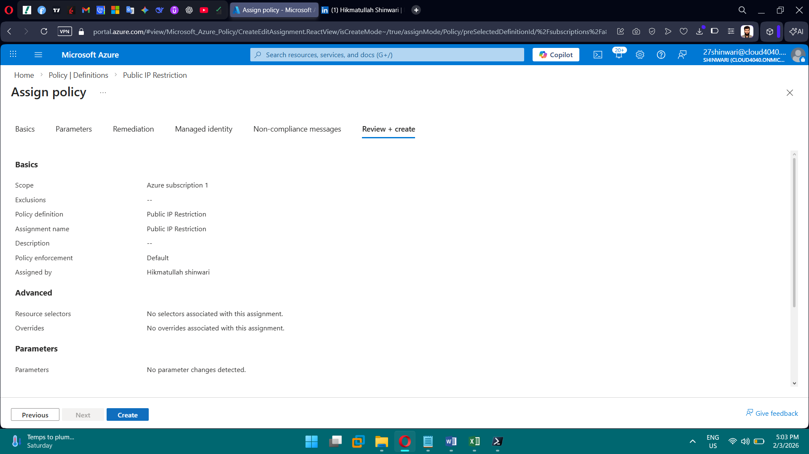

**PHASE 4 — Core Networking (Hub-Spoke)**

**Tasks**

1. Create Hub VNet
2. Create 4 Spoke VNets
3. Create subnets (App + VM)
4. Create NSGs
5. Create UDRs
6. Peer VNets
7. (Optional) Document Firewall & Bastion

**Brief Explanation of Phase 4:**

I implemented a Hub-Spoke network architecture in Azure with subnet-level NSGs and private VNet peering to enforce Zero Trust and prevent lateral movement. CIDR-based IP planning ensured scalable, non-overlapping address spaces.

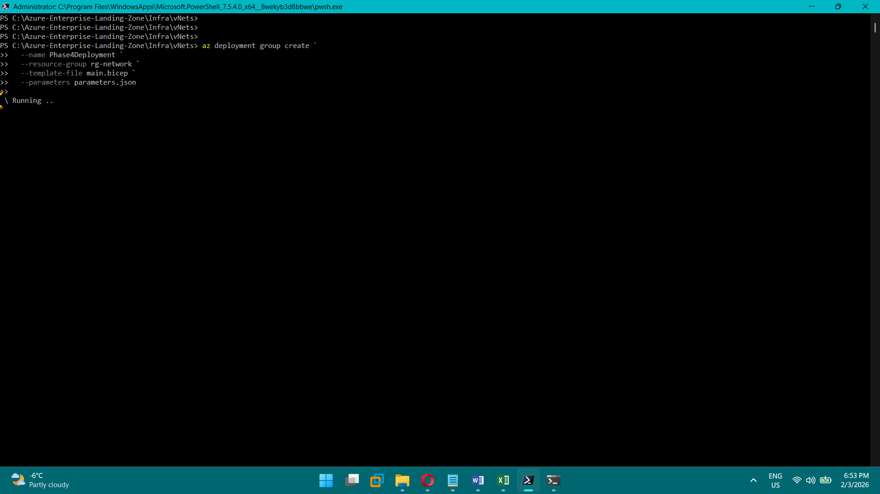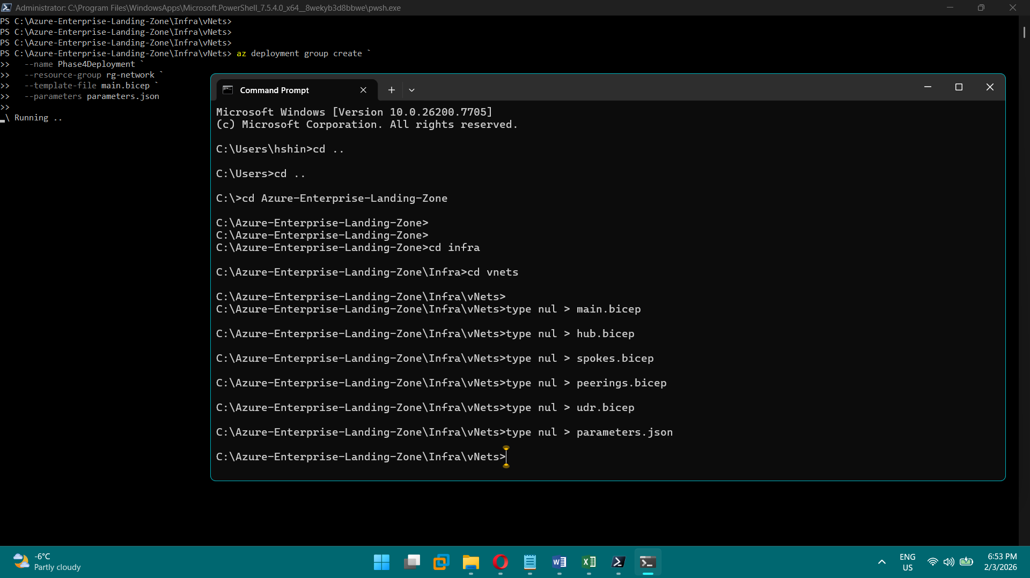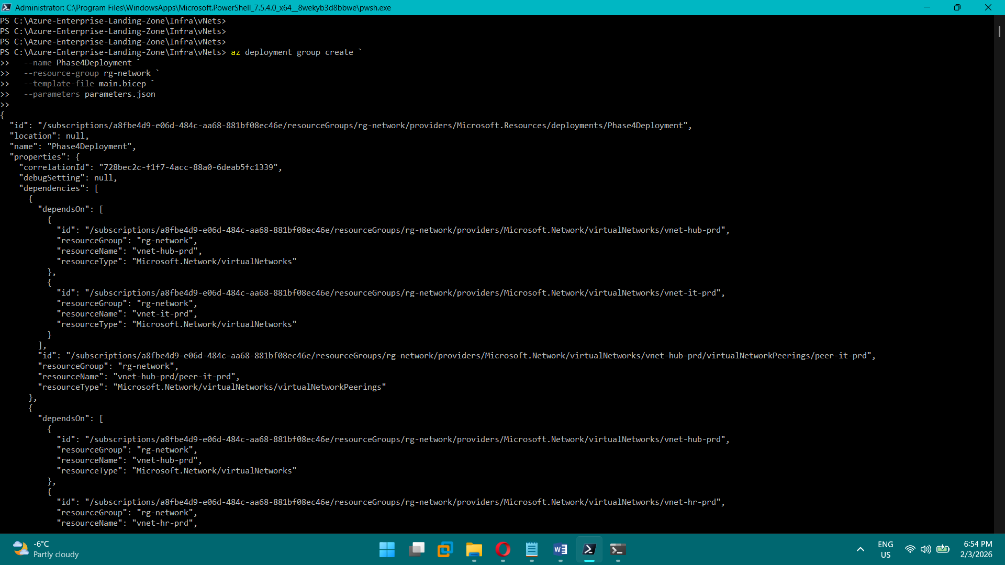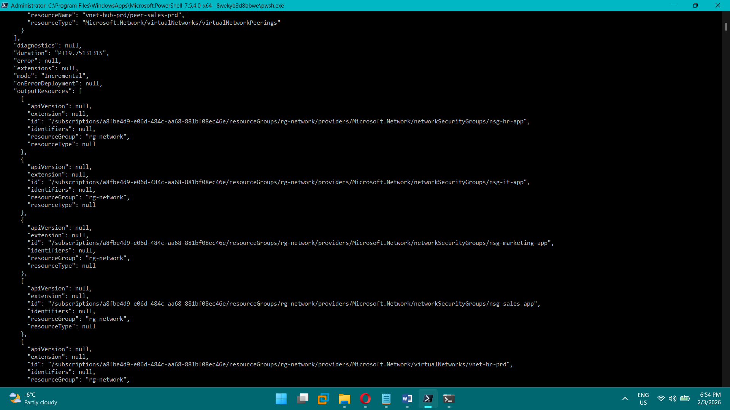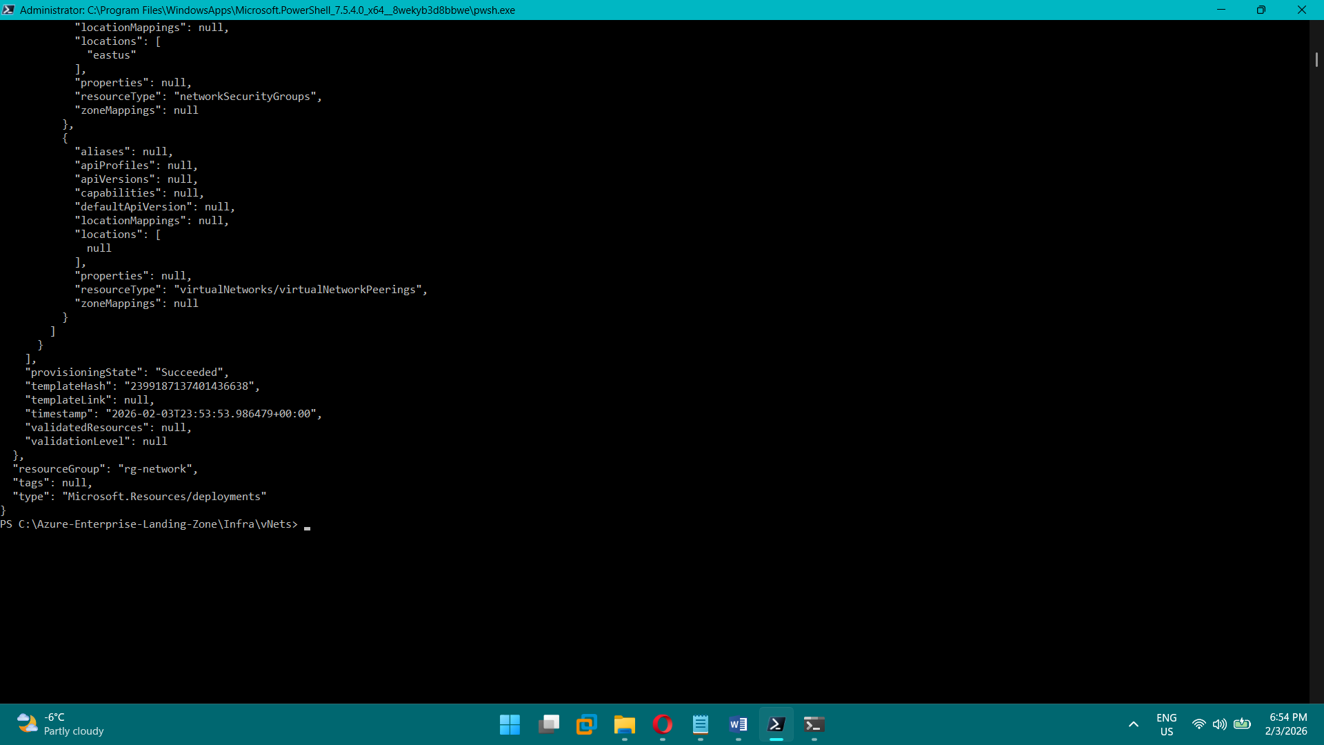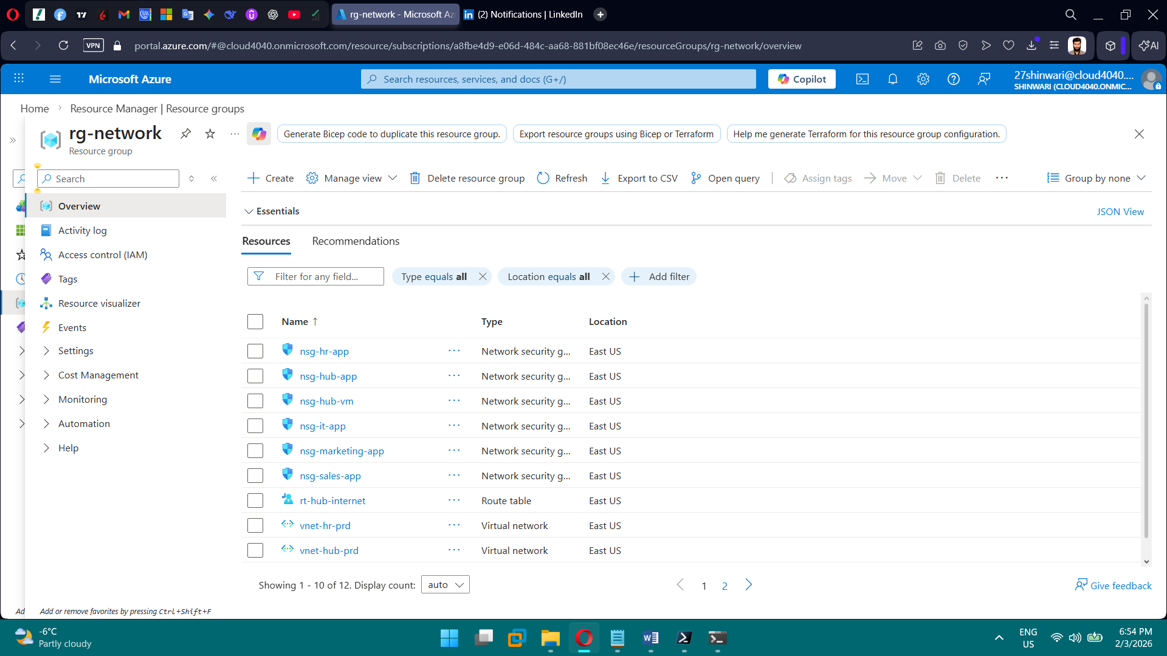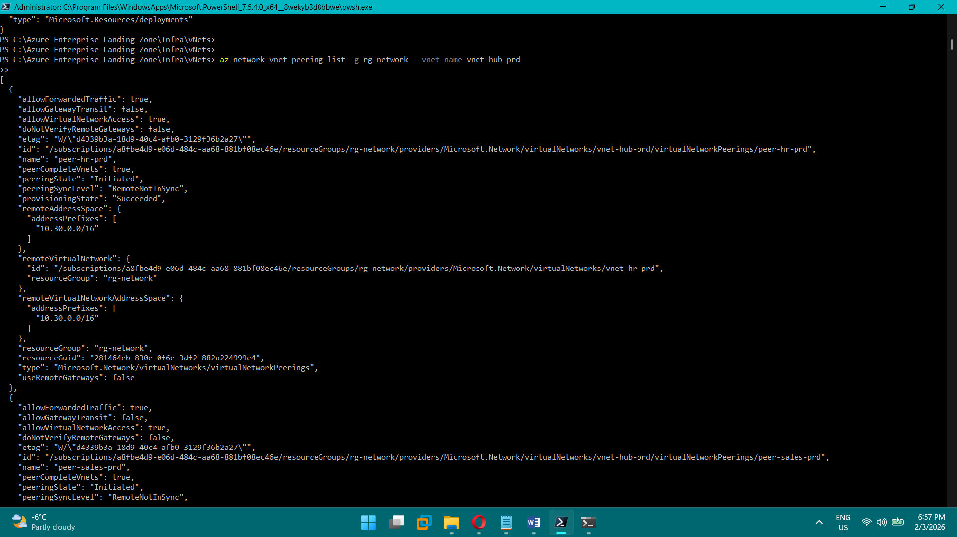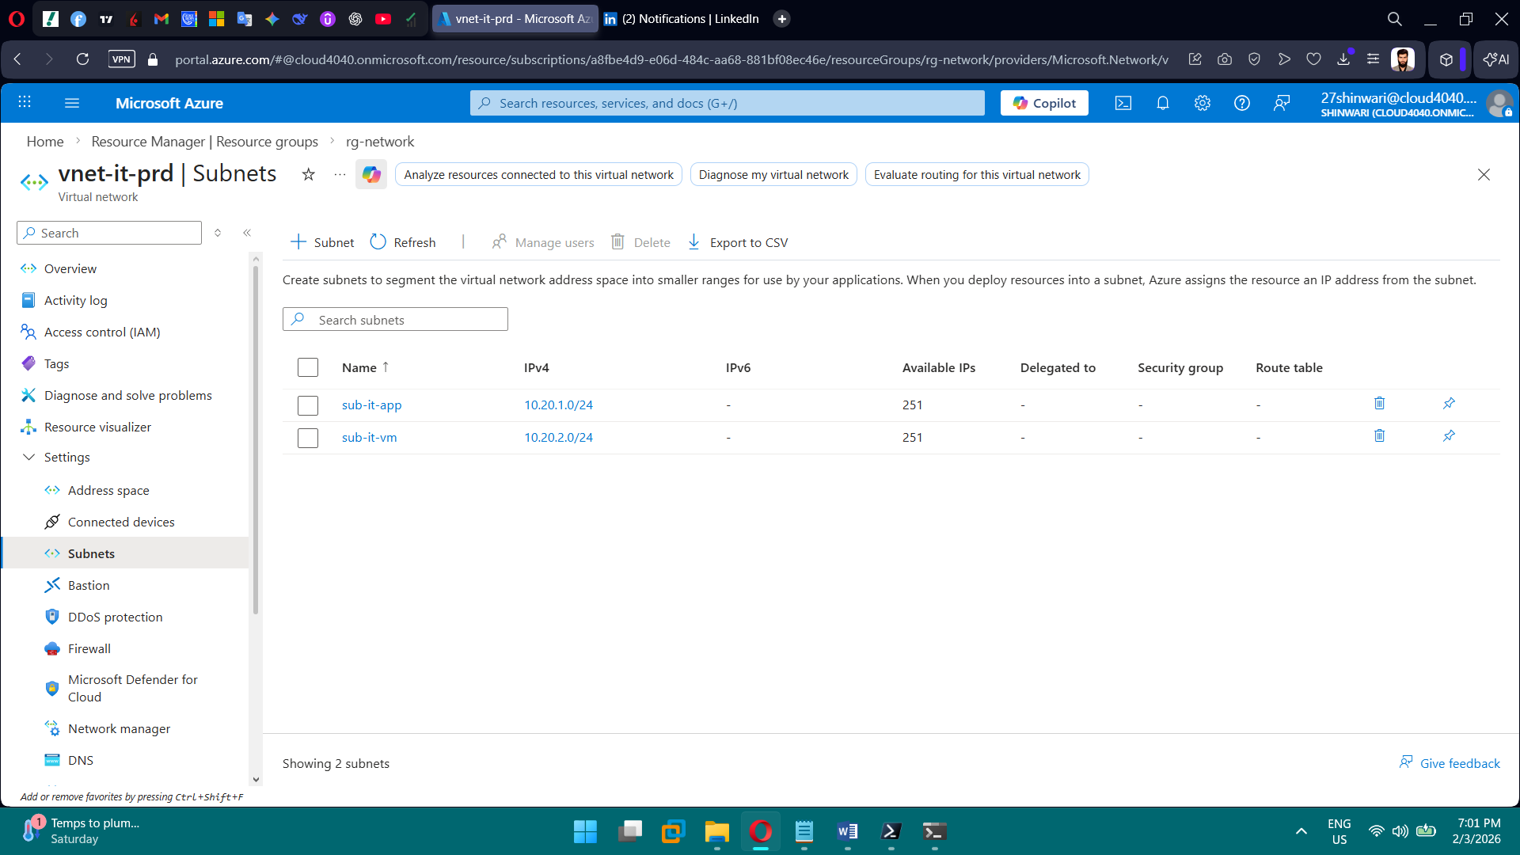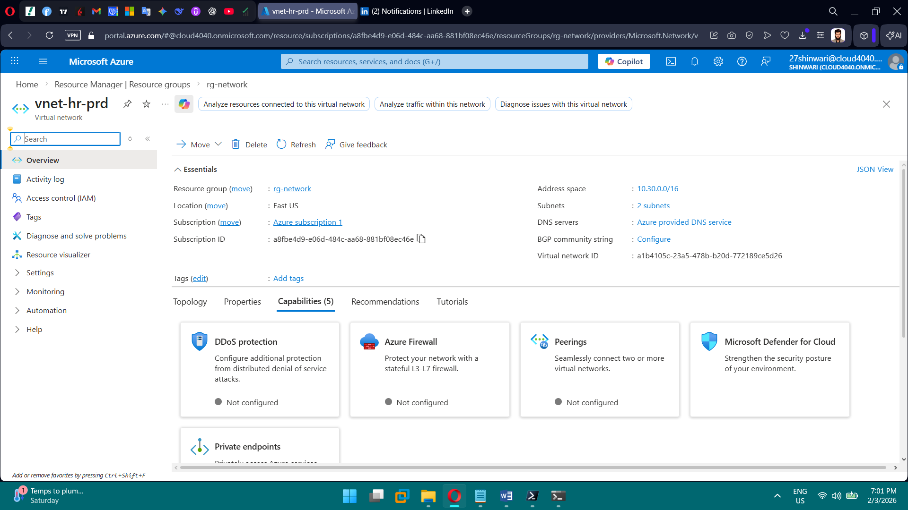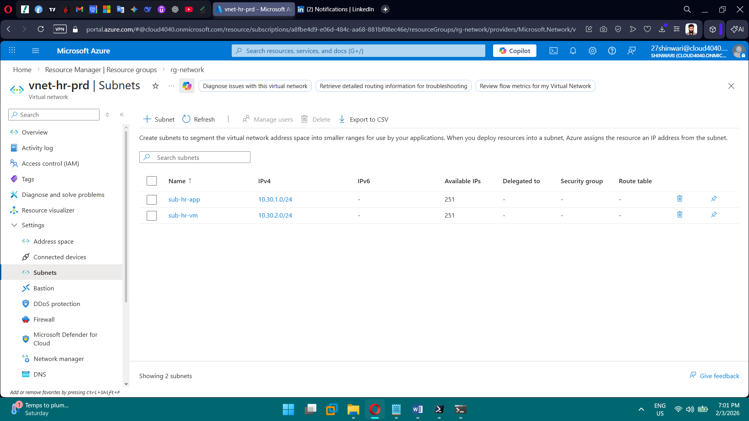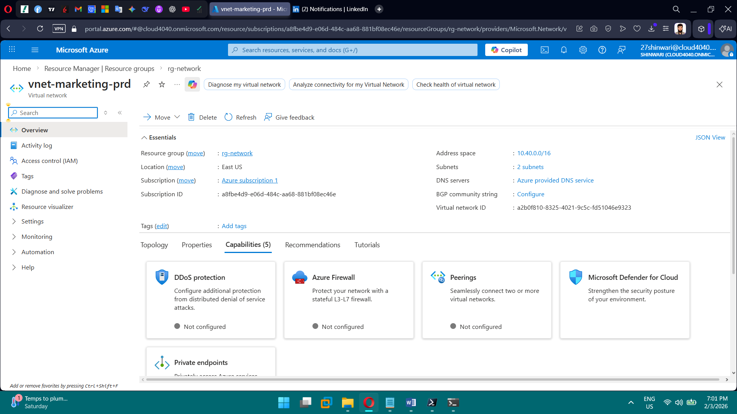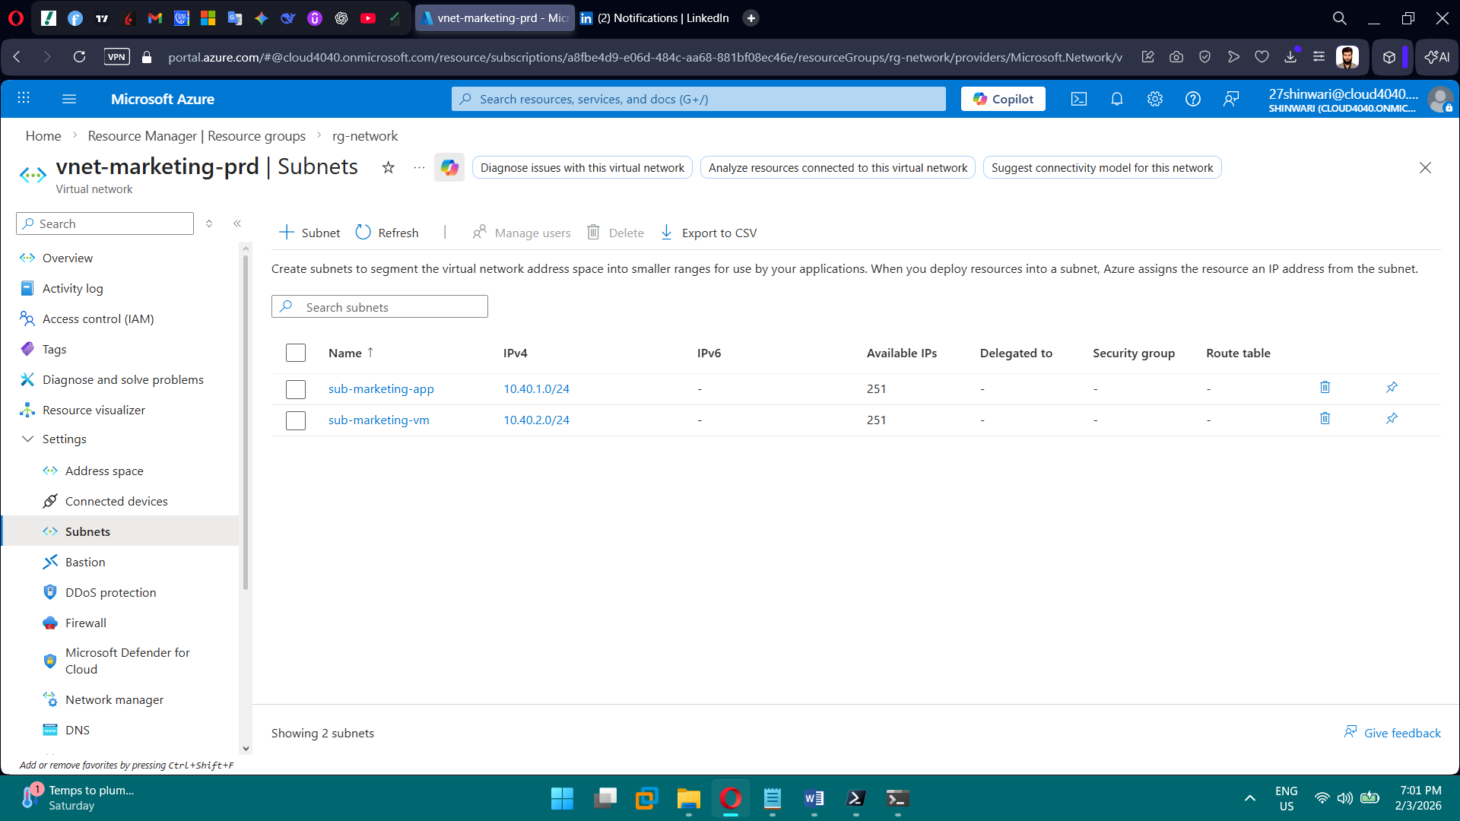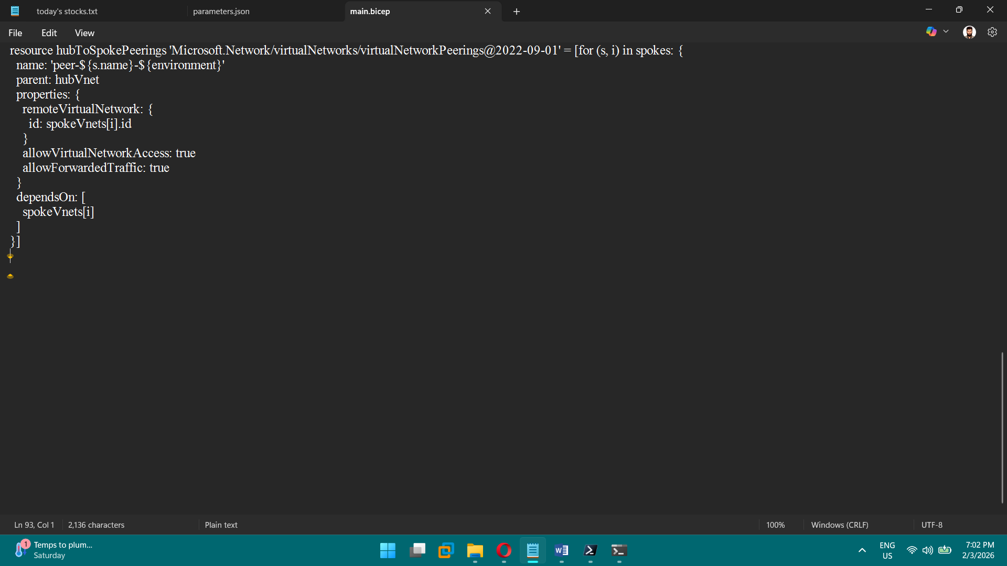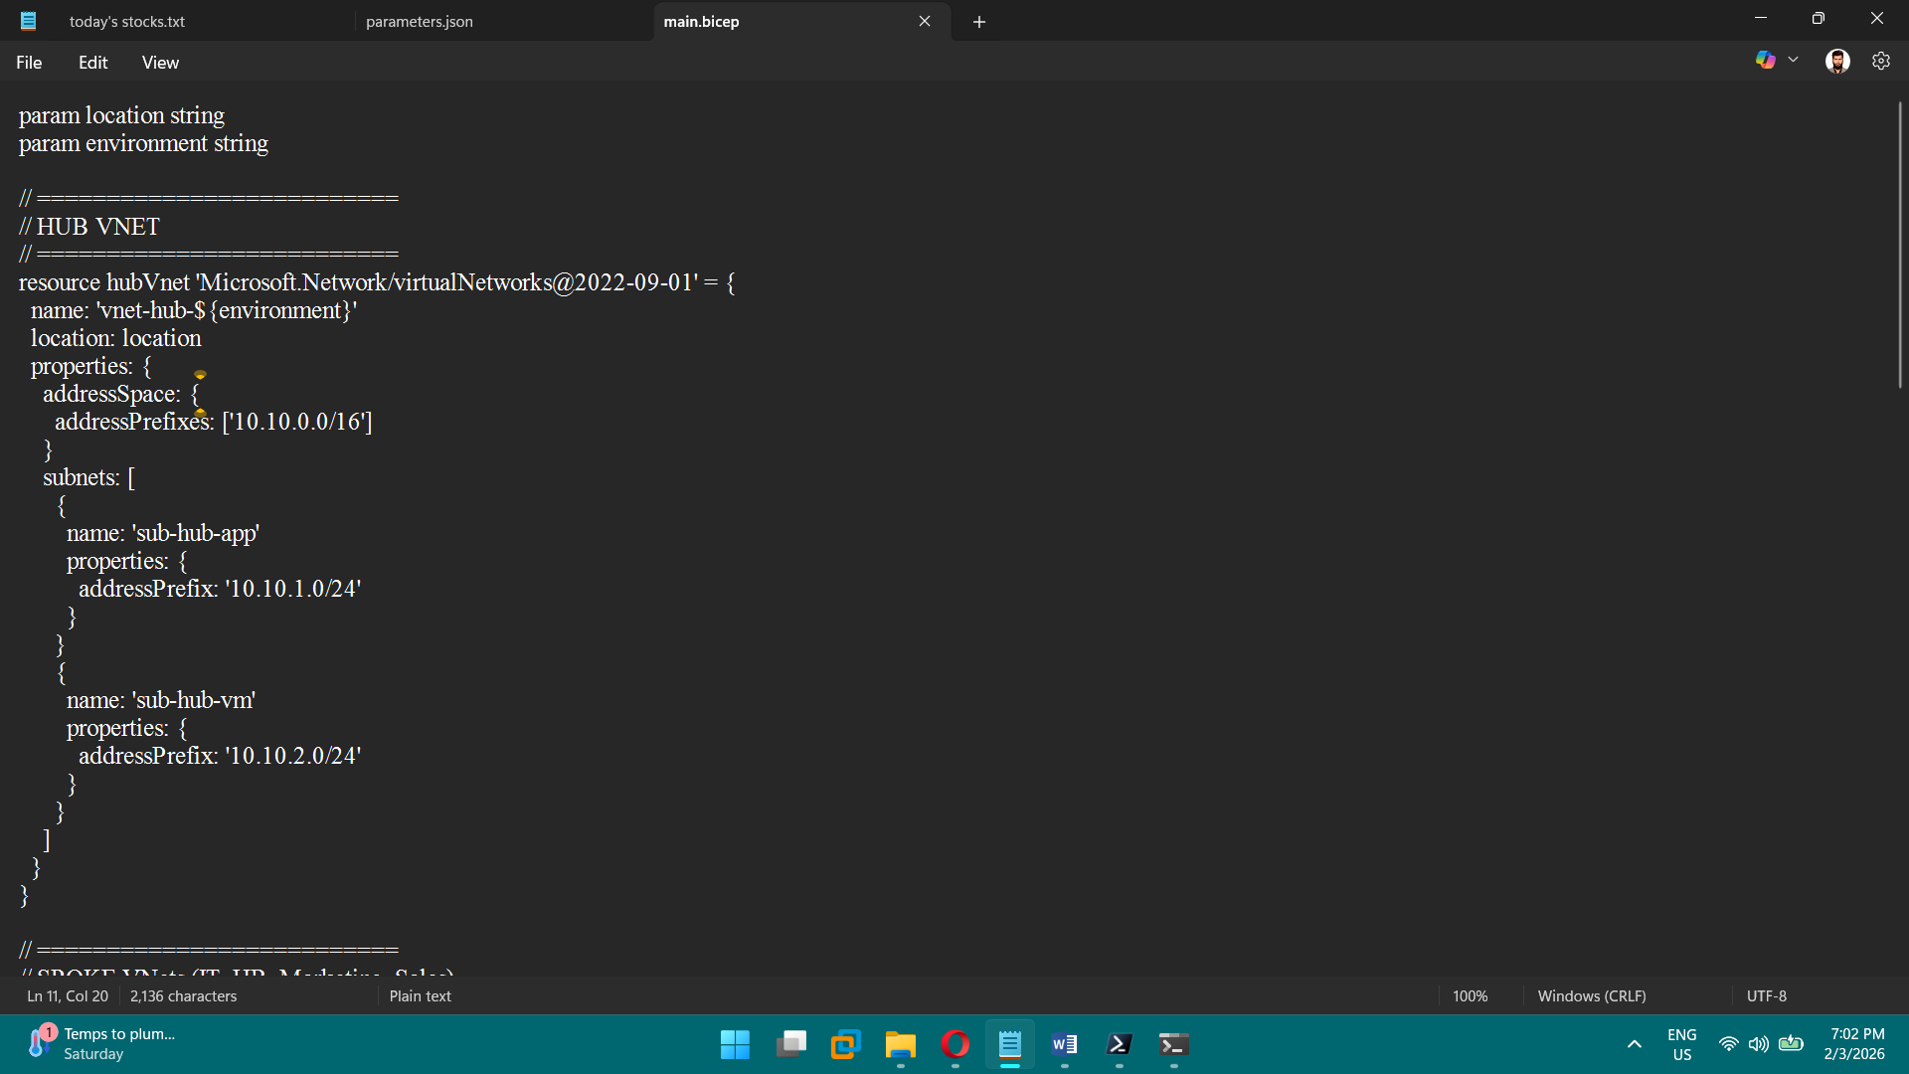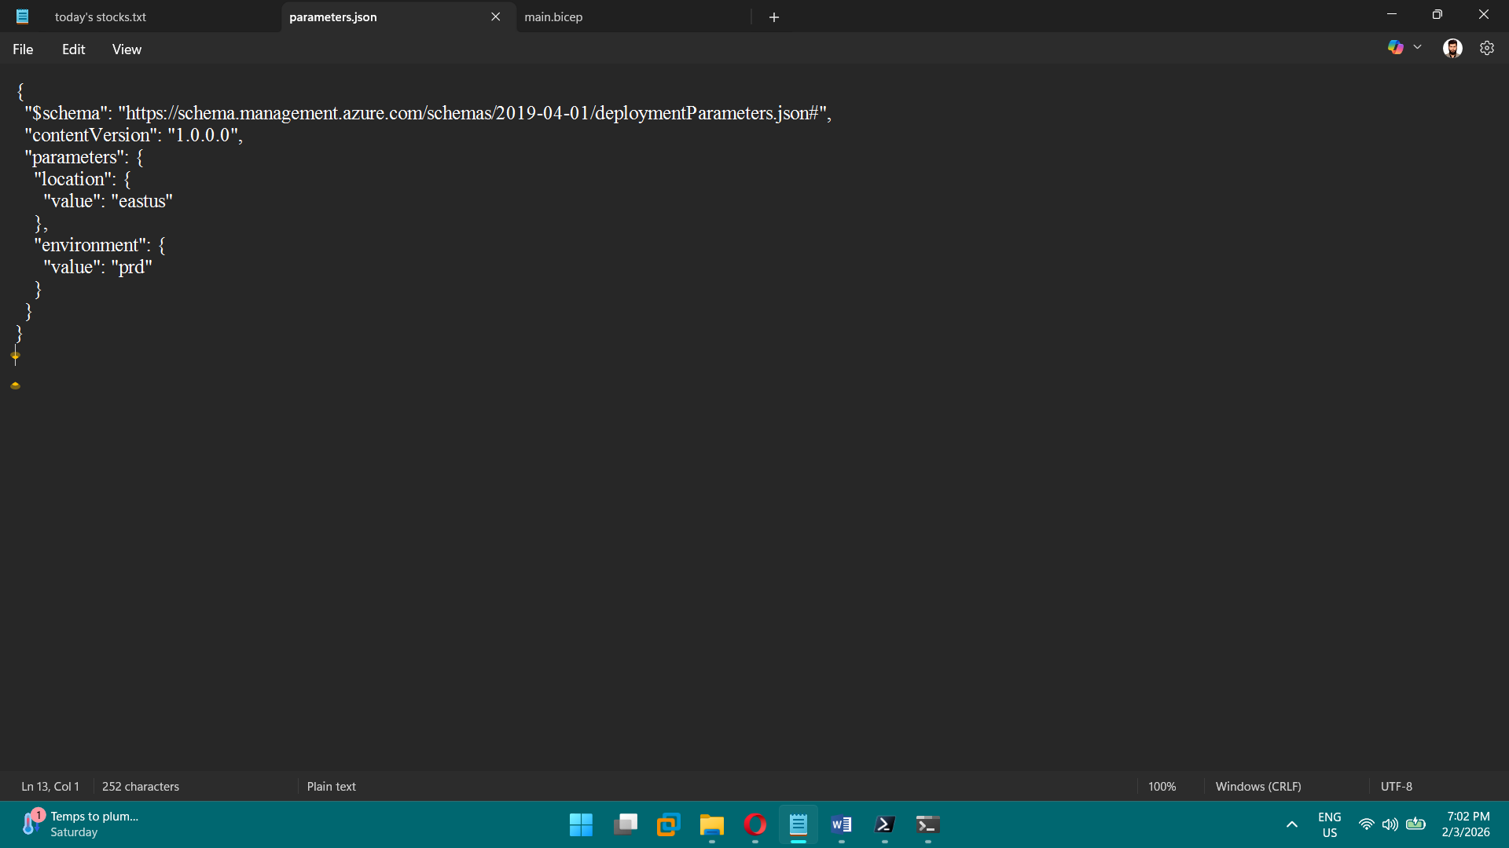

**PHASE 5 — Compute (VMs & VMSS)**

**Tasks**

1. Deploy 1 VMs per department
2. Configure auto-shutdown
3. Create VM Scale Sets
4. Configure scaling rules
5. Create load balancer
6. Validate HA

**Brief Explanation:** We deployed virtual machines in Azure using Bicep to automate infrastructure creation and maintain consistency. We configured auto-shutdown on the VMs to reduce operational costs during non-working hours. We implemented high availability by placing the VMs behind a standard Azure Load Balancer. We introduced Virtual Machine Scale Sets to enable automatic scaling based on workload demand. Finally, we validated the high availability and scalability by checking health probes and traffic distribution.

